**Tregoze Primary School**

**Admissions for 2025/2026**

Does your child start school in September 2025?

We are holding tours for you to come and look around our school.

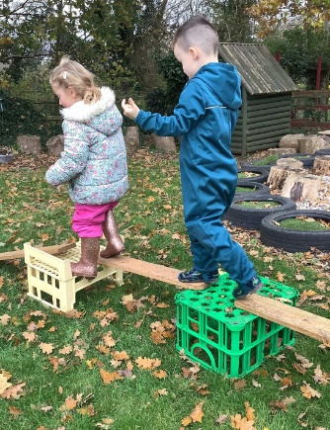Thursday 7th November 9.30am to 11.30am

Monday 11th November 1.30pm to 3.30pm

Please telephone or email the school if you would like to attend

Tel: 01793 876800

Or

Email: admin@tregoze -pri swindon.sch.uk

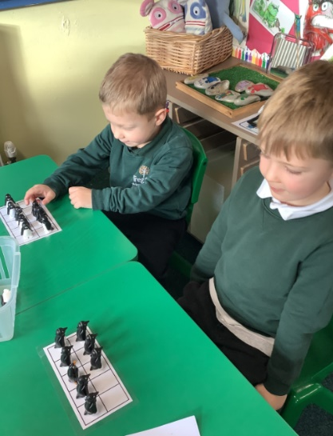**DON’T FORGET!**

**Closing date for Primary**

**admissions**

**is 15th January 2025**