Art and Design and Technology
In Art this term the children will be learning about Egyptian art, looking at symbols and their meanings and making a scroll.
For DT the children will be learning cross-stitch and applique to create an Egyptian collar.
Music
In music lessons the children will be having drumming lessons. The children will earn about how to write down music. They will also take part in a project with the English National Opera.
English
We are exploring the text The Iron Man by Ted Hughes and Winter’s Child by Angela McAllister and the Poem TheMagic Box by Kit Wright.
The children’s writing focus will be setting description and diary writing, inspired by the Iron Man and character description and persuasive letter writing, inspired by Winter’s child.
We will be following the spellings programme for year 3.
Modern Foreign Languages
We learning about France, greetings and counting to 10.

History and Geography
We will research the Ancient Egyptians and learn about their civilisation. How we know so much about them and where they fit on a historical timeline. They will learn about how important the River Nile is, their gods and beliefs about life and death.
They children will learn about where Egypt is and be able to label key features such as the River Nile, Red Sea and the desserts. The children will learn about oceans, seas and continents.



The Ancient Egyptians
Year 3 Mrs Terry
The

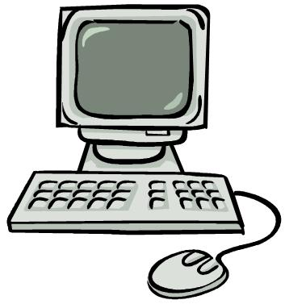

Maths
We will begin with place value – understanding the value of all digits in 3-digit numbers. Understanding writing, ordering, comparing and rounding 3-digit numbers, using apparatus to represent numbers in different ways. We will also be looking at some addition, subtraction and multiplication methods, focussing on learning the 3 and 4 times tables and then geometry. There will be regular lessons to teach children methods and skills to solve a variety of maths problems.
Times tables will also be a big focus and children will learn and be tested for quick recall regularly.

Science
The children will be learning and developing their scientific skills through the study of skeletons, movement, nutrition, diet and rocks.

Computing
The children will be learning about computing systems and networks by comparing digital and non-digital devices. They will learn about input-process-output.
They will also learn about creating media and use a range of techniques to create a stop frame animation.
Computer safety
The children will be exploring self-image and identity, Privacy and security and online bullying.
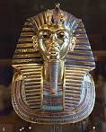
R.E
Our key Religious questions will be:
“What does it mean to be a Hindu in Britain today?” “ How do people from different communities celebrate festivals?”

Physical Education – Dance, Football, Tag rugby and Muay Thai.
PSCHE Jigsaw /Values
Our Values will be focussed around responsibility and tolerance this term.
Our Jigsaw themes are ‘Being Me in My World’ and ‘Celebrating differences’.

