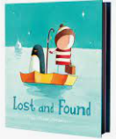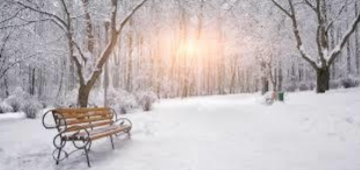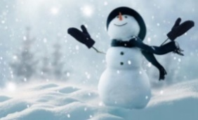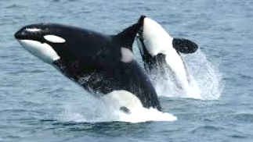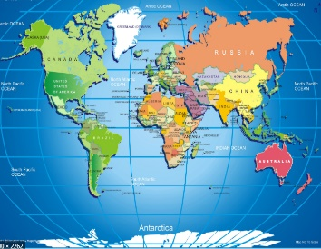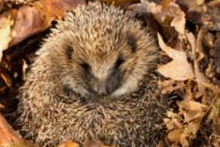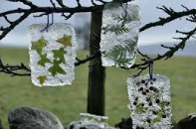

**Things to talk about ……**

Can you name the seasons?

Can you name the months of the year?

What is winter?

What will the weather be like?

What does winter look like?

What animals will we see in winter?

What should we wear in winter?

What happens in winter?

* Many animals hibernate or migrate
* Most trees and plants stop growing Where in the world do you live?
* Where is the United Kingdom?
* Where are the polar regions of the world?

**ICE** The temperature outside drops during winter. When it becomes too cold water will freeze and turn into ice.

Can you use an old lid to freeze water and create some art?

**Reception Term 3**

**Frozen Worlds – Winter & Antarctic**

**Polar Regions**

Find out where in the world these animals live?

Elephant seal Seal lion Penguin

Orca whale Sperm whale Albatross

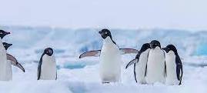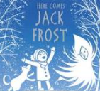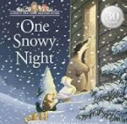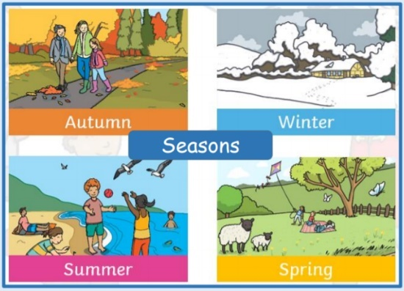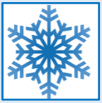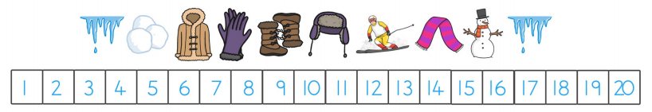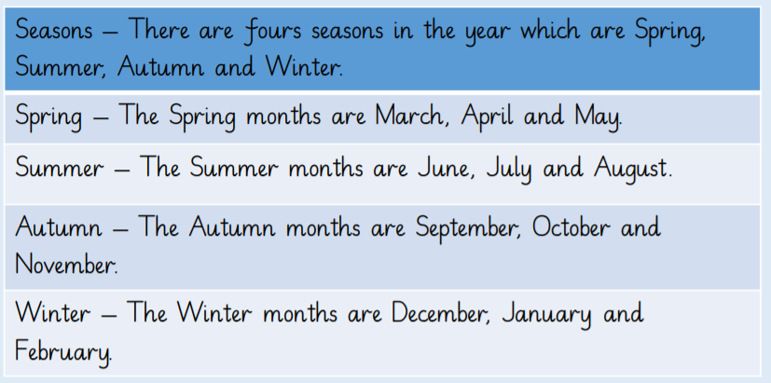

**Key Vocabulary**  Winter Autumn Spring Summer cold freeze ice snow Polar Artic Antarctic melt solid weather liquid ocean land country