Key Stage: EYFS
Daily Learning: Year Reception | Date: Wednesday 15th July 2020
General Information
With this being the last full week of the summer term, if it had been a normal year we would be having lots of end of year events. One event is the annual teddy bears picnic. This year things are different but hopefully you can have a picnic with family or meet a friend in the park. The next two days learning focuses on picnic preparation.

Tomorrow’s zoom meeting is for everyone and it will start at 1.15pm. Please bring your teddy bear to the meeting and have some learning ready to show.

Please forward any photos for the school blog to either myself or Mrs Doran. We will then forward them to Miss Pugh. It will be the last blog so it would be fabulous if you all could send in a photo.

We will be setting home learning for the last three days of term. The home learning will be slightly different. We are producing one plan to cover the three days and it will be uploaded by 9.00 am on Friday 17th July.

Please email if you have any questions or queries.
Exercise Time!
Jumping Jacks
- Stand by a cone or and small object - your teddy, at least 2m apart from everybody else if in a public place.
- Carry out the cone command as it is called out.
Cone commands
- Star jump! Jump in the air and make a
star shape.
- Side to side! Jump side to side over the cone.
- Back and forth! Jump forwards and backwards over the cone.
- Hop round! Hop round the cone.
- Hop over! Hop over the cone!
- Hopscotch! Jump and hop next to the cone.

Phonics (20mins):
Daily: Recap flashcards of all sounds (phase 2&3). Either make flashcards by copying the sounds from your child’s sound book, download a free set from http://www.letters-and-sounds.com/or buy them from Amazon. Please practise reading the tricky words everyday with your child. Either use the mini flashcards at the back of the sound book or look at them on https://www.phonicsplay.co.uk/ (free access).

Today’s focus:
I am learning to spell the Phase 3 tricky words
OR
I am learning to spell the Phase 4 tricky words

Focus on the tricky words suitable for your child. Practise spelling them.
Being able to spell the phase 2 and 3 words, in particular, will help prepare your child for year 1. I have uploaded a list of all the tricky words. If your child can read and spell all the phase 3 words, please focus on the phase 4 ones.

I am learning to read and write words containing the ‘ure’ trigraph.
Main - Recap the long ‘ure’ sound
Using phoneme fingers, say the word sure and count the sounds – s-ure. Ask your child to write the word and draw sound buttons under it. Repeat for pure, cure, insure

Then practise reading the following words
secure | manure | sure | cure

Finally practise reading these sentences.

Look at his hair.
Are you sure you are right?
Does manure smell?

I have a pair of socks.

Reading:
Daily: Please hear your child read one book a day and practise a word list.

Finding reading books suitable for your child can be challenging. Oxford Owls does have free e books to download. The books include Biff and Chip and Read, Write Inc (These are phonic based. They do not use the same colour bands as Biff and Chip). You can find books by age or level. Happy Reading!

https://home.oxfordowl.co.uk/books/free-ebooks/

Bug Club
A selection of books has been allocated to your child; please try to read at least three of them.
https://www.activelearnprimary.co.uk/login?c=0

Please remember to do the bug quizzes by clicking on the green bug heads and to close the book at the end by clicking on the red circle with the cross. Then the book will show as completed when we log on to the website and we know to allocate new books.

Keep practising the high frequency words. If your child can read them, practise spelling them. (Saved under ongoing reception resources as phase 2 or 3 or 4 high frequency words.)

High Frequency Words- These words are a mixture of phonetic words and tricky words that the children should be able to read on sight (have instant recall). Please help your child to learn them starting with phase 2 words, then phase 3 words and then phase 4.

Word boxes- Continue practising blending by working through the word boxes saved under ongoing resources. I have added some more word lists if your child can read the others. Word box lists 22-24.

Writing:
I am learning to write a list. I can use my sounds to sound out words.

You are going to have a teddy bears picnic tomorrow. You may want to go out and have an actual picnic or you may prefer to have one with your toys. Today you are going to plan what you like.
Write a list of food and equipment (picnic rug) you need for your picnic. Remember to write your list going down the page with one item on each line.
I am learning to write a sentence with clear finger spaces and a full stop.
Then write a sentence to say where you will have the picnic.

Handwriting:
Daily: Practise three lines in your school book of writing the letter or letters below. Each day we will give a different letter. Make sure your child is using the school script and put a finger space between each letter. Please do three lines of the same letter if your child is finding it challenging.

Check your child is using the correct ‘snappy finger’ pencil grip. This is easier to do with a large, chunky writing pencil.

Line 1 ‘u’
Line 2 ‘r’
Line 3 ‘ure’

Please only join the letters if your child can form the individual letters correctly and you show them how to join the ‘r’ to the ‘e’ correctly.

Please do not join all letters in other writing yet.

Mathematics:
Daily: If your child is not secure with numbers to 20 please practise reading these in and out of order and see if they can put them in the correct order. Practise writing numbers correctly to 10/20 either on a whiteboard, chalkboard on in the book provided. If your child is confident with numbers to 20 please practise counting to 100 and reading/writing random numbers from a hundred square - download from google images or Twinkl.co.uk

Warm up - Complete one of the teddy bear dot-to-dots. At the bottom of the page continue the numbers. How far can you go?
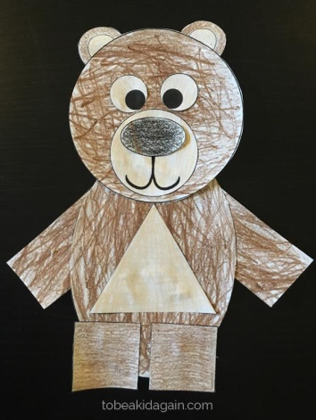
Main - I am learning to name 2D shapes.
Using either the uploaded sheets or by drawing around circles, rectangles, triangles etc make a shape picture of a teddy bear.
Challenge - Try to include as many shapes as possible. What could a hexagon be? You may want to do a background so it is easier to get a variety of shapes in your picture.
Once the picture is finished tell an adult the names of all the shapes you have used.

Knowledge and Understanding of the World/ Expressive Arts/ Topic:

I am learning to design and make ( cook)

With the help of an adult, make some picnic food- either cakes or biscuits. If you are feeling very clever you make want to make them teddy bear themed.

https://www.annabelkarmel.com/recipes/chocolate-teddy-bear-cupcakes-2/

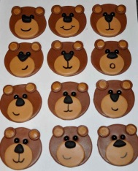fondant toppers 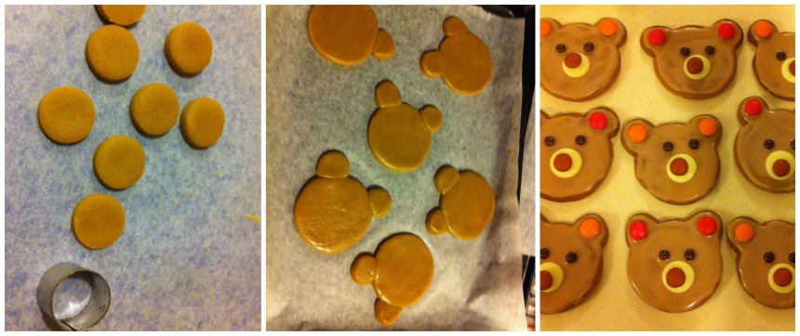

If you want to cut out the cooking phase and just decorate cakes or plain biscuits such as rich teas, you just need some icing and sweets to decorate.

These faces could be more bear like with chocolate button ears.

I look forward to seeing photos of all your baking!

I can sing a song
Learn a song.

Choose a song to sing along to and try to learn.
https://email.outoftheark.com/t/y-l-udirgk-tdtlhifkh-i/

