Key Stage: EYFS
Daily Learning: Year Reception | Date: Thursday 16th July 2020
General Information

Today’s zoom meeting is for everyone and it will start at 1.15 pm this afternoon. Please have your teddy bear with you and some learning ready to show. This will be our last home learning zoom, but there will be a farewell zoom for all the children on Tuesday 21st at 3 pm.

Please forward any photos for the school blog to either myself or Mrs Doran. We will then forward them to Miss Pugh for the last blog of the year.

Please email if you have any questions or queries.
Exercise Time!
Game 2- Mr Men
- Stand at least 2m apart.
- Listen for the names of the Mr Men and move in the appropriate way, remembering to stay 2m apart.
- Can you think up any Mr Men of your own?
- Mr Slow – Move slowly around the space.
- Mr Rush – Move quickly around the space.
- Mr Bounce – Jump up and down.
- Mr Muddle – Walk backwards around the space (remember to look where you are going).
- Mr Small – Crouch down and move low
to the ground.
- Mr Strong – Stand still and flex your muscles

Phonics (20mins):
Daily: Recap flashcards of all sounds (phase 2&3). Either make flashcards by copying the sounds from your child’s sound book, download a free set from http://www.letters-and-sounds.com/or buy them from Amazon. Please practise reading the tricky words everyday with your child. Either use the mini flashcards at the back of the sound book or look at them on https://www.phonicsplay.co.uk/ (free access).

Today’s focus:
WALT spell the Phase 3 tricky words
OR
WALT spell the Phase 4 tricky words

Focus on the tricky words suitable for your child. Practise spelling them. A copy of all the tricky words was uploaded yesterday.

I am learning to read and write words two- syllable words. ,
Main- Recap what a two syllable word is. Say bedroom and clap each syllable as you say the word bed-room. Repeat for penlid.

Then practise reading the following words
toothbrush | carpark | armchair | farmyard

Finally practise spelling these words.
bedroom | carpark | armchair | raindrop

Reading:
Daily: Please listen to your child read one book a day and practise a word list.

Finding reading books suitable for your child can be challenging. Oxford Owls does have free e books to download. The books include Biff and Chip and Read, Write Inc (These are phonic based. They do not use the same colour bands as Biff and Chip). You can find books by age or level. Happy Reading!

https://home.oxfordowl.co.uk/books/free-ebooks/

Bug Club
Some books have been allocated to your child; please try to read at least three books a week, if you have online access.
https://www.activelearnprimary.co.uk/login?c=0

Keep practising the high frequency words. If your child can read them, practise spelling them. (Saved under ongoing reception resources as phase 2 or 3 or 4 high frequency words.)

High Frequency Words- These words are a mixture of phonetic words and tricky words that the children should be able to read on sight (have instant recall). Please help your child to learn them starting with phase 2 words, then phase 3 words and then phase 4.

Which word box/ list is your child working on? Let me know if you need more blending resources. Your child should be practising blending every day.
Word boxes- Continue practising blending by working through the word boxes saved under ongoing resources. I have added some more word lists if your child can read the others. Word box lists 22-24.
Writing:
I am learning to write a simple sentence or more.

Today you are going to write a simple invitation to someone inviting them to come to your picnic. You could invite a friend, a brother or sister or your mum or dad.
An invitation needs to tell someone when and where the picnic is. (You could write an invitation for an imaginary picnic if you decide not to have a picnic.). Here’s an example:
Dear Mummy,

Please come to my picnic on Thursday at 2 o’clock in the garden. Remember to bring your teddy!

Please reply to me.

Miss Cope

Decorate your invitation.

If you prefer you can use the uploaded invitation template.
Handwriting:
Daily: Practise three lines in your school book of writing the letter or letters below. Each day we will give a different letter. Make sure your child is using the school script and put a finger space between each letter. Please do three lines of the same letter if your child is finding it challenging.

Check your child is using the correct ‘snappy finger’ pencil grip. This is easier to do with a large, chunky writing pencil
Line 1 ‘b’
Line 2 ‘be’
Line 3 ‘bear’

Mathematics:
Daily: If your child is not secure with numbers to 20 please practise reading these in and out of order and see if they can put them in the correct order. Practise writing numbers correctly to 10/20 either on a whiteboard, chalkboard on in the book provided. If your child is confident with numbers to 20 please practise counting to 100 and reading/writing random numbers from a hundred square - download from google images or Twinkl.co.uk

Warm- up – I am learning to count in twos
Use a number line or hundred square to help. Can you count up to 20 in twos? Practise with an adult and then try by yourself.
MATHS QUIZ
Main- Today you are completing half the uploaded quiz. You will finish the rest tomorrow. The quiz goes over many of the areas of learning we have covered this year. How much can you remember? If you are unable to print out the quiz and write the answers on the sheets, read (with adult help) the questions off the screen and write the answers in your book. There are two quizzes to choose from- one is longer and more detailed.
Knowledge and Understanding of the World/ Expressive Arts/ Topic:

This afternoon you are going to have your picnic.
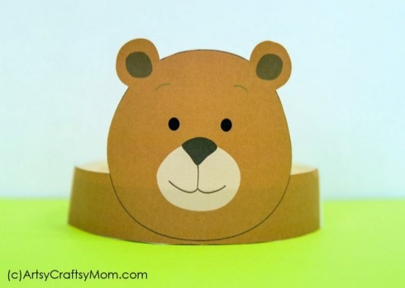
I am learning to make and design
Make a bear head band to wear at the picnic.
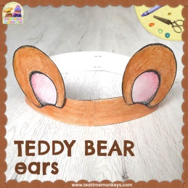

With the help of an adult, make a sandwich.

Have a picnic!

Please send in photos of the preparations or a photo of you at the picnic.

