Key Stage: EYFS
Daily Learning: Year Reception | Date: Wednesday 1st July 2020
General Information
I hope you are all enjoying the sports festival and are collecting lots of points for your house.

Please note there is no PSHE assembly this week due to it being our Sports festival. PSHE assembly will be back at 2pm on Wednesday 8th July.

The zoom meeting is for everyone and will start at 1.15pm tomorrow. Please have some learning ready to show. I will send out an invitation as you will require a password to join. Also don’t forget to send us ‘secret’ emails about ‘wow’ moments at home and some of those children will get a special shout out, instead of certificates at the end of the week that we usually do. This could be school learning related but doesn’t need to be. It could be about excellent behaviour, being super kind, extra helpful or all of these! Don’t forget to remind me if your child has had a birthday this week.

Please forward any photos for the school blog to either myself or Mrs Doran. We will then forward them to Miss Pugh who is uploading the blog for all classes.

I hope everyone is enjoying using Bug Club. Books will only show as completed if the bug questions/ quizzes have been completed. Please give us feedback on how your child found the books. We can allocate different levels as required. You can also use Maths Factor with your active learn login and it is a great way to practise basic number skills.

Please email if you have any questions or queries.
Exercise Time! The Sports Festival

Sports Star of the day | Sarah Storey- see Power Point
Warm up/down activity | Wacky walks-
Family sport activity | To try and go for a family bike or scooter ride!
Sports competition event | How many hops can you do in a minute?  Don’t forget to record your total on the table that has been emailed as they count towards your final house score!

Phonics (20mins):
Daily: Recap flashcards of all sounds (phase 2&3). Either make flashcards by copying the sounds from your child’s sound book, download a free set from http://www.letters-and-sounds.com/or buy them from Amazon. Please practise reading the tricky words every day with your child. Either use the mini flashcards at the back of the sound book or look at them on https://www.phonicsplay.co.uk/ (free access).

Today’s focus:
I am learning to read and spell the Phase 3 tricky words – be, he, me, she, we, my, by, you, was, they
OR
I am learning to read and spell the Phase 4 tricky words –went, said, have, like, so, do, some,little, there, were, come, one, when, out, what,

Warm Up- Choose one of the above tricky words lists and practise reading the words. Then practise writing them. You may want to focus on writing 3 or 4 words a day.

I am learning to read and spell words containing the ‘or’ sound

Main- Recap the ‘or’ sound
Using phoneme fingers, say the word for and count the sounds - f-or. Ask your child to write the word and draw sound buttons under it. Repeat for fork, cord, cork
.
Then practise reading the following words

lord | born | torn | sort

Finally practise reading these sentences.

The cork can float.
The old lord can hold a fork.
Can you sort the torn things?
or
Finally practise reading this sentence.
The fork is red.

Reading:
Daily: Please hear your child read one book a day and practise a word list.

Finding reading books suitable for your child can be challenging. Oxford Owls does have free e books to download. The books include Biff and Chip and Read, Write Inc (These are phonic based. They do not use the same colour bands as Biff and Chip). You can find books by age or level. Happy Reading!

https://home.oxfordowl.co.uk/books/free-ebooks/

Bug Club
A selection of books have been allocated to your child, please try to read at least three of them.
https://www.activelearnprimary.co.uk/login?c=0

Please remember to do the bug quizzes by clicking on the green bug heads and to close the book at the end by clicking on the red circle with the cross. Then the book will show as completed when we log on to the website and we know to allocate new books.

Keep practising the high frequency words. If your child can read them, practise spelling them. (Saved under ongoing reception resources as phase 2 or 3 or 4 high frequency words.)

High Frequency Words- These words are a mixture of phonetic words and tricky words that the children should be able to read on sight (have instant recall). Please help your child to learn them starting with phase 2 words, then phase 3 words and then phase 4.

Word boxes- Continue practising blending by working through the word boxes saved under ongoing resources. I have added some more word lists if your child can read the others. Word box lists 22-24.

Writing:
I am learning to write an information book. I am learning to write a simple sentence with clear finger spaces and a full stop.

Choose your next mini-beast to write about. If you need more facts about your chosen mini-beast remember to use the information cards.
Write the heading on the top line. Then write a sentence or two about the mini-beast. Remember to use clear finger spaces and neat handwriting as you will want other people to be able to read your book.
Finally draw a careful picture and colour it in. Information books often have diagrams in them. Can you make your picture into a diagram?

Handwriting:
Daily: Practise three lines in your school book of writing the letter or letters below. Each day we will give a different letter. Make sure your child is using the school script and put a finger space between each letter. Please do three lines of the same letter if your child is finding it challenging.

Check your child is using the correct ‘snappy finger’ pencil grip. This is easier to do with a large, chunky writing pencil.
Line 1 ‘o’
Line 2 ‘r’
Line 3 ‘or’

Please only join the letters if your child can form the individual letters correctly and you show them how to join the ‘o’ to the ‘r’ correctly. The o is a top joiner, unlike most letters that join onto a new letter from the line/ the bottom.
Please only join letters during handwriting practice and do not join letters in other writing situations yet.

Mathematics:
Daily: If your child is not secure with numbers to 20 please practise reading these in and out of order and see if they can put them in the correct order. Practise writing numbers correctly to 10/20 either on a whiteboard, chalkboard on in the book provided. If your child is confident with numbers to 20 please practise counting to 100 and reading/writing random numbers from a hundred square - download from google images or Twinkl.co.uk

Warm- up – I am learning to say the number one less than a given number
Say the number one less than… Level 1- up to 10/ then 20
Level 2- up to 20 and then beyond

Quick fire –ask your child 5 questions and/or use Abacus maths Pesky Pests by logging on to Active Learn

I am learning to add 2 groups using either objects or a numberline to count on.

Main - Recap how to write a number sentence. Ask your child to write the following number sentences and to solve them. Use either objects or a numberline.
Level 1 | Level 2
4+2= | 5+3=
3+1= | 4+6=
5+3= | 9+4=
Please check all numbers are formed correctly and are facing the correct way.

Now choose one of the uploaded activities
- A PowerPoint which covers addition to 10
- Butterfly addition sheet to either 10 or 20
- Numicon adding to 20
- Challenge – numberline addition to 30

If you are unable to print, please write 5 number sentences in your child’s exercise book for them to complete.
Knowledge and Understanding of the World/ Expressive Arts/ Topic:

I am learning to create and make using different materials

I can make a model
make a 3D mini-beast Using either clay, salt dough, papier-mache or play dough.
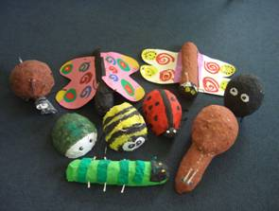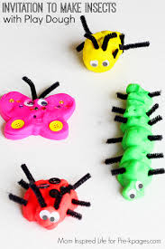
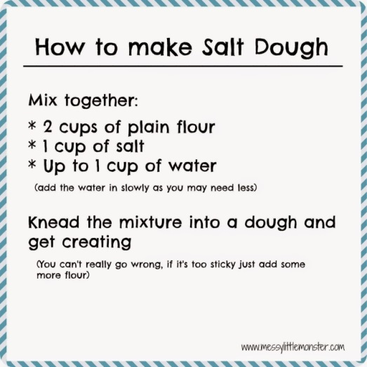

OR

I can make a bee
Make a bee using any materials you like. Look at the pictures below for ideas or you may have a better idea of your own. Don’t forget to send in your photos for the blog.
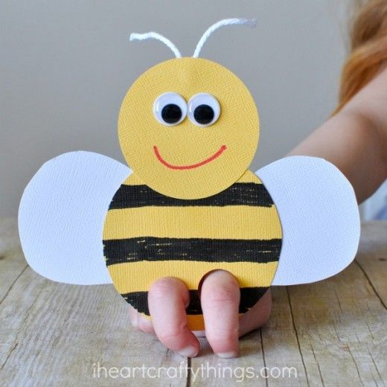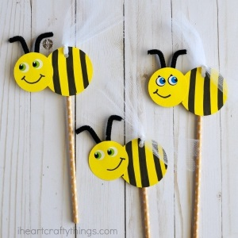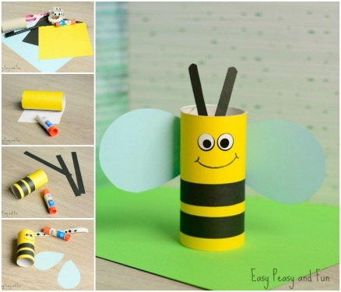
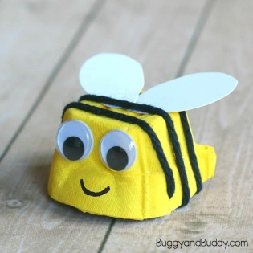

I can sing a song
Learn a song.

Choose a song to sing along to and try to learn.
https://email.outoftheark.com/t/y-l-udirgk-tdtlhifkh-i/

Useful websites:
http://www.letters-and-sounds.com/
https://www.phonicsplay.co.uk/ username: march20 password: home
https://www.twinkl.co.uk/
https://www.topmarks.co.uk/ learning games 5-7 years
https://www.purplemash.com/login/
https://www.discoveryeducation.co.uk/
https://literacytrust.org.uk/family-zone/
https://www.booksfortopics.com/homebooks-3-5?utm_campaign=91b8033a-2701-4f95-aace-8d1e2ce95762&utm_source=so&utm_medium=mail&cid=76ce0357-1ddf-4ade-9d8f-e45f7b412278
https://www.youtube.com/watch?v=K6r99N3kXME&feature=youtu.be

Useful apps:
Alphablocks
Cebeebies Go Explore
Jolly Phonics

