Key Stage: EYFS Final Week
Daily Learning: Year Reception | Date: Monday 20th – Wednesday 22nd July 2020
General Information
What a year! This has to be the most challenging year any school has faced during my teaching career and that is a very long time! I would like to thank you for all your support and for embracing the role of home teacher whilst juggling all your other commitments, which can’t have been easy. You have been brilliant. I am just disappointed that we didn’t get the opportunity to all be back in the school as a single class before the end of this academic year- I have missed all the children and the opportunity to see them grow and fulfil their potential in reception.

We will have one final farewell get together via Zoom on Tuesday at 3 pm, an invitation will be sent out on Monday. It would be fabulous if everyone could make it. It is a themed farewell to fit in with our learning. Please come as a pirate or mermaid/ sea creature or simply wear a homemade pirate hat or sea/ beach themed hat. There are details on how to make them below. We look forward to seeing you.

Finally, have a relaxing and happy summer holiday. Take care and stay safe.

Please email if you have any questions or queries before the end of term.
Exercise Time!
Captain Says Game. ( We will try and play this at our farewell zoom)
- Stand at least 2m apart.
- Follow the pirate command as it is called out.
- Remember to stay 2m apart.
Pirate Commands
- Climb the rigging! Move your arms and legs up
and down as if you are climbing the rigging.
- Captain’s aboard! Stand up straight and salute.
- Scrub the decks! Crouch down low and pretend
to scrub the floor.
- Man overboard! Pretend to swim.
- Dig for treasure! Pretend to dig for treasure.
- Rats on board! Sit on the floor, hugging your
knees into your chest.
- Land ahoy! Put one hand above your eyes as if you have
spotted land. Point with the other hand to show your fellow pirates.
Phonics (20mins):
Phonics
Here’s a selection of phonic activates you could work through:

This website has a variety of games for all levels
https://www.topmarks.co.uk/english-games/5-7-years/letters-and-sounds

Phase 3
https://www.phonicsplay.co.uk/resources/phase/3/buried-treasure

This website is good to practise all the sounds the children have learnt at school so far
https://www.bbc.co.uk/bitesize/topics/zcqqtfr

and there’s a tricky word clip that could be helpful
https://www.bbc.co.uk/bitesize/topics/zvq9bdm/articles/zr728xs

Buried treasure game
Snakes and ladders
Bingo

Phase 4
https://www.phonicsplay.co.uk/resources/phase/4/buried-treasure

Here’s a great little spelling game
https://www.phonicsbloom.com/uk/game/alien-escape?phase=4

B Buried treasure game
Snakes and ladders

You could use house hold items or items found in nature to make words or sentences.

Reading:

Please read regularly throughout the summer holiday. We suggest you read three times a week.
Books will be set for all the children using Bug Club. You will need your activelearn password to get on to the website. Please let me know if you have any problems with logging on or if you need your password resent. I know some children have been reading actual books from other reading schemes, which is great. Do try to use Bug Club, if you have internet access as these books are very similar / in line with our school reading scheme.
Do let us know before the end of term if you feel the books set are not the correct level for your child.

Bug Club
https://www.activelearnprimary.co.uk/login?c=0

Please remember to do the bug quizzes by clicking on the green bug heads and to close the book at the end by clicking on the red circle with the cross. Then the book will show as completed when we log on to the website and we know to allocate new books.

You can also use oxford owl, which has a range of books including Biff and Chip books which we use in school.
https://home.oxfordowl.co.uk/books/free-ebooks/

Don’t forget to practise blending using the word box lists, each time you read with your child. Hard copies of the lists have been printed and are outside the school front door should your require them. If your child has completed all the lists, please just focus on the high frequency words and reading books.
Word boxes- Continue practising blending by working through the word boxes saved under ongoing resources. I have added some more word lists if your child can read the others. Word box lists 22-24.

Continue reading the tricky words and high frequency words once a week.

High Frequency Words- These words are a mixture of phonetic words and tricky words that the children should be able to read on sight (have instant recall). Please help your child to learn them starting with phase 2 words, then phase 3 words and then phase 4.

Writing:
Please choose one writing task a day from the list below.
- Read / listen to Pirate Adventure on YouTube. It is a Biff and Chip adventure.
https://www.youtube.com/watch?v=u94-cQf58vk
Write a sentence or two about the story or your favourite part of the book.
OR Challenge –to retell the story or write your own version. Your story will need a beginning, middle and end.
- Complete one of the ‘Under the sea’ sheets. Write a sentence about each photo.
- Draw a pirate, mermaid or sea creature (real or imaginary) and then write two or three sentences to describe your character.
- Complete the seaside rhyming words sheet.
- Go through the ‘What can you see?’ PowerPoint. It has lots of interesting facts. Then complete the ‘What can you see under the sea? ‘sheet. Write a sentence or two about the picture. OR Draw your own pictures of creatures that live under and sea and using the information in the PowerPoint write about them.
- Go through the ‘All about Pirates’ PowerPoint. Write an information page about pirates.
- Message in a bottle- If you were shipwrecked and needed rescuing what message would you write in a bottle? There is an uploaded sheet you can use.
Example- Help! I am stuck on an island. Please come and save me.

Mathematics:

Please complete one activity a day from the following list;
- Addition to 20 – Seaside colouring by number Level 2 or Level 1 counting objects addition- under the sea sheet. OR Addition – Crack the Pirate code addition sheet.
- Missing numbers up to 50. You may need a hundred square to help you.
- Cut and Stick ordering to 20. Stick the fish in the correct order.
- Doubling – Treasure chests sheet
- Pirate sharing- Work through the Pirate sharing PowerPoint. Then complete the halving activities.
Knowledge and Understanding of the World/ Expressive Arts/ Topic:

KUW Activities
- Floating and sinking Experiment
Choose ten objects. Can you predict which ones will float and which will sink? Sort the objects into two groups- group 1- Objects you think will sink, Group 2- Objects you think will float. Say you say why? I think the pencil will ……. because …… Now test each object. Regroup the objects into ones that float and objects that sink. Can you say what is special about the objects that float / sink?

- Make an egg float Experiment
The sea is made up of salty water. It is easier to float in salty water. Let’s prove it! Put a fresh egg into a jug of water. Does it float or sink? Now add a tablespoon of salt and stir. Does the egg float or sink? Keep adding salt until you see a change.
- The Seaside in the past and now.
Look at the PowerPoint called Seaside holidays now and then. Would you have liked a holiday at the seaside more than a hundred years ago? Would a bathing machine be fun or not? Now complete the cut and stick sheet comparing the past with today.

Expressive Activities
- Make a pirate hat (and eye patch/ telescope). You could use newspaper or paper paper. I have uploaded some instructions and templates. OR Make a sea themed hat. (decorate a long strip of paper with fish and other sea creatures.

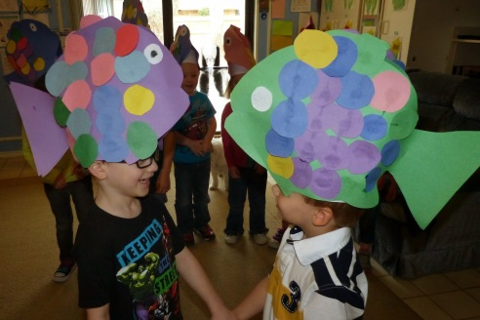
OR you could make a fish hat. Remember you need a hat for our farewell zoom.

- Make a treasure chest from a shoe box and make treasure to go in it. OR you could make a 2D flat treasure chest
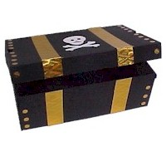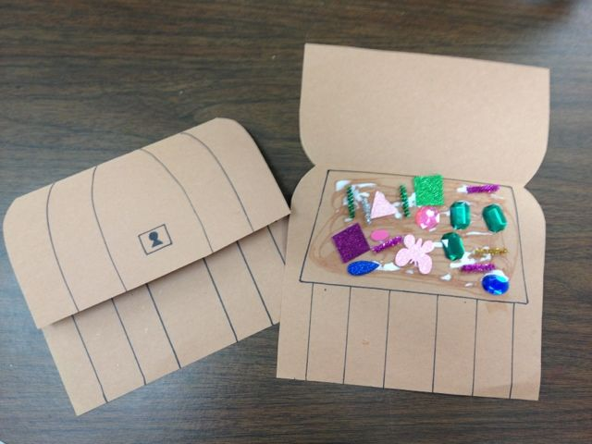

- Make a treasure map. Draw an island and add features. Paint it with cold tea to make it look old. OR use the uploaded sheet.
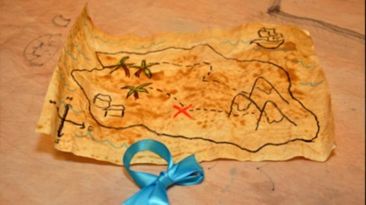

- Draw and paint a pirate / mermaid or any sea creature.
- Make an underwater scene- either 2D or 3D
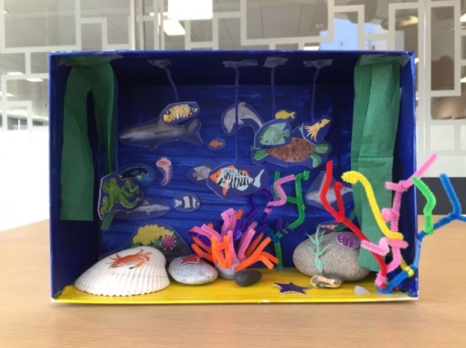

- Make a beach scene. These ones use a paper plate but you could use anything for your base- paper, card, a box.

