Key Stage: EYFS
Daily Learning: Year Reception | Date: Thursday 21st May 2020
How is the daily learning going this week? Do let us know if we can help in any way.

It was lovely to see so many of you yesterday for Miss King’s final day. Hopefully we will be able to see her with the baby later in the term.
The zoom meeting is today at 3 pm for children in group 2 (first names beginning with I-V). Please have some learning ready to show. I will send out an invitation as you will require a password to join. Also don’t forget to send us ‘secret’ emails about ‘wow’ moments at home and some of those children will get a special shout out, instead of certificates at the end of the week that we usually do. This could be school learning related but doesn’t need to be. It could be about excellent behaviour, being super kind, extra helpful or all of these! Don’t forget to remind me if your child has had a birthday this week.

Reception’s blog was updated yesterday. Do have a look on the website - it is a great way to see what everyone else has been doing and don’t forget to send in photos. I can add photos to the blog today or tomorrow.

Tomorrow is officially an INSET day, which is why I have moved the zoom meeting. Sorry about the late notice but with this unusual / strange situation all the staff had forgotten until Mrs Lovegrove mentioned it in a staff meeting. We are uploading planning for Friday. I have put Reception’s on the website today; this is so you can choose from either day’s planning. On Friday the children are asked to write part of a story or all of it, it would be great if children could try that activity today.

Happy half term!

Please email if you have any questions or queries.
Exercise Time!
PE with Joe Wicks
https://www.youtube.com/watch?v=K6r99N3kXME&feature=youtu.be
Mindfulness/Yoga:
Try starting your day with some relaxing mindfulness or yoga.
https://www.youtube.com/results?search_query=cosmic+yoga
Use the Cosmic kids website
Phonics (20mins):
Daily: Recap flashcards of all sounds (phase 2&3). Either make flashcards by copying the sounds from your child’s sound book, download a free set from http://www.letters-and-sounds.com/or buy them from Amazon. Please practise reading the tricky words everyday with your child. Either use the mini flashcards at the back of the sound book or look at them on https://www.phonicsplay.co.uk/ (free access).

Today’s focus: To write tricky words was and you and cvcc / ccvc words

Warm up - Ask your child to write the tricky - was / you - discuss which bit is the tricky bit.

Ask your child to write the following words with sound buttons underneath.
gift, band, bent , sweet- challenge- groan, scoop, sniff
Check spellings are correct.

Either in their exercise book or on a whiteboard/ chalkboard or using magnetic letters, ask your child to write the following sentences.
Level 1
The gift was red.
It was a big sweet.

Level 2
Scoop the sweets into a bag.
Chomp the sweets and crunch them up.

Say the sentence. Ask your child to say it back. Count the words together. Then ask them to write it reminding them to use the school script, finger spaces and a full stop. Once written let them check they have the correct number of words. Ask them to read the sentence to you. Check the spelling together. Ask your child to tick each correct letter and to correct mistakes.

Reading:
Daily: Please hear your child read one book a day and practise a word list.

Finding reading books suitable for your child can be challenging. Oxford Owls does have free e books to download. The books include Biff and Chip and Read, Write Inc (These are phonic based. They do not use the same colour bands as Biff and Chip). You can find books by age or level. Happy Reading!

https://home.oxfordowl.co.uk/books/free-ebooks/

Keep practising the high frequency words. If your child can read them, practise spelling them. (Saved under ongoing reception resources as phase 2 or 3 or 4 high frequency words.)

High Frequency Words- These words are a mixture of phonetic words and tricky words that the children should be able to read on sight (have instant recall). Please help your child to learn them starting with phase 2 words, then phase 3 words and then phase 4.

Word boxes- Continue practising blending by working through the word boxes saved under ongoing resources. I have added some more word lists if your child can read the others. Word box lists 22-24.

Writing:
I am learning to retell a story orally. (To prepare for a writing activity )

Watch and listen to the story Rosie’s Walk, about a hen who lives on a farm. The story is unusual as it is only one sentence long, and much of the story is told through the pictures, so look carefully. It also contains lots of positional/ directional language which links to our maths learning.
https://www.youtube.com/watch?v=aynZh1-fsBg Rosie’s walk.

After, use the picture cards uploaded to sequence the story and to retell it to a family member.

(If you are unable to print the pictures, you could use them on the screen as prompts or draw some simple pictures or use the YouTube video with the sound off.)

The Story text
Rosie the hen went for a walk across the yard, around the pond, over the haystack, past the mill, through the fence and under the beehives and got back in time for dinner.
Handwriting:
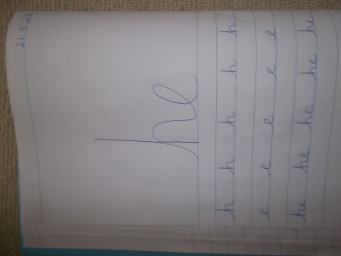
Daily: Practise three lines in your school book of writing the letter or letters below. Each day we will give a different letter. Make sure your child is using the school script and put a finger space between each letter. Please do three lines of the same letter if your child is finding it challenging.

Line 1 ‘h’
Line 2 ‘e’
Line 3 ‘he’
Please only join letter is your child can form the individual letters correctly and you show them how to join correctly.

Mathematics:
Daily: If your child is not secure with numbers to 20 please practise reading these in and out of order and see if they can put them in the correct order. Practise writing numbers correctly to 10/20 either on a whiteboard, chalkboard on in the book provided. If your child is confident with numbers to 20 please practise counting to 100 and reading/writing random numbers from a hundred square - download from google images or Twinkl.co.uk
Challenge- Practise counting in twos to ten/ twenty. Use a hundred square to help.
Practise counting in tens to a hundred.

I am learning to add two numbers together (using either objects or a numberline.)
Quick fire oral questions. Encourage your child to use their fingers for answers up to 10, or a number line for above.
Level 1 | Level 2
2+1= | 4+3=
3+3= | 6+6=
5+2= | 3+7=
4+4= | 5+7=
2+3= | 8+8=
4+5= | 12+3=

I am learning to describe position using words like ‘behind’ or ‘next to’.

Make a Rosie the hen stick puppet. Either cut out one from the saved images or draw your own.
Adult to ask child to put Rosie in various places / positions eg put Rosie under the table.

Key vocabulary- under, over, in front of, behind, next to, between, above, below
Challenge words- left, right
Knowledge and Understanding of the World/ Expressive Arts/ Topic:

I am learning to make a model using different materials.
Finish making papier-mache piggy bank or model. Paint and decorate it.

I am learning to draw a map to represent a journey/ route.
You will need an A3 piece of paper or a double page of the exercise book. Draw a map to show the route Rosie took about the farm. Use arrows to show direction. Use the text to remember the correct order. (There are some images of Rosie’s walk maps below.) You may find the uploaded Rosie’s walk word mat helpful as it has key vocabulary and simple pictures on it.

I look forward to seeing your maps.

Rosie the hen went for a walk across the yard, around the pond, over the haystack, past the mill, through the fence and under the beehives and got back in time for dinner.

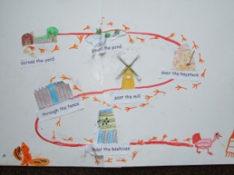
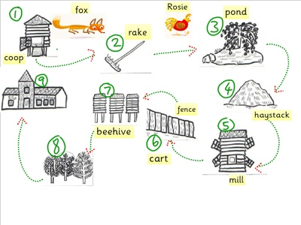

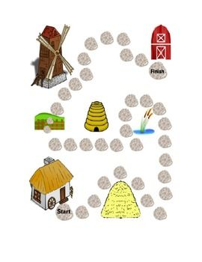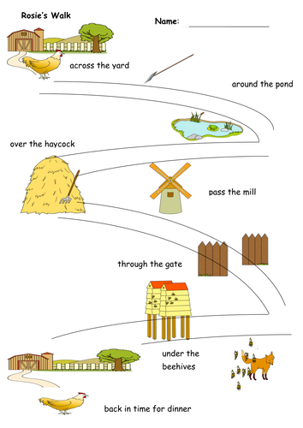

I can sing a song
Learn a song.
How are you getting on with learning ‘Wake Up’ and ‘Moving to the Music’?
https://www.youtube.com/watch?time_continue=28&v=5idAk316hpY&feature=emb_title
Wake Up

https://www.youtube.com/watch?time_continue=130&v=f-EVUKcSSVY&feature=emb_logo
Moving to the Music

Choose a song to sing along to and try to learn.
https://email.outoftheark.com/t/y-l-udirgk-tdtlhifkh-i/
I like ‘When it’s a Sunny Day’.

Useful websites:
http://www.letters-and-sounds.com/
https://www.phonicsplay.co.uk/ username: march20 password: home
https://www.twinkl.co.uk/ sign up with offer code: UKTWINKLHELPS
https://www.topmarks.co.uk/ learning games 5-7 years
https://www.purplemash.com/login/
https://www.discoveryeducation.co.uk/
https://literacytrust.org.uk/family-zone/
https://www.booksfortopics.com/homebooks-3-5?utm_campaign=91b8033a-2701-4f95-aace-8d1e2ce95762&utm_source=so&utm_medium=mail&cid=76ce0357-1ddf-4ade-9d8f-e45f7b412278
https://www.youtube.com/watch?v=K6r99N3kXME&feature=youtu.be daily PE lessons

Useful apps:
Alphablocks
Cebeebies Go Explore
Jolly Phonics

