Key Stage: EYFS
Daily Learning: Year Reception | Date: Thursday 2nd July 2020
General Information

The zoom meeting is for everyone and will start at 1.15 pm this afternoon. Please have some learning from last week’s planning or this week’s ready to show. It would be great if you could show a page of your mini-beast information book. Please note our Zoom meeting will finish promptly today at 1.45, so you have time to get ready for the dance class at 2pm

Please forward any photos for the school blog to either myself or Mrs Doran. We will then forward them to Miss Pugh who is uploading the blog for all classes.

Please email if you have any questions or queries.
Exercise Time! The Sports Festival

Sports Star of the day | Marcus Rashford - see Power Point
Warm up/down activity | Jungle Stretches-
Family Sports Activity | Dance class via Zoom with 4motion 2pm-3pm (Zoom details will be emailed out nearer the time)
Sports competition event | There is no sports competition today as the results need to be collected and verified!  Please remember to email back your results table to the following address: k.pugh@tssfirst.co.uk  These need to be sent back by midday today in order to count. Unfortunately, any sent after this time will not be included.

Phonics (20mins):
Daily: Recap flashcards of all sounds (phase 2&3). Either make flashcards by copying the sounds from your child’s sound book, download a free set from http://www.letters-and-sounds.com/or buy them from Amazon. Please practise reading the tricky words everyday with your child. Either use the mini flashcards at the back of the sound book or look at them on https://www.phonicsplay.co.uk/ (free access).

Today’s focus:
I am learning to read and spell the Phase 3 tricky words – be, he, me, she, we, my, by, you, was, they
OR
I am learning to read and spell the Phase 4 tricky words –went, said, have, like, so, do, some, little, there, were, come, one, when, out, what,

Warm Up- Choose one of the above tricky words lists and practise reading the words. Then practise writing them. You may want to focus on writing 4 or 5 words a day.

I am learning to read and spell words containing the ‘igh’ sound

Main- Recap the ‘igh’ sound
Using phoneme fingers, say the word high and count the sounds- h-igh. Ask your child to write the word and draw sound buttons under it. Repeat for sigh, light, night.

Blending for reading
Then practise reading the following words
tight | might | right | sight

Finally practise writing these sentences.
Is it light at night?
This might be tight for me.
or
Write this sentence.
The night is not light.

Reading:
Daily: Please listen to your child read one book a day and practise a word list.

Finding reading books suitable for your child can be challenging. Oxford Owls does have free ebooks to download. The books include Biff and Chip and Read, Write Inc (These are phonic based. They do not use the same colour bands as Biff and Chip). You can find books by age or level. Happy Reading!

https://home.oxfordowl.co.uk/books/free-ebooks/

Bug Club
Some books have been allocated to your child, please try to read at least three books a week, if you have online access.
https://www.activelearnprimary.co.uk/login?c=0

Keep practising the high frequency words. If your child can read them, practise spelling them. (Saved under ongoing reception resources as phase 2 or 3 or 4 high frequency words.)

High Frequency Words- These words are a mixture of phonetic words and tricky words that the children should be able to read on sight (have instant recall). Please help your child to learn them starting with phase 2 words, then phase 3 words and then phase 4.

Word boxes- Continue practising blending by working through the word boxes saved under ongoing resources. I have added some more word lists if your child can read the others. Word box lists 22-24.
Writing:
I am learning to write an information book. I am learning to write a simple sentence with clear finger spaces and a full stop.

Choose your next mini-beast to write about. If you need more facts about your chosen mini-beast remember to use the information cards.
Write the heading on the top line. Then write a sentence or two about the mini-beast. Remember to use clear finger spaces and neat handwriting as you will want other people to be able to read your book.
Finally draw a careful picture and colour it in. Information books often have diagrams in them. Can you make your picture into a diagram?
If you have finished the information pages of your book, then write your contents page. You may want to look at an information book you have at home or one on Bug Club, to see how a contents page looks and works. First number all the pages of your book, including the contents page. Then write the headings of each of your pages in order on the contents page. Write the page numbers next to the heading words. You can make a contents page by folding a piece of A4 paper and writing Contents at the top of the page or you can use the uploaded template.
Handwriting:
Daily: Practise three lines in your school book of writing the letter or letters below. Each day we will give a different letter. Make sure your child is using the school script and put a finger space between each letter. Please do three lines of the same letter if your child is finding it challenging.

Check your child is using the correct ‘snappy finger’ pencil grip. This is easier to do with a large, chunky writing pencil.

Line 1 ‘i’
Line 2 ‘g’
Line 3 ‘igh’ Please only join the letters if your child can form the individual letters correctly and you show them how to join ‘i’ to ‘g’ and ‘h’ correctly.

Please only join letters during handwriting practice and do not join letters in other writing situations yet.

Mathematics:
Daily: If your child is not secure with numbers to 20 please practise reading these in and out of order and see if they can put them in the correct order. Practise writing numbers correctly to 10/20 either on a whiteboard, chalkboard on in the book provided. If your child is confident with numbers to 20 please practise counting to 100 and reading/writing random numbers from a hundred square - download from google images or Twinkl.co.uk

Warm- up – I am learning to say the number one less than a given number
say the number one less than… Level 1- up to 10/ then 20
Level 2- up to 20 and then beyond

Ask your child 5 questions and/ or use Abacus maths Pesky Pests by logging on to Active Learn, if you didn’t use it yesterday.

I am learning to add 2 groups using either objects or a number line to count on.

Main- Ask your child to write the following number sentences and to solve them. Use either objects or a numberline.
Level 1 | Level 2
4+3= | 5+6=
7+1= | 8+9=
6+2= | 7+5=
Please check all numbers are formed correctly and are facing the correct way.

Complete either one of today’s uploaded sheets listed below or one of the activities from yesterday. If you are unable to print, please write 5 number sentences in your child’s exercise book for them to complete.
Now choose one of the uploaded activities
- Adding objects up to 10
- Addition to 20 number cards
- Using a number line to 20
Knowledge and Understanding of the World/ Expressive Arts/ Topic:

I am learning to create and make using different materials.

I can make a model
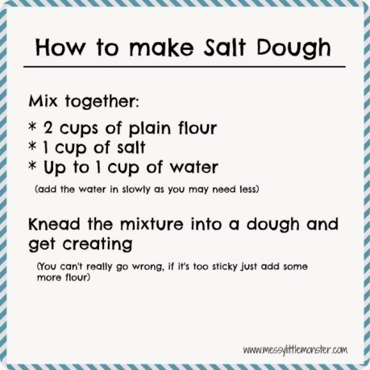
Using either clay, salt dough, papier- mache, play dough make a 3D mini-beast. Finish your model.
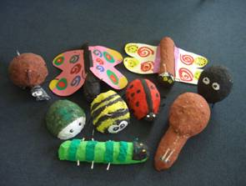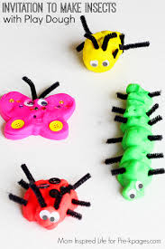

OR
I can make a bee or any other mini-beast you like.
Make a bee using any materials you like. Look at the pictures below for ideas or you may have a better idea of your own. Don’t forget to send in your photos for the blog.
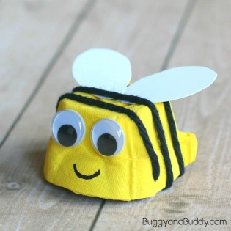
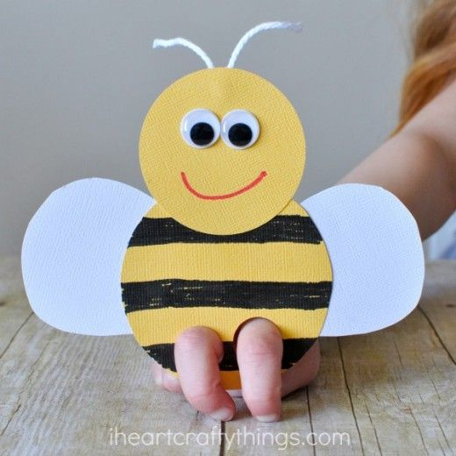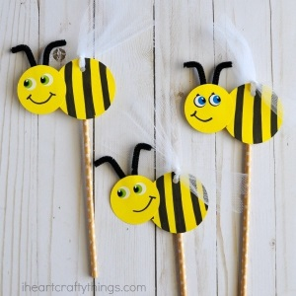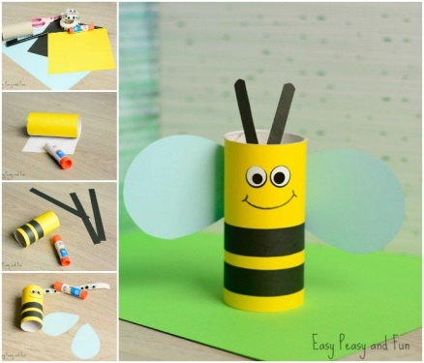

I can sing a song
Learn a song.

Choose a song to sing along to and try to learn.
https://email.outoftheark.com/t/y-l-udirgk-tdtlhifkh-i/

