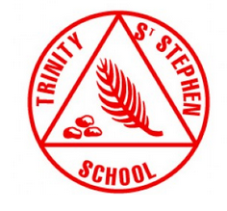
Trinity St Stephen Church of England First School After School Care

Priority Booking Form

Whole Term: 10 January 2022 to 08 April 2022 (12 Weeks)

Name of child: |  | Cost per session | Cost per term | Please  tick | Year Group: | Cost per session | Cost per term | Please  tick
Monday  (12 sessions) | 3.15pm to 5pm | £15 | £180 |  | 3.15pm to 6pm | £18 | £216
Tuesday  (12 sessions) | 3.15pm to 5pm | £15 | £180 |  | 3.15pm to 6pm | £18 | £216
Wednesday  (12 sessions) | 3.15pm to 5pm | £15 | £180 |  | 3.15pm to 6pm | £18 | £216
Thursday  (12 sessions) | 3.15pm to 5pm | £15 | £180 |  | 3.15pm to 6pm | £18 | £216

Ad-hoc Sessions: Wednesday 05 January Thursday 06 January

All completed booking forms need to be returned to school by Monday 13 December. Payment can be made via Scopay or by using childcare vouchers.

Ad-hoc slots can be booked on the day if there is availability. Each session will be charged at a flat rate of £20 per child. Please contact the school office via email afterschoolcare@tssfirst.co.uk to check availability before making payment.

A penalty for collecting your child after 6pm will be charged at £20 to cover the cost of overtime for staff. Cancellations received more than twenty-four hours in advance will receive a credit against future bookings. No credit will be given for cancellations on the day.

Please note any medical or dietary information the club leaders need to be aware of below:

