English Work – Poetry lessons
Lesson 1. WALT: I can discuss and perform a poem
- Look at this poem called The Bug Chant. It’s by Tony Mitton.

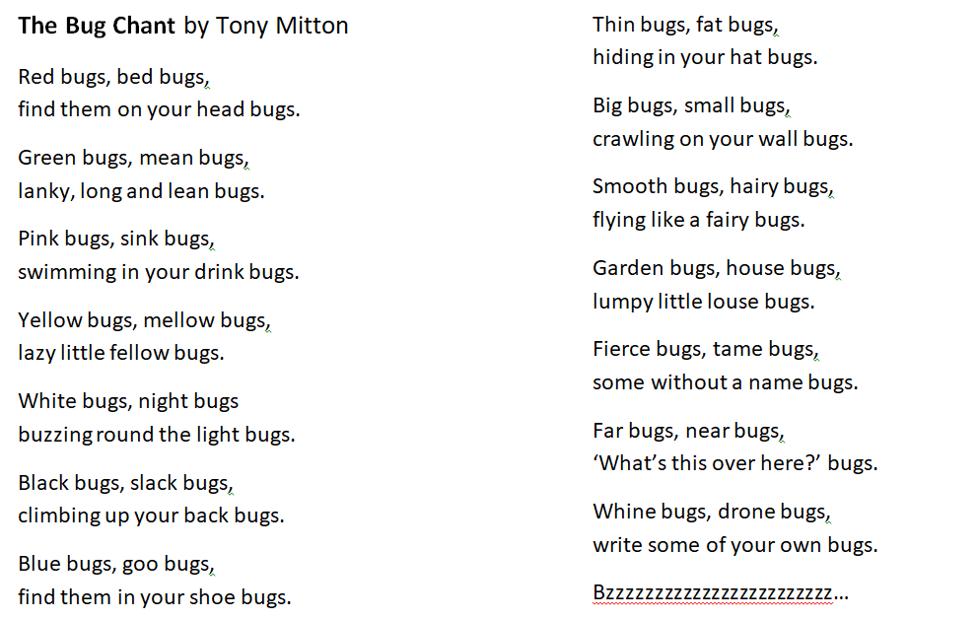

- Read it aloud. Do you like this poem? Why?
- What do you notice about the poem? Are there any patterns?
- I can find rhyming patterns and patterns in the punctuation he used.
- Try and learn a few verses to perform to a sibling or parent – maybe you could perform it via video call to a grandparent. Try to vary your expression, volume and pace (speed).

Lesson 2. WALT: I can write and perform a ‘chant’ poem
- Look again at The Bug Chant. It is really just a list. What makes it fun to perform and good at creating images?
- I think it has a strong rhythm, regular rhyme, contrasts in descriptions and amusing images (‘climbing up your back bugs’ etc.)
- Which adjectives do you think to help to create a strong image? (e.g. lanky, smooth, fierce, etc.)
- Words which build an image around a noun are called noun phrases (‘lazy little fellow’, ‘lanky, long and lean bugs’).
- What if the poem was about a different animal? What about cats? Write a list of adjectives and verbs that describe cats. How do they move, what do they look like, what do they do?
- Here are a couple of lines of a poem about cats that I have modelled on the Bug Chant. It has the same rhyming pattern, punctuation and strong rhythm.

The Cat Chant
Thin cats, fat cats,
blinking like a bat cats.
Furry cats, purry cats,
tails are very twirly cats.
Tabby cats, king cats,
leaping like a spring cats.
- Can you use your list of adjectives and verbs to write a 3 or 4 verses of your own poem about cats? Remember to find rhymes and try to match the rhythm too.

