Week beginning 1st June 2020

Our first English topic will be ‘The Lighthouse Keepers Lunch.’
Below I am giving you 5 lessons/ideas for the week.

Monday | 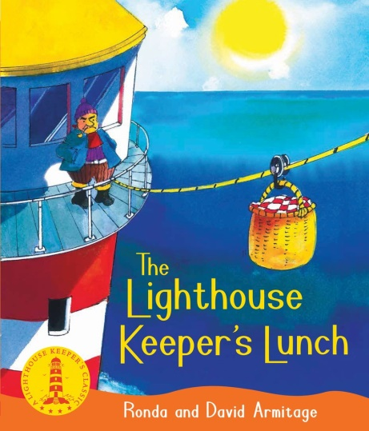  Explain that this week we are going to be looking at a new story. Before we read it I would like you to look at the front cover and title and predict what you think the story might be about.  Which characters do you think will be in the story?  Where do you think it will be set?  What do you think might happen?  Write at least 4 sentences about your predictions. Go over that there is no right/wrong; we are just making our prediction.  Remember to use capital letters and full stops!
Tuesday | Today we are going to read the story.  Here is a link to YouTube where you can listen to the story:  https://www.youtube.com/watch?v=46wCRq50Wwg  Now you have listened to the story can you answer the following questions:  Who are the main characters you meet in the story?  What happens in the beginning?  What happens in the middle?  What happens in the end?  Can you write a blurb for the story? Go over that a blurb goes on the back of the book and helps someone learn what the story is about. Write at least 4 sentences.
Wednesday | I am attaching Lighthouse Keepers lunch story cut outs.  You can cut them out (or make your own) and retell the story.  Can you remember the main parts of the story? The beginning, the middle, the end?  Put events into order and also try and use vocabulary from the book.  You could attach the cut outs and put them on lolly sticks and create your own puppet show.  I am also attaching a story map template in case as an extra challenge you would also like to complete one of those to retell the story.
Thursday | Today we are going to think about the main characters in the story and write some character descriptions.  Go over who the main characters in the story are.  I am attaching a document with the main characters on so you can go through each main character.  Today I would like you to choose one to describe in detail.  Draw a picture of them.  You can write about what they look like and how they act in the story. What do their actions in the story tell you about them?  You could do 2 characters if you want or all of them!  Eg If you chose Mr Grinling you might say that he is hungry because he wants to eat his lunch but the seagulls keep taking it. He is also hardworking because he looks after the lighthouse by himself.
Friday | I am going to keep Fridays as a grammar lesson.  Today I would like to focus on punctuation today.  Can you name different punctuation that you use in your writing?  I am attaching a Popping Punctuation PowerPoint for you to go through.  I am also attaching Popping Punctuation activities you can complete.  You could write your own sentences using  ABC capital letters  . Full stops  ? Question marks  ! Exclamation marks  IF you would like a challenge you could start to introduce speech marks and write some sentences using those.

