❤️ Compassion 🤝Trust 🦉Wisdom 👥Friendship 🕊️Peace 🏫Fellowship



Privacy notice for parents and
carers

Date: | August 2026 | Approved
Review Date: |  | Signed  Title:





Thriving and Achieving in a Caring Christian Community
This is my commandment, that you love one another as I have loved you. John Ch15 v12

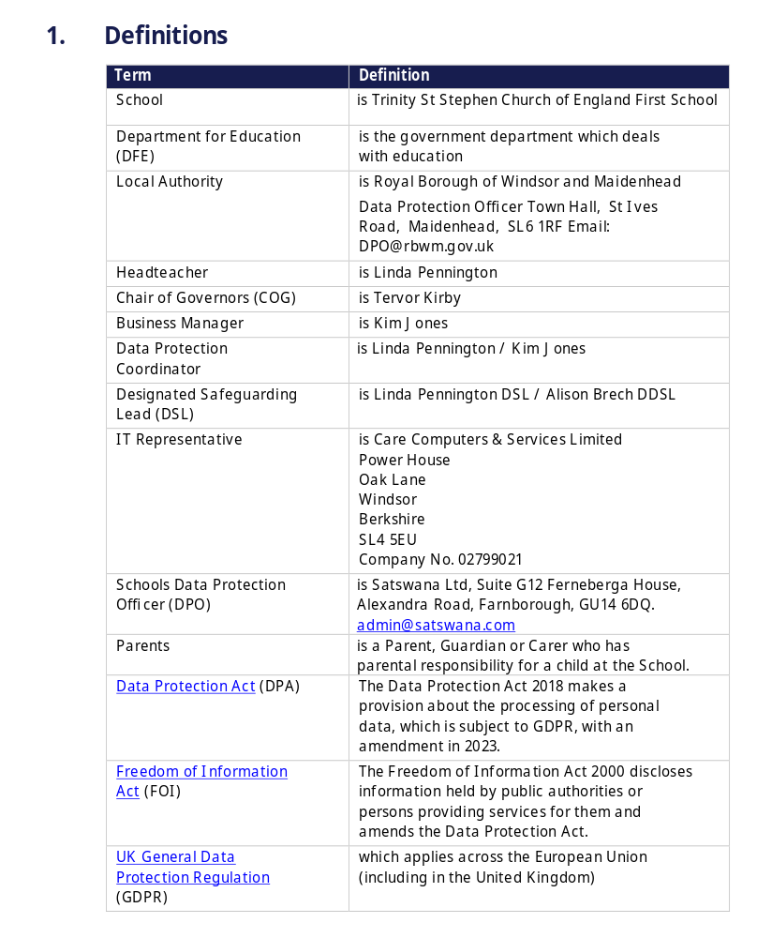

Contents
- Introduction
- The personal data we hold
- Why we use this data
- Our lawful basis for using this data
- Collecting this data
- How we store this data
- Who we share data with
- Your rights
- Complaints
- Contact us

1. Introduction
Under UK data protection law, individuals have a right to be informed about how our school uses any personal data that we hold about them. We comply with this right by providing ‘privacy notices’ (sometimes called ‘fair processing notices’) to individuals where we are processing their personal data.
This privacy notice explains how we collect, store and use personal data about parents and carers of pupils at our school.
We, St Stephen Church of England First School, Vansittart Road, Windsor, SL4 5DF
01753 862540 | office@tssfirst.co.uk are the ‘data controller’ for the purposes of UK data protection law.

2. The personal data we hold
Personal data that we may collect, use, store and share (when appropriate) about you includes, but is not restricted to:
- Contact details and contact preferences (such as your name, address, email address and telephone numbers)
- Bank details
- Details of your family circumstances
- Details of any safeguarding information including court orders or professional involvement
- Records of your correspondence and contact with us
- Details of any complaints you have made
- Information about your use of our information and communication systems, equipment and facilities (e.g. school computers)

We may also collect, use, store and share (when appropriate) information about you that falls into ‘special categories’ of more sensitive personal data. This includes, but is not restricted to:
- Information about any health conditions you have that we need to be aware of
- Photographs and CCTV images captured in school
- Information about your religion, as part of our admissions arrangements
We may also hold data about you that we have received from other organisations, including other schools and local authorities.

3. Why we use this data
We collect and use the data listed above to:
- Report to you on your child’s attainment and progress
- Keep you informed about the running of the school (such as emergency closures) and events
- Process payments for school services and clubs
- Provide appropriate pastoral care
- Protect pupil welfare
- Administer admissions waiting lists
- Assess the quality of our services
- Carry out research
- Comply with our legal and statutory obligations
- Make sure our information and communication systems, equipment and facilities (e.g. school computers) are used appropriately, legally and safely
We will only use your personal information for the purposes for which we have collected it, unless we reasonably consider that we need to use it for another reason and that reason is compatible with the original purpose. If we need to use your personal information for an unrelated purpose, we will notify you and explain the legal basis which allows us to do so.
Please note that we may process your personal information without your knowledge or consent, in compliance with the above rules, where this is required or permitted by law.
3.1 Use of your personal data for marketing purposes
Where you have given us consent to do so, we may send you marketing information by email or text promoting school events, campaigns, charitable causes or services that may be of interest to you.
You can withdraw consent or ‘opt out’ of receiving these emails and/or texts at any time by selecting the ‘Unsubscribe’ link at the bottom of any such communication, or by contacting us (see ‘Contact us’ below).
3.2 Use of your personal data in automated decision-making and profiling
We do not currently process any parents’ or carers’ personal data through automated decision-making or profiling. If this changes in the future, we will amend any relevant privacy notices in order to explain the processing to you, including your right to object to it.
3.3 Use of your personal data for filtering and monitoring purposes
While you’re in our school, we may monitor your use of our information and communication systems, equipment and facilities (e.g. school computers). We do this so that we can:
- Comply with health and safety and other legal obligations
- Comply with our policies (e.g. child protection policy, IT acceptable use policy) and our legal obligations
- Keep our network(s) and devices safe from unauthorised access, and prevent malicious software from harming our network(s)
- Protect your child’s welfare

4. Our lawful basis for using this data
Where you have provided us with consent to use your data, you may withdraw this consent at any time. We will make this clear when requesting your consent, and explain how you would go about withdrawing consent if you wish to do so.
4. Our lawful basis for using this data
Our lawful bases for processing your personal data for the purposes listed in section 3 above are as follows:
- Public Task Basis: For the purposes of a, b, d, e, g, h, and j, in accordance with the ‘public task’ basis – we need to process data to fulfil our statutory function as a school as set out here:
  - Education Act 1996 & Education Act 2005 (for reporting progress, administering curriculum, and managing school facilities)
  - DfE Statutory Guidance: Keeping Children Safe in Education (KCSIE) (covering your Section 3.3 filtering and monitoring obligations to protect pupil welfare)
  - DfE Statutory Guidance: Working Together to Safeguard Children (for pastoral care and protecting welfare)
- Legal Obligation Basis: For the purposes of e, f, i, and j, in accordance with the ‘legal obligation’ basis – we need to process data to meet our responsibilities under law as set out here:
  - Education (Pupil Information) (England) Regulations 2005 (for statutory reporting and pupil records)
  - School Admissions Code (for administering admissions and waiting lists)
  - Health and Safety at Work etc. Act 1974 (ensuring safe systems, equipment, and tracking emergency closures)
  - Children and Families Act 2014 (for special educational needs monitoring)
- Consent Basis: For the purposes of 3.1 (Marketing), in accordance with the ‘consent’ basis – we will obtain clear, affirmative consent from you to use your personal data.
  - You have the right to withdraw this consent at any time by using the ‘Unsubscribe’ links provided or contacting the school office.
- Vital Interests Basis: For the purposes of d and e, in accordance with the ‘vital interests’ basis – we will use this personal data in an emergency, life-or-death situation.
  - This allows us to share your emergency contact information or critical family context with emergency services or healthcare professionals if you or your child are incapacitated.
- Contract Basis: For the purposes of c (Process payments for school services and clubs), in accordance with the ‘contract’ basis – we need to process personal data to fulfil a contract with you or to help you enter into a contract with us.

  - This applies when you sign up for transactional, paid provisions like school meals, wraparound childcare clubs, or optional paid school trips.
- Legitimate Interests Basis: This basis does not apply to our core purposes.
  - In line with Information Commissioner's Office (ICO) Lawful Basis Guidance, as a public authority, we cannot rely on legitimate interests for processing carried out in the performance of our core educational and safeguarding tasks.

4.1 Our basis for using special category data
For ‘special category’ data, we only collect and use it when we have both a lawful basis, as set out above, and 1 of the following conditions for processing as set out in UK data protection law:
- We have obtained your explicit consent to use your personal data in a certain way
- We need to perform or exercise an obligation or right in relation to employment, social security or social protection law
- We need to protect an individual’s vital interests (i.e. protect your life or someone else’s life), in situations where you’re physically or legally incapable of giving consent
- The data concerned has already been made manifestly public by you
- We need to process it for the establishment, exercise or defence of legal claims
- We need to process it for reasons of substantial public interest as defined in legislation
- We need to process it for health or social care purposes, and the processing is done by, or under the direction of, a health or social work professional or by any other person obliged to confidentiality under law
- We need to process it for public health reasons, and the processing is done by, or under the direction of, a health professional or by any other person obliged to confidentiality under law
- We need to process it for archiving purposes, scientific or historical research purposes, or for statistical purposes, and the processing is in the public interest
For criminal offence data, we will only collect and use it when we have both a lawful basis, as set out above, and a condition for processing as set out in UK data protection law. Conditions include:
- We have obtained your consent to use it in a specific way
- We need to protect an individual’s vital interests (i.e. protect your life or someone else’s life), in situations where you’re physically or legally incapable of giving consent
- The data concerned has already been made manifestly public by you
- We need to process it for, or in connection with, legal proceedings, to obtain legal advice, or for the establishment, exercise or defence of legal rights
- We need to process it for reasons of substantial public interest as defined in legislation

5. Collecting this data
We will only collect and use your data when the law allows us to (as detailed above in section 4 of this notice). While the majority of information we collect about you is mandatory, there is some information that can be provided voluntarily.
Whenever we seek to collect information from you, we make it clear whether you must provide this information (and if so, what the possible consequences are of not complying), or whether you have a choice.
Most of the data we hold about you will come from you, but we may also hold data about you from:
- Local authorities
- Government departments or agencies
- Your children
- Police forces, courts or tribunals
- Other schools and trusts

6. How we store this data
We keep personal information about you while you are a parent or carer at our school. We may also keep it beyond your work at our school if this is necessary. Our Records Management & Data Retention Policy sets out how long we keep information. Available on our website or via the school office – office@tssfirst.co.uk
We have put in place appropriate security measures to prevent your personal information from being accidentally lost, used or accessed in an unauthorised way, altered or disclosed.
We will dispose of your personal data securely when we no longer need it.

7. Who we share data with
We do not share information about you with any third party without consent unless the law and our policies allow us to do so.
Where it is legally required, or necessary (and it complies with UK data protection law), we may share personal information about you with:
- Our local authority, Royal Borough of Windsor & Maidenhead (Achieving for Children) to meet our legal obligations to share certain information with it, such as safeguarding concerns
- Government departments or agencies
- Department for Education
- Our regulator, OFSTED
- Suppliers and service providers:
- Care Computers IT Representative
- Caterlink – Food Supply Agency
- ScoPay – School Payment Portal
- Financial Administration
- Our auditors
- Department for Education Survey and research Team
- Health authorities
- Security organisations
- Health and social welfare organisations
- Professional advisers and consultants
- Charities and voluntary organisations – e.g. support agencies
- Police forces, courts, tribunals
7.1 Transferring data internationally
- Other schools or educational establishments – When you are transferring from an international setting
- Government departments or agencies – If advised/ approved by our own Government and Safeguarding agencies in line with UK Law.
- Security organisations - If advised/approved by our own Government and Safeguarding agencies in line with UK Law.
International third parties, may hold different data protection legislation.

8. Your rights
8.1 How to access personal information that we hold about you
You have a right to make a ‘subject access request’ to gain access to personal information that we hold about you.
If you make a subject access request, and if we do hold information about you, we will (subject to any exemptions that may apply):
- Give you a description of it
- Tell you why we are holding it, how we are processing it, and how long we will keep it for
- Explain where we got it from, if not from you
- Tell you who it has been, or will be, shared with
- Let you know whether any automated decision-making is being applied to the data, and any consequences of this
- Give you a copy of the information in an intelligible form
You may also have the right for your personal information to be transmitted electronically to another organisation in certain circumstances.
If you would like to make a request, please contact us (see ‘Contact us’ below).
8.2 Your other rights regarding your data
Under data protection law, you have certain rights regarding how your personal data is used and kept safe. For example, you have the right to:
- Object to our use of your personal data where it is likely to cause, or is causing damage or distress
- Prevent your data being used to send direct marketing
- Object to and challenge the use of your personal data for decisions being taken by automated means (by a computer or machine, rather than by a person)
- In certain circumstances, have inaccurate personal data corrected or blocked
- In certain circumstances, have the personal data we hold about you deleted or destroyed, or restrict its processing
- Withdraw your consent, where you previously provided it for the collection, processing and transfer of your personal data for a specific purpose
- In certain circumstances, be notified of a data breach
- Make a complaint to the Information Commissioner’s Office
- Claim compensation for damages caused by a breach of the data protection regulations
We may refuse your information rights request for legitimate reasons, which depend on why we’re processing it. Some rights may not apply in these circumstances:
- Your right to have all personal data deleted or destroyed doesn’t apply when the lawful basis for processing is legal obligation or public task
- Your right to receive a copy of your personal data, or have your personal data transmitted to another controller, does not apply when the lawful basis for processing is legal obligation, vital interests, public task or legitimate interests
- Right to object to use of your private data doesn’t apply when the lawful basis for processing is contract, legal obligation or vital interests. And if the lawful basis is consent, you don’t haven’t the right to object, but you have the right to withdraw consent

See information on types of lawful basis in section 4 of this privacy notice.
To exercise any of these rights, please contact us (see ‘Contact us’ below).

9. Complaints
We take any complaints about our collection and use of personal information very seriously.
If you think that our collection or use of personal information is unfair, misleading or inappropriate, or have any other concerns about our data processing, please raise this with us in the first instance. You can make a complaint to us at any time by contacting Linda Pennington, Headteacher at headteacher@tssfirst.co.uk
Alternatively, you can make a complaint at any time to the Information Commissioner’s Office:
- Report a concern online at https://ico.org.uk/make-a-complaint/
- Call 0303 123 1113
- Or write to: Information Commissioner’s Office, Wycliffe House, Water Lane, Wilmslow, Cheshire, SK9 5AF

10. Contact us
If you have any questions or concerns, or would like more information about anything mentioned in this privacy notice, please contact our data protection officer:
Our data protection officer is: Satswana Ltd, Suite G12 Ferneberga House, Alexandra Road, Farnborough, GU14 6DQ. admin@satswana.com
However, our data protection lead has day-to-day responsibility for data protection issues in our school.
If you have any questions or concerns, or would like more information about anything mentioned in this privacy notice, please contact them: Satswana Ltd, Suite G12 Ferneberga House, Alexandra Road, Farnborough, GU14 6DQ. admin@satswana.com



