❤️ Compassion 🤝Trust 🦉Wisdom 👥Friendship 🕊️Peace 🏫Fellowship



Privacy notice for governors and
other volunteers

Date: | August 2026 | Approved
Review Date: |  | Signed  Title:





Thriving and Achieving in a Caring Christian Community
This is my commandment, that you love one another as I have loved you. John Ch15 v12

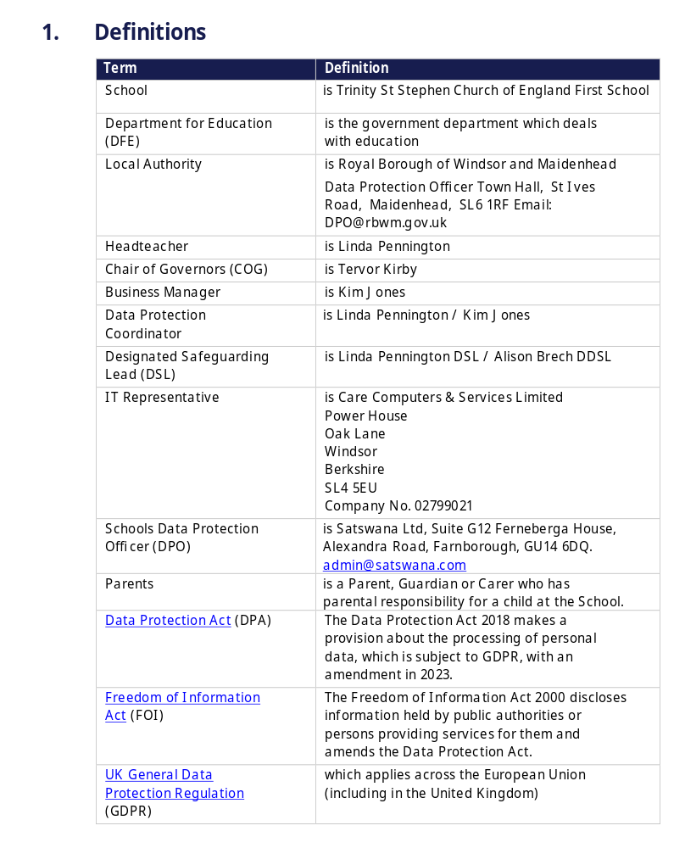

Contents
- Introduction
- The personal data we hold
- Why we use this data
- Our lawful basis for using this data
- Collecting this data
- How we store this data
- Who we share data with
- Your rights
- Complaints
- Contact us

1. Introduction
Under UK data protection law, individuals have a right to be informed about how our school uses any personal data that we hold about them. We comply with this right by providing ‘privacy notices’ (sometimes called ‘fair processing notices’) to individuals where we are processing their personal data.
This privacy notice explains how we collect, store and use personal data about governors and volunteers at our school.
We, St Stephen Church of England First School, Vansittart Road, Windsor, SL4 5DF
01753 862540 | office@tssfirst.co.uk are the ‘data controller’ for the purposes of UK data protection law.

2. The personal data we hold
Personal data that we may collect, use, store and share (when appropriate) about you includes, but is not restricted to:
- Your name
- Contact details
- References
- Evidence of qualifications
- Employment details
- Information about business and pecuniary interests
- Information about your use of our information and communication systems, equipment and facilities (e.g. school computers)
We may also collect, use, store and share (when appropriate) information about you that falls into ‘special categories’ of more sensitive personal data. This includes, but is not restricted to:
- Information about any health conditions you have that we need to be aware of
- Information about disability and access requirements
- Photographs and CCTV images captured in school
We may also collect, use, store and share (when appropriate) information about criminal convictions and offences.
We may also hold data about you that we have received from other organisations, including other schools and local authorities, and the Disclosure and Barring Service in respect of criminal offence data.

3. Why we use this data
We use the data listed above to:
- Establish and maintain effective governance
- Meet statutory obligations for publishing and sharing governors details
- Facilitate safe recruitment, as part of our safeguarding obligations towards pupils
- Undertake equalities monitoring
- Ensure that appropriate access arrangements can be provided for volunteers who require them
- Make sure our information and communication systems, equipment and facilities (e.g. school computers) are used appropriately, legally and safely
If you fail to provide certain information when requested, we may not be able to perform the contract we have entered into with you, or we may be prevented from complying with our legal obligations (such as to ensure the health and safety of our workers and pupils).
We will only use your personal information for the purposes for which we have collected it, unless we reasonably consider that we need to use it for another reason and that reason if compatible with the original purpose. If we need to use your personal information for an unrelated purpose, we will notify you and explain the legal basis which allows us to do so.
Please note that we may process your personal information without your knowledge or consent in compliance with the above rules where this is required or permitted by law.
3.1 Use of your personal data for marketing purposes
Where you have given us consent to do so, we may send you marketing information by email or text promoting school events, campaigns, charitable causes or services that may be of interest to you.
You can withdraw consent or ‘opt out’ of receiving these emails and/or texts at any time by selecting the ‘Unsubscribe’ link at the bottom of any such communication, or by contacting us (see ‘Contact us’ below).
3.2 Use of your personal data in automated decision-making and profiling
We do not currently process any governor or other volunteers’ personal data through automated decision-making or profiling. If this changes in the future, we will amend any relevant privacy notices in order to explain the processing to you, including your right to object to it.
3.3 Use of your personal data for filtering and monitoring purposes
While you’re in our school, we may monitor your use of our information and communication systems, equipment and facilities (e.g. school computers). We do this so that we can:
- Comply with health and safety and other legal obligations
- Comply with our policies e.g. child protection policy, IT acceptable use policy and our legal obligations

- Keep our network(s) and devices safe from unauthorised access, and prevent malicious software from harming our network(s)

4. Our lawful basis for using this data
Where you have provided us with consent to use your data, you may withdraw this consent at any time. We will make this clear when requesting your consent, and explain how you would go about withdrawing consent if you wish to do so.
4.1 Our basis for using special category data
Our lawful bases for processing your personal data for the purposes listed in section 3 above are as follows:
- For the purposes of a) Establish and maintain effective governance, in accordance with the ‘public task’ basis – we need to process data to fulfil our statutory function as a school as set out here:
- The School Governance (Constitution) (England) Regulations 2012
- The School Governance (Roles, Procedures and Allowances) (England) Regulations 2013
- The Department for Education's (DfE) statutory Maintained Schools Governance Guide [1, 2]
- For the purposes of b) Meet statutory obligations for publishing and sharing governors details, c) Facilitate safe recruitment, as part of our safeguarding obligations, and f) Monitoring of system, equipment and facility use, in accordance with the ‘legal obligation’ basis – we need to process data to meet our responsibilities under law as set out here:
- Section 538 of the Education Act 1996 (which legally mandates the collection and sharing of governor data via the DfE's Get Information About Schools database
- The DfE's statutory What Maintained Schools Must Publish Online guidance (covering the mandatory publication of governor names, terms, interests, and meeting attendance on the school website)
- The School Staffing (England) Regulations 2009 (which sets out the legally required vetting checks for anyone working or volunteering in a school environment).
- Keeping Children Safe in Education (KCSIE) statutory guidance (mandating safer recruitment and Section 128 checks for governors)
- The Education (Information About Individual Pupils) (England) Regulations 2013
- The Health and Safety at Work etc. Act 1974 (mandating that we keep an accurate record of who is on site, including volunteers, for fire safety and accident reporting)
- For the purposes of 3.1 Marketing purposes, in accordance with the ‘consent’ basis we will obtain clear, explicit consent from you before using your personal data to promote school events or services.
- For the purposes of Emergency medical situations or accidents on school site, in accordance with the ‘vital interests’ basis we will use this personal data in a life-or-death situation where you are incapacitated.
- For the purposes of e) Ensure that appropriate access arrangements can be provided for volunteers who require them, in accordance with the ‘legitimate interests’ basis where there’s a minimal privacy impact and we have a compelling operational reason, specifically:
- To fulfil our moral duty of care to support volunteer accessibility, well-being, and safe physical inclusion across our primary school premises

For ‘special category’ data, we only collect and use it when we have both a lawful basis, as set out above, and 1 of the following conditions for processing as set out in UK data protection law:
- We have obtained your explicit consent to use your personal data in a certain way
- We need to perform or exercise an obligation or right in relation to employment, social security or social protection law
- We need to protect an individual’s vital interests (i.e. protect your life or someone else’s life), in situations where you’re physically or legally incapable of giving consent
- The data concerned has already been made manifestly public by you
- We need to process it for the establishment, exercise or defence of legal claims
- We need to process it for reasons of substantial public interest as defined in legislation
- We need to process it for health or social care purposes, and the processing is done by, or under the direction of, a health or social work professional or by any other person obliged to confidentiality under law
- We need to process it for public health reasons, and the processing is done by, or under the direction of, a health professional or by any other person obliged to confidentiality under law
- We need to process it for archiving purposes, scientific or historical research purposes, or for statistical purposes, and the processing is in the public interest
For criminal offence data, we will only collect and use it when we have both a lawful basis, as set out above, and a condition for processing as set out in UK data protection law. Conditions include:
- We have obtained your consent to use it in a specific way
- We need to protect an individual’s vital interests (i.e. protect your life or someone else’s life), in situations where you’re physically or legally incapable of giving consent
- The data concerned has already been made manifestly public by you
- We need to process it for, or in connection with, legal proceedings, to obtain legal advice, or for the establishment, exercise or defence of legal rights
- We need to process it for reasons of substantial public interest as defined in legislation

5. Collecting this data
We will only collect and use your data when the law allows us to (as detailed above in section 4 of this notice). While the majority of information we collect about you is mandatory, there is some information that can be provided voluntarily.
Whenever we seek to collect information from you, we make it clear whether you must provide this information (and if so, what the possible consequences are of not complying), or whether you have a choice.
Most of the data we hold about you will come from you, but we may also hold data about you from:
- Local authorities
- Government departments or agencies
- Police forces, courts or tribunals
- Other schools or trusts
- References gained from contacts supplied by you

6. How we store this data
We keep personal information about you while you are a governor or volunteer at our school. We may also keep it beyond your work at our school if this is necessary. Our Records Management & Data Retention Policy sets out how long we keep information about governors and other volunteers. Available on our website or via the school office – office@tssfirst.co.uk
We have put in place appropriate security measures to prevent your personal information from being accidentally lost, used or accessed in an unauthorised way, altered or disclosed.
We will dispose of your personal data securely when we no longer need it.

7. Who we share data with
We do not share information about you with any third party without consent unless the law and our policies allow us to do so.
Where it is legally required, or necessary (and it complies with UK data protection law), we may share personal information about you with:
- Our local authority, Royal Borough of Windsor & Maidenhead (Achieving for Children) to meet our legal obligations to share certain information with it, such as safeguarding concerns
- Government departments or agencies
- Our regulator, OFSTED
- Our auditors
- Health authorities
- Security organisations
- Professional advisers and consultants
- Charities and voluntary organisations
- Police forces, courts and tribunals
7.1 Transferring data internationally
- Other schools or educational establishments – When you are transferring from an international setting
- Government departments or agencies – If advised/ approved by our own Government and Safeguarding agencies in line with UK Law.
- Security organisations - If advised/approved by our own Government and Safeguarding agencies in line with UK Law.
International third parties, may hold different data protection legislation.

8. Your rights
8.1 How to access personal information that we hold about you
You have a right to make a ‘subject access request’ to gain access to personal information that we hold about you.
If you make a subject access request, and if we do hold information about you, we will (subject to any exemptions that may apply):
- Give you a description of it
- Tell you why we are holding it, how we are processing it, and how long we will keep it for
- Explain where we got it from, if not from you

- Tell you who it has been, or will be, shared with
- Let you know whether any automated decision-making is being applied to the data, and any consequences of this
- Give you a copy of the information in an intelligible form
You may also have the right for your personal information to be transmitted electronically to another organisation in certain circumstances.
If you would like to make a request, please contact us (see ‘Contact us’ below).
8.2 Your other rights regarding your data
Under data protection law, you have certain rights regarding how your personal data is used and kept safe. For example, you have the right to:
- Object to our use of your personal data where it is likely to cause, or is causing, damage or distress
- Prevent your data being used to send direct marketing
- Object to and challenge the use of your personal data for decisions being taken by automated means (by a computer or machine, rather than by a person)
- In certain circumstances, have inaccurate personal data corrected or blocked
- In certain circumstances, have the personal data we hold about you deleted or destroyed, or restrict its processing
- Withdraw your consent, where you previously provided it for the collection, processing and transfer of your personal data for a specific purpose
- In certain circumstances, be notified of a data breach
- Make a complaint to the Information Commissioner’s Office if you feel we have not used your information in the right way
- Claim compensation for damages caused by a breach of the data protection regulations
We may refuse your information rights request for legitimate reasons, which depend on why we’re processing it. Some rights may not apply in these circumstances:
- Your right to have all personal data deleted or destroyed doesn’t apply when the lawful basis for processing is legal obligation or public task
- Your right to receive a copy of your personal data, or have your personal data transmitted to another controller, does not apply when the lawful basis for processing is legal obligation, vital interests, public task or legitimate interests
- Right to object to use of your private data doesn’t apply when the lawful basis for processing is contract, legal obligation or vital interests. And if the lawful basis is consent, you don’t haven’t the right to object, but you have the right to withdraw consent
See information on types of lawful basis in section 4 of this privacy notice.
To exercise any of these rights, please contact us (see ‘Contact us’ below).

9. Complaints
We take any complaints about our collection and use of personal information very seriously.
If you think that our collection or use of personal information is unfair, misleading or inappropriate, or have any other concerns about our data processing, please raise this with us in the first instance. You can make a complaint to us at any time by contacting Linda Pennington, Headteacher at headteacher@tssfirst.co.uk
Alternatively, you can make a complaint at any time to the Information Commissioner’s Office:
- Report a concern online at https://ico.org.uk/make-a-complaint/
- Call 0303 123 1113
- Or write to: Information Commissioner’s Office, Wycliffe House, Water Lane, Wilmslow, Cheshire, SK9 5AF

10. Contact us
If you have any questions or concerns, or would like more information about anything mentioned in this privacy notice, please contact our data protection officer:
Our data protection officer is: Satswana Ltd, Suite G12 Ferneberga House, Alexandra Road, Farnborough, GU14 6DQ. admin@satswana.com
However, our data protection lead has day-to-day responsibility for data protection issues in our school.
If you have any questions or concerns, or would like more information about anything mentioned in this privacy notice, please contact them: Satswana Ltd, Suite G12 Ferneberga House, Alexandra Road, Farnborough, GU14 6DQ. admin@satswana.com



