Foundation subjects Summer Term 2020 week beginning July 13th
Science | This week is the Royal Society’s summer festival which this year has gone online. There are lots of activities for the whole family to enjoy. Explore the programme on this link and choose some things to have a go at. You might want to keep exploring next week and into the summer as the activities will stay online.  https://royalsociety.org/science-events-and-lectures/2020/summer-science-online/programme/
Music | Here is a musical activity you might enjoy about a musician called Florence Price: https://www.bbc.co.uk/bitesize/articles/zpxm8hv  You could make a sound recording of your piece and you could also think about how you could write it down. Graphic scores use pictures or symbols to represent the sounds. Here is an example:  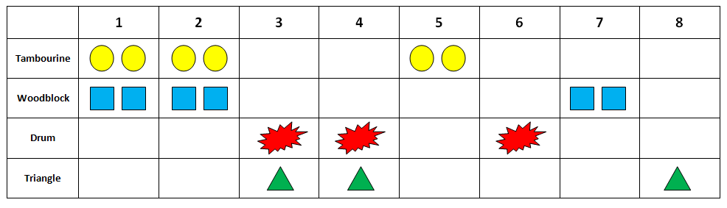  There are lots of great activities through the BBC ten pieces programme. https://www.bbc.co.uk/teach/ten-pieces

You might also like to look at these links:
Drama: https://www.bbc.co.uk/bitesize/articles/zt32kty
Reading: if you like riding your bike you might like to learn a bit more about this amazing cyclist https://www.bbc.co.uk/bitesize/articles/zt36wnb

