Week beginning 1st June 2020

Here are the Foundation subject ideas for this week.
Science | Topic-animals  Ask the children what animals need to stay alive?  Do you what different kinds of foods animals eat? Can you name any?  https://www.bbc.co.uk/bitesize/clips/zwfd2p3 Video to watch  Go over the words herbivore, carnivore and omnivore. If you have different foods to show to explain each group that would be great.  I am attaching an animal sorting activity to complete.  I would also like you to choose an animal. Decide which food group it comes into and create your own menu for that animal.
Art/DT | As we are looking at ‘The Lighthouse Keepers Lunch’ in DT we are going to be making our own Lighthouses.  Can you google some imagine of Lighthouses and think about what they look like. Are they all the same? What general features do they have?  This week I would just like you to plan what your Lighthouse will look like and what materials you need/are going to use.  Make a list and then you can collect junk modelling ready for the making next week.  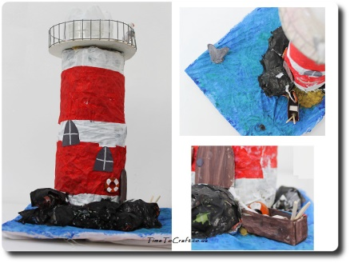  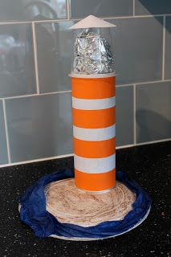  Some examples below that might give you inspiration:  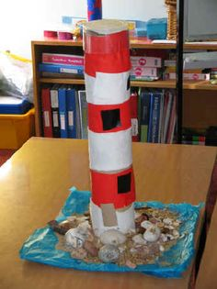
PSHE | Topic- Changing me  To introduce you can watch the video linked below  https://www.bbc.co.uk/teach/class-clips-video/science-ks1-animal-life-cycles/zrg9kmn  Go through how animals change.  Do we change at all?  Can mum/dad/grandparent/an adult in the house show the children a sequence of how they have changed- baby, toddler, child, young adult etc.  We start as a baby and go through stages of growth.  Muddle the pictures up that you have shown them and see if they can order them correctly.  I am attaching some life cycle cards that you may want to order.
RE | Key question: Are Rosh Hashanah and Yom Kippur important to Jewish children?  Can you read a story to your child about someone needing to say sorry?  https://www.youtube.com/watch?v=EOgGfUz1znc An example here but feel free to choose a book you have.  Have you ever needed to say sorry for something?  How did it feel?  Did the person forgive you?  How did that feel?  Was it hard to forgive someone when they said sorry to you?  I want your child to think about what forgiveness means.  An idea is that they draw something they would like to achieve in Year 2 thinking about when Year 1 is over. This means we are looking forward to Year 2 and will be letting go of Year 1.
Computing | Please log on to purple mash and finish off the coding and game you were making if you haven’t already.  You can play the coding games again.

