Phonics Screening Practice List
Real Words
blinking | snacking
smirks | glad
snatched | scallop
when | scam
thrift | blab
shroud | magic
wrinkle | light
spray | job
platter | night
thread | moan


Phonics Screening Practice List

Nonsense Alien Words
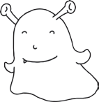  cazz | 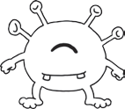  laff
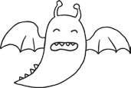  quigh | 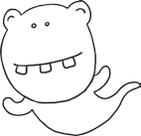  murt
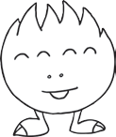  bramp | 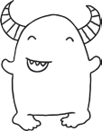  huch
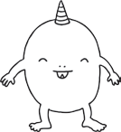  blurch | 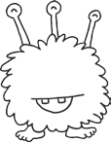  nake
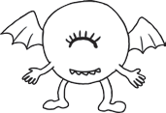  paner | 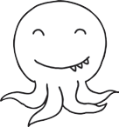  jow
strigh | semp
slew | hake
grobble | lound
righ | fush
sper | wert

