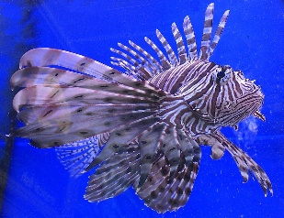
Mrs Dewar’s Year 4 Maths
Lion Fish
Week 4
- 56 + _____ = 100
- 5 x 5 = ______
- Name the angle _____________
- 6 x 3 =
- Double 15 =
- Half of 110 =
- 127 + 13 =
- 50 ÷ 1 =
- What fraction is 0.3 =
- What is ½ as a decimal =
- How many mm in a 5 cms =
- How many cm in a metre =
- How many g in a kg =
- How many minutes in an hour =
- 100 x 0 =

