[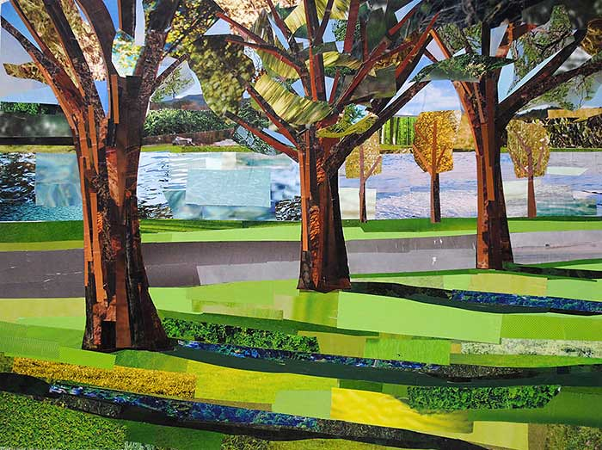](https://www.google.co.uk/url?sa=i&url=https://www.flickr.com/photos/megancoyle/34542922285&psig=AOvVaw0kHh7DOft36ZmUJRss3tsk&ust=1579295170310000&source=images&cd=vfe&ved=0CAIQjRxqFwoTCPix_4yDiecCFQAAAAAdAAAAABAJ)

[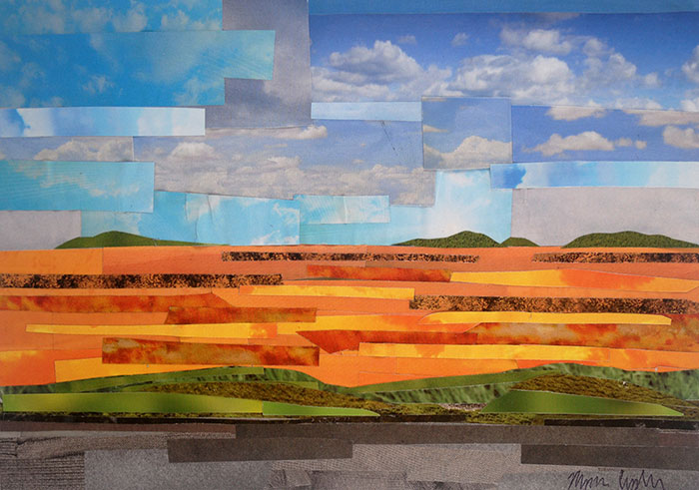](https://www.google.co.uk/url?sa=i&url=https://megancoyle.com/tag/landscape/&psig=AOvVaw0kHh7DOft36ZmUJRss3tsk&ust=1579295170310000&source=images&cd=vfe&ved=0CAIQjRxqFwoTCPix_4yDiecCFQAAAAAdAAAAABAD)

[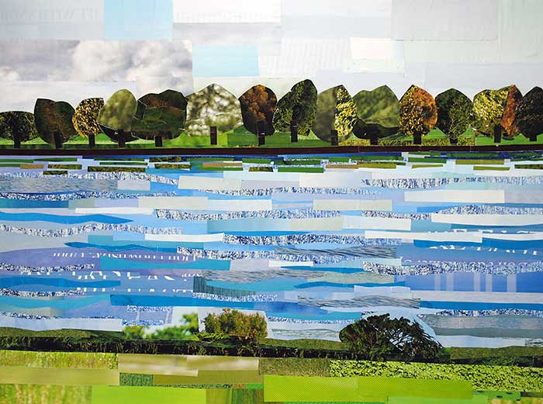](https://www.google.co.uk/url?sa=i&url=https://hiveminer.com/Tags/landscape%2Cmegancoyle/Recent&psig=AOvVaw0kHh7DOft36ZmUJRss3tsk&ust=1579295170310000&source=images&cd=vfe&ved=0CAIQjRxqFwoTCPix_4yDiecCFQAAAAAdAAAAABAc)

[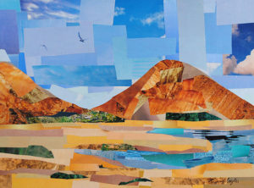](https://www.google.co.uk/url?sa=i&url=https://megancoyle.com/learn/high-school/scapes/landscape-collages/&psig=AOvVaw0kHh7DOft36ZmUJRss3tsk&ust=1579295170310000&source=images&cd=vfe&ved=0CAIQjRxqFwoTCPix_4yDiecCFQAAAAAdAAAAABAV)

[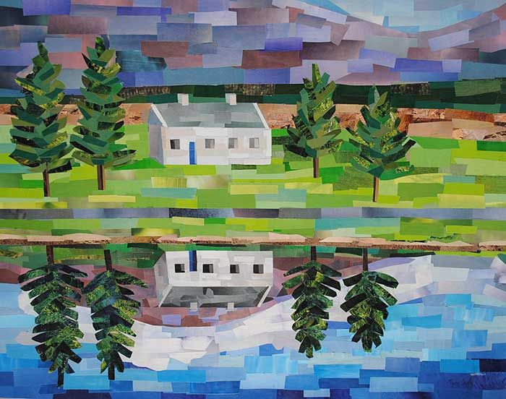](https://www.google.co.uk/url?sa=i&url=https://www.pinterest.com/pin/689824867900837002/&psig=AOvVaw0kHh7DOft36ZmUJRss3tsk&ust=1579295170310000&source=images&cd=vfe&ved=0CAIQjRxqFwoTCPix_4yDiecCFQAAAAAdAAAAABAi)