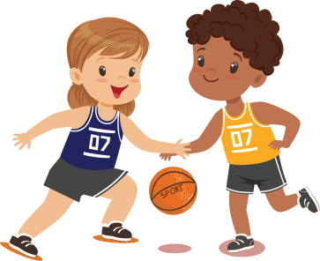
In the table below, you can find some activity ideas to keep active at home.
There’s something in here to suit everyone’s needs.

Type | Title | Link | Age Group | Description
Home Activities | Active Kids Do Better | Website | 5-11 | Fun home activities, games
 | Busy Toddler | Website | 4-11 | Arts and crafts ideas
 | Change4Life Games | Website | 5-11 | 10 minute shake up games
 | Creative Steps | Website | 4-11 | Fun home dance videos - updated weekly
 | Deck of Cards Game | Facebook | All | Physical family activity
 | Get Set Tokyo | Website | 5-11 | Great home activities needing little equipment and space
 | I Moves | Website | 4-9 | Fun videos to copy
 | Kid Do | Website | 5-11 | Sporty activities at home
 | Primary PE Planning | Website | 4-11 | Fun game ideas
 | Ready Set Ride | Website | 4-9 | Videos, fun games to prepare/learn how to ride
 | Scouts | Website | 5-11 | Fun indoor activities
 | Ways to keep active indoors | Website | 5-11 | List of home activities, games
 |  | Website
 |  | Website
Home Challenges | Chance to Shine - Cricket | Youtube | 5-11 | Challenges and videos released every couple of days
 | Dan the Skipping Man | Youtube | 5-11 | Skipping tutorials
 | Jump Rope UK | Website | All | Challenges and videos released every couple of days
 | Prime Coaching Sport | Youtube | 5-11 | Skills Challenges videos
Home Dancing | Active Kids Do Better | Website | 5-11 | Create short easy dance routines including music.
 | BBC Supermovers | Website | 5-11 | Dancing and learning videos on Maths, English, PHSE
 | Go Noodle | Website | 5-11 | Fun songs to dance and sing along to
Home Fitness | PE Coordinator | Website | 5-11 | List of fitness challenges
 | The Body Coach | Youtube | 5-11 | Live - 9 a.m. everyday fitness/PE videos to do at home
 |  | Youtube | All | Videos of kids workouts for home
Home Lessons | Twinkl | Website | All | 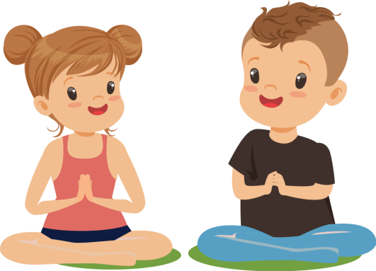
Social Media | Get Set 5 PE | Twitter | 5-11 | Ideas

