Who do you admire?
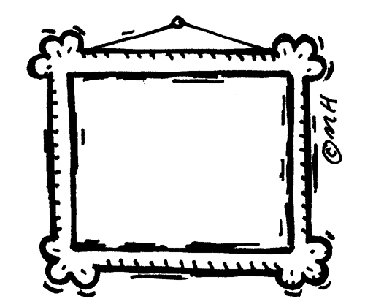
Can you draw a picture of someone you admire? It could be someone famous, a family member or a friend. Can you write a sentence or two to say why you admire them?
Please email your pictures to me as I would love to see them k.pugh@tssfirst.co.uk

____________________________________________________________________________________________________________________

