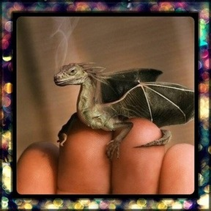

Questions for discussion:
- Where is it from?
- Why is it so small?
- Are there more like him?
- Where does he live?
- How will you look after it?
- Will you keep it a secret or tell someone?
- What is it called?
- Is it magic? What magic can it do?
I like to imagine that it is a really small dragon which you can keep in your pocket but when you need to it can grow huge so that you can ride it.

