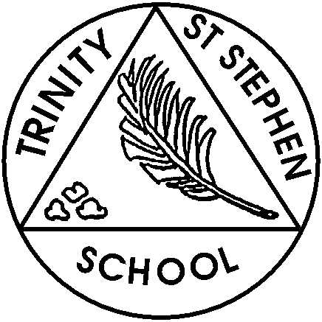

Monday 5th February 2023

This week in Reception

Last Thursday we had a great time at the Hong Kong restaurant. There are lots of photos on the school website, many showing how good we were at using chopsticks. This week we are introducing the traditional tale ‘The Three Little Pigs’. On Thursday we will be celebrating the Chinese New Year.
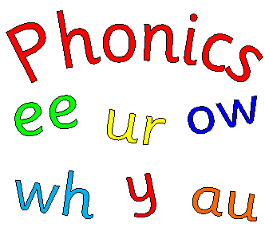
Phonics
This week we will introduce the digraph ‘ur’. We will also focus on blending and segmenting cvc and ccvc words. We will go over all the tricky words we have covered and practise writing the phase 2 tricky words- I, the, to, go, no, into.
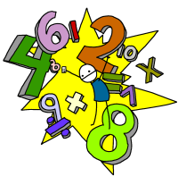
English and Topic
Our writing focus will be based on describing the three little pigs or the wolf.

Maths
We will be using money to make amounts and to pay for food in our new role play.

What can you do at home?
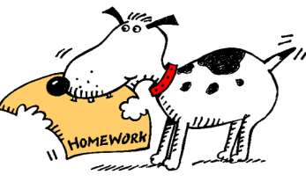
- Please practise writing cvc words (eg. Jug, cat), ccvc words (eg. ship, thin, flag) and cvcc (tent, fish). Words with three or four sounds.
- Practise reading the tricky words we have covered. Mini flashcards are at the back of your child’s sound book and you can look for the tricky words in books. Please practise writing all the tricky words.
- Please listen to/read with your child and make comments in the reading record. Please keep this in their book bags each day as we regularly check these and update them once we have allocated a new reading book. Ideally your child should be reading with you five times a week.
- Keep practising name writing using the school script and other letters, in particular ‘e’, ‘s’, and ‘f’ and ‘i’, ‘l’, ‘t’ and ‘j’ as we will be focusing on these letters in class.
- Please practise adding two sets of objects and record simple number sentences.

Action points
- There is no show and tell this week as we are not in school on Friday. Group 2 will be after half term, on Friday 24th and Group 3 will be on 1st March. The theme is Traditional Tales- My favourite character/s. Your child can bring in the book with their favourite character in and/ or a drawing or model of their favourite character. Your child may want to write a sentence about why they like the character. Be as creative as you like! In a previous class news the dates were incorrect, apologies.
- Please check all school uniform is named, especially hats, gloves and scarves.
- PE kits will be coming home for washing over half term. Please return on the first day back.
- Please ensure that your child has a named water bottle in school every day.
- We are sending home an extra reading book for the holidays. Please try to read at least 5 times over the break. It is important to reread books to develop fluency.

If you have any concerns please feel free to come and chat to one of us.

Have a relaxing break,

Reception Team

