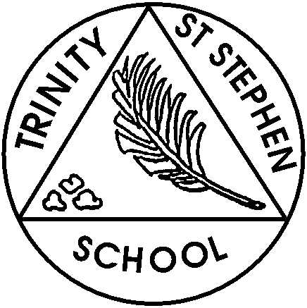

**Tuesday 22nd April 2025**

**This week in Reception**

Welcome back! This term our learning focus is on animals and we will be introducing bears by reading the story ‘We’re going on a bear hunt’.

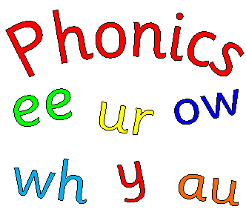

**Phonic focus for this week**

This week we will re-cap all sounds and tricky words. We will focus on reading and writing words with three sounds.

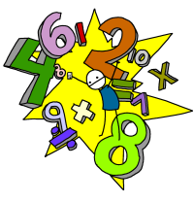

**English and Topic**

We will be talking and writing about our Easter news. Encouraging the children to write independently using a capital letter, finger spaces and full stops. We will also be doing learning activities based around ‘We’re going on a bear hunt’; acting out the story, making our own maps with labels and writing captions for the story.

**Maths**

This week we will be counting to 20 and beyond and identifying patterns.

**What can you do at home?**

1. 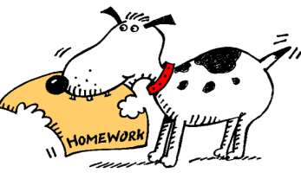Please practise reading and writing the high frequency words.
2. Practise reading and writing phase 3 digraphs and trigraphs
3. Please listen to/read with your child and make comments in the reading record. Please keep this in their book bags each day as we regularly check these and update them.
4. Practise adding and taking away using objects or a number line up to 10/20 or beyond.
5. Practise finding the pairs that make 5 and then 10 ( number bonds)
6. Practise sentence writing. Find a picture of anything that interests your child in a magazine or on the internet and ask your child to write about it. Try to do this 2 or 3 times a week.

**Action points**

* Show and tell - The theme is our favourite meal/ foods. Your child could draw a picture, take a photo, make a collage on a paper plate, bring in some cooking etc. You could challenge your child to write a caption or sentence to go with their show and tell. Group 1 is on 25th April. Group 2 will be on 2nd May, and group 3 will be 9th May.
* **BEARS-** Please bring in a teddy bear or Tuesday or Wednesday. The bear shouldn’t be too large or too precious as we will be keeping them in school for at least a week, to draw them, measure them and write about them.
* **Sewing-** The children will be sewing a bear face onto a piece of hessian. If you are able to help with either cutting out the faces, this can be done and home, or helping with the sewing in class, please let us know. We plan to sew next Thursday and Friday.
* Please ensure that your child has a named water bottle in school every day.
* Please make sure PE kits are back in school and all items of clothing are named.

If you have any concerns, please feel free to come and chat to one of us.

*Reception Team.*