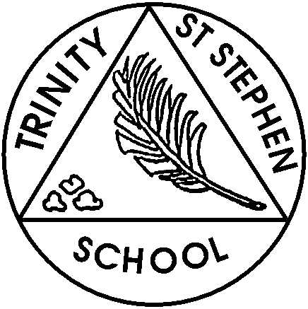

**Monday 25th November**

**This week in Reception**

This week we will be learning about day and night.

On Thursday we go to the post office in preparation for our new role play and to launch our learning about ‘People who help Us’. We will learn how to buy a stamp and post our letters.

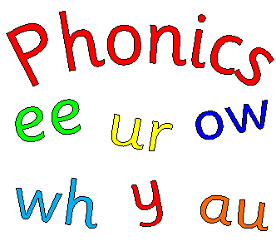

**Phonic focus for this week**

This week we will introduce –y, z, zz, qu,

We will use monster phonic actions and songs to help support the learning. We will introduce the tricky words- you, my, they

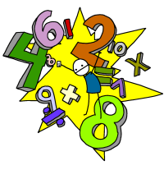

**Maths**

This week we will be recognising and naming 3d shapes – cube, cuboid, sphere, pyramid and cone.

**What can you do at home?**

1. ****Please help your child practise the sounds and make sure the sound book is in their book bag the following Thursday so the new sounds can be stuck in.
2. Practise reading the tricky words we have covered. Mini flashcards are at the back of your child’s sound book and you can look for the tricky words in books.
3. **Please listen to/read with your child and make comments in the reading record each time you read together**. Please keep this in their book bags each day as we regularly check these and update them once we have allocated a new reading book. Ideally your child should be reading with you five times a week, including practising their word box if they have one.
4. Keep practising name writing using the school script and other letters.
5. Practise recognising and using coins- 1p, 2p, 5p, 10p. Have a mixture of the coins in a bowl and ask your child to sort them. Make amounts up to 10 pence, initially using 1p coins,
6. Recognise and name 3d shape around the home and the outside environment.

**Action points**

* **Show & Tell this** **Friday, 29th December will be group 2.** The theme is ‘2D shapes’. The children could go on a shape hunt and take photos, make a shape mobile or draw a shape picture. Be as creative as you like. The children need to be able to name the shapes- square, rectangle, circle, triangle, and may want to include hexagon, pentagon and octagon- and describe them, (number of sides and corners.)  **Group 3 will be on the 6th December**
* Please ensure that your child has a named water bottle in school every day.
* **Post office resources**- If anyone has any spare stationery- cards, envelopes, postcards etc., please send them in. Also, please can you collect used birthday cards and send in just the front picture. We will reuse them and make them into ‘new’ cards. Thank you.

If you have any concerns please feel free to come and chat to one of us.

*Reception Team*