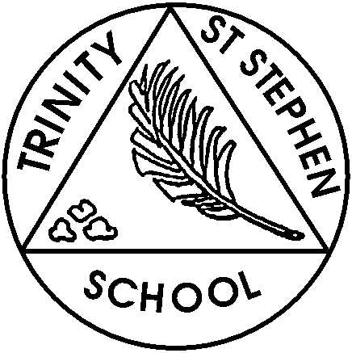

Monday 27th April 2026

Well done to all the children. They have been so grown up coming in by themselves each morning- We are impressed!

This week in Reception
This week we are continuing to learn about animals. We will be finishing bears and focusing on pets. On Tuesday, we will have Poppy, a very friendly dog, visiting. Later this half term a vet will come in to tell us how he cares for pets and other animals.
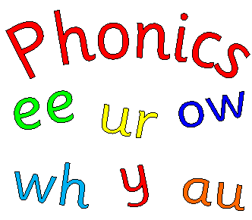
Phonic focus for this week
We have covered all the sounds the children learn in reception. The children are doing really well but please keep practising the digraphs and trigraphs. This week, we will learn our last tricky words for this year. The words are ‘there’ and ‘put’. In our phonic lessons the focus now is on reading and writing CVCC words.


English and Topic
We will write some sentences about pets. The children will be encouraged to write more than one sentence using school writing, clear finger spaces and full stops. We will also be looking at some nonfiction reading and writing.

Maths
This week we will complete the White Rose unit- How many now? Which practices both addition and subtraction. We will continue to practise doubling and counting in twos.

What can you do at home?

- Please practise reading and writing the high frequency words.
- Practise reading and writing phase 3 digraphs and trigraphs
- Please listen to/read with your child and make comments in the reading record. Please keep this in their book bags each day as we regularly check these and update them.
- Practise adding and taking away using objects or a number line up to 10/20 or beyond.
- Practise counting in twos to 20 and number bonds to 5/10.
- Practise doubling numbers up to 10 and halving numbers by sharing objects practically.
- Practise sentence writing. Find a picture of anything that interests your child in a magazine or on the internet and ask your child to write about it. Try to do this 2 or 3 times a week.

Action points
- This week’s show and tell is group 2. The theme is favourite food. Week 3 will be the following week.
- Bike group 3 on Friday. Please bring in helmets.
- Please return an outstanding Odds Farm consent forms.
- Please ensure that your child has a named water bottle in school every day.

If you have any concerns please feel free to come and chat to one of us.

Reception Team.

