ASKING QUESTIONS ABOUT PLANTS AND SEEDS

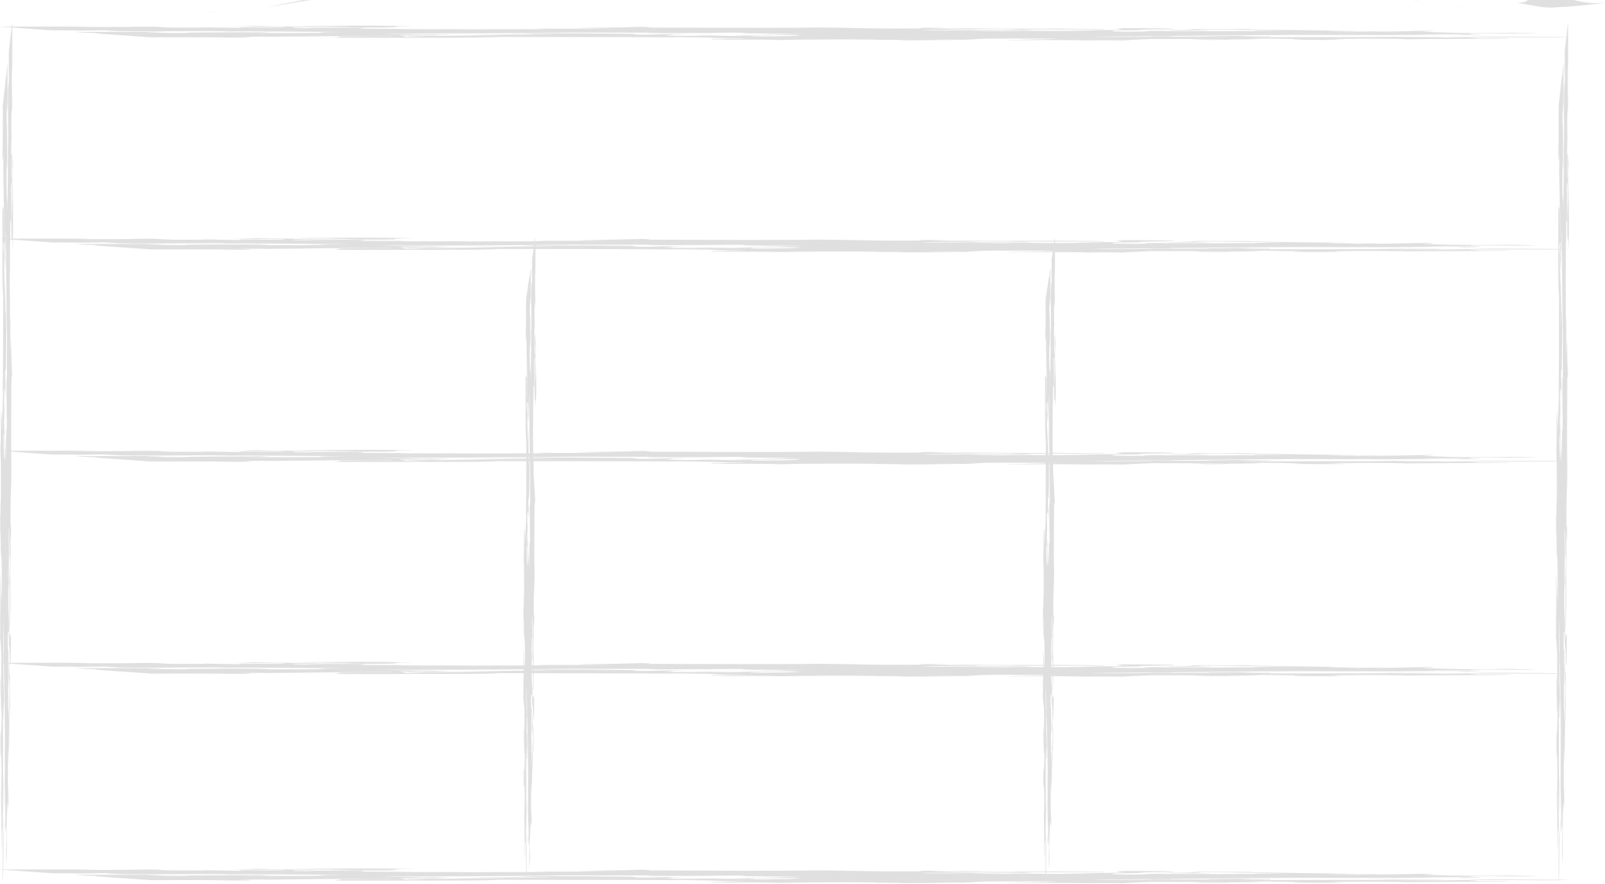

How … ?

Where … ?

What … ?

Why … ?

Can … ?

What would  
happen if … ?

Does … ?

When … ?

Will … ?

Question stems

