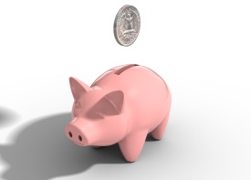

Tom had 17p in his piggy bank. He used 9p on a new toy.

How much money did he have left?

C:\Users\rlove1.306\AppData\Local\Microsoft\Windows\Temporary Internet Files\Content.IE5\PIEO9LZ1\MC900264268[1].wmf

Lucy had 28 sweets. She gave 12 to her friend.

How many did she have left?

C:\Users\rlove1.306\AppData\Local\Microsoft\Windows\Temporary Internet Files\Content.IE5\PIEO9LZ1\MC900264268[1].wmf

C:\Users\rlove1.306\AppData\Local\Microsoft\Windows\Temporary Internet Files\Content.IE5\97IP5H6K\MC900112658[1].wmf

There are 25 biscuits on a plate. 11 get eaten. How many are left now?



There are normally 30 children in the class. 19 were off sick.

How many children were in school today?

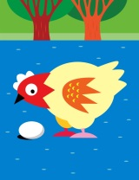Some hens laid 38 eggs. The farmer took 21 to eat.

How many eggs were left?



Tom had 86p in his piggy bank. He used 34p on a new toy.

How much money did he have left?

C:\Users\rlove1.306\AppData\Local\Microsoft\Windows\Temporary Internet Files\Content.IE5\PIEO9LZ1\MC900264268[1].wmf

Lucy had 98 sweets. She gave 20 to her friend.

How many did she have left?

C:\Users\rlove1.306\AppData\Local\Microsoft\Windows\Temporary Internet Files\Content.IE5\PIEO9LZ1\MC900264268[1].wmf

C:\Users\rlove1.306\AppData\Local\Microsoft\Windows\Temporary Internet Files\Content.IE5\97IP5H6K\MC900112658[1].wmf

There are 45 biscuits on a plate. 23 get eaten. How many are left now?



There are normally 60 children in the class. 41 were off sick.

How many children were in school today?

Some hens laid 80 eggs. The farmer took 37 to eat.

How many eggs were left?