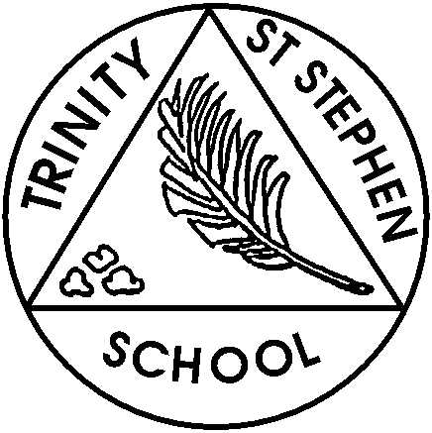
This week in Year 3…
Dear Parents and Carers,
Welcome to Year 3. I look forward to working with you and your children this year. We had three lovely days last week and much of our work was based around a book by Oliver Jeffers ‘Here we are’ and we will continue to use this book over the next week as it provides plenty of opportunities to work on well-being as well as writing, art and aspects of other subjects.
In this weekly newsletter you can expect to find an outline of the learning focus for Maths and English each week as well as details of the homework. There may be other items of news and information as needed.
Homework:
Homework is being set online and will start next week. I will set it on Fridays to be completed by the following Friday.
Spelling: spelling lists will be uploaded to the school website under Class News. There are two lists, Cheetahs and Lions. Your child should know which group they are in but if in doubt do email me or pick the one which you think best fits. The words cover the same spelling rule but one group has fewer words. The colour spelling groups will be finalised this week and words made available shortly.
- Maths: there will be a worksheet based on the work we will do during the week (eg. number bonds and place value) and a support sheet; please choose the one which your child is comfortable with. There will be a challenge either as part of the worksheet or as an extra document.
- Reading: children should be reading for at least 15 minutes each day. While books won’t be coming home just yet and we are in the process of assessing each child to determine their current reading level, please read books you have at home, magazines such as The Week Junior’s sister Science and Nature, the newspaper First News which is specifically written for this age group.

This week we will be learning:
English: We will be working on writing instructions using imperative verbs and adverbs to describe how to do the instruction. We will also be using time words such as firstly, next and finally to help order the instructions.
Maths:
We will be revisiting number bonds to 10, 20 and 100, adding and subtracting using number bonds and revising place value.
Other information:
- Healthy snacks. In Year 3 they are no longer eligible for the free fruit snack provided by the Government in KS1. If you would like to send them with a healthy snack for morning break to help keep energy levels up then please do. Examples of healthy snacks include fruit, vegetables, yoghurt and cheese. Please make sure they do not contain any nuts.
- PE kit needs to be kept at school; if you have not yet sent it in then please send it as soon as possible as PE lessons start this week.

EM

