THE IDEA
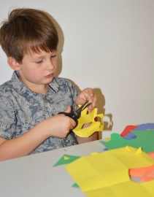
© Tate Liverpool family activity
You are going to make your very own Matisse-inspired collage. Take a closer look at nature and be creative with shapes and colours as you cut out your own masterpiece!
Henri Matisse is a French artist known for making colourful works of art. He used a variety of materials in his work, including paint, bronze (for his sculptures), and he also made drawings using charcoal. As Matisse became older, he began to work with brightly coloured paper and would ‘paint with scissors’ to cut out shapes, animals, leaves, dancers and flowers and then arrange them.
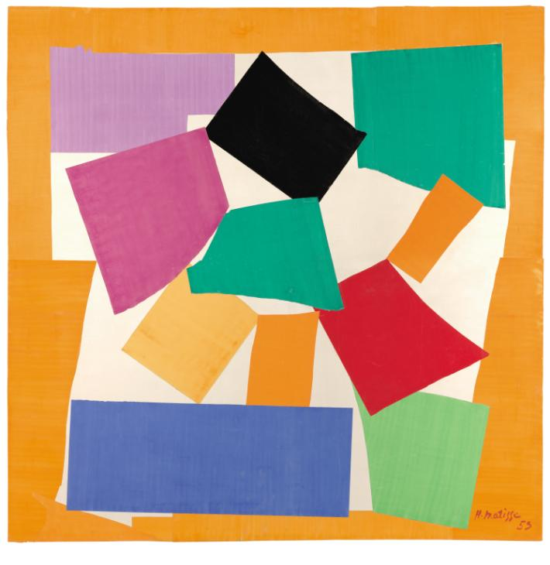
Henri Matisse
The Snail 1953
Tate
© Succession Henri Matisse/DACS 2020
One of Matisse's most famous works is called The Snail. Does the spiral pattern of shapes remind you of anything?
It was made in 1953 and shows Matisse's interest in bright colours. He arranged complementary colours alongside each other to create a vibrant effect. For example, you'll see that by putting green next to red, and blue next to orange the colours seem to buzz and really attract your attention.

WHAT YOU NEED

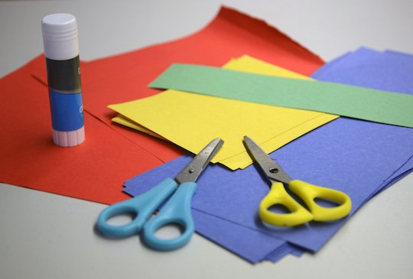
© Tate Liverpool family activity
- Brightly coloured paper
- Scissors
- A clear space to work on
- Glue
- Pencil
- Music
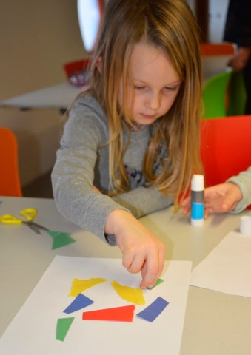
- Creativity (essential!)

DO IT!

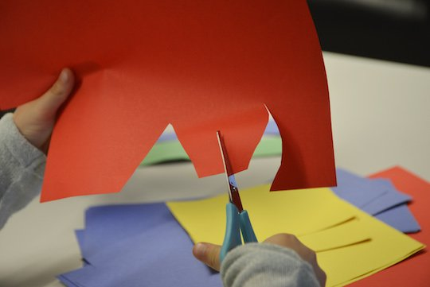

- Matisse would listen to music as he worked. To get the creative juices flowing put on the radio and let the fun times begin.
- Take your scissors and cut out shapes from the brightly coloured paper. They can be any shape you want; they can be wavy like the sea or sharp like a cactus, they can be in the shape of love hearts or spell out words! Just let your imagination take over.
- When you have made a pile of brightly coloured shapes take a large sheet of coloured paper and start composing your picture. This means arranging the shapes onto the page to make a picture that looks nice. Composition is very important to artists' work. Don't be afraid to experiment with your shapes, they can be apart or touching. You could even overlap them to make a new shape – just play around and see what happens.
- Once you're happy with your picture you can stick your paper shapes down.

