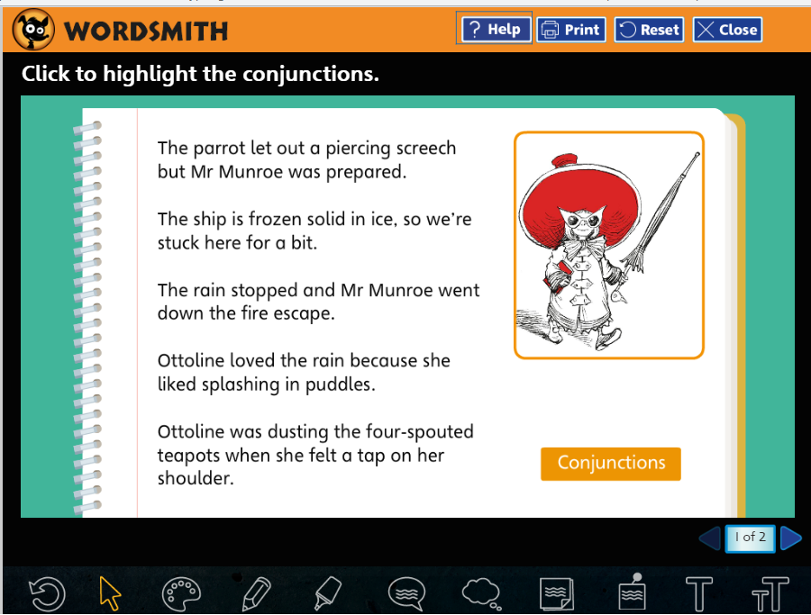
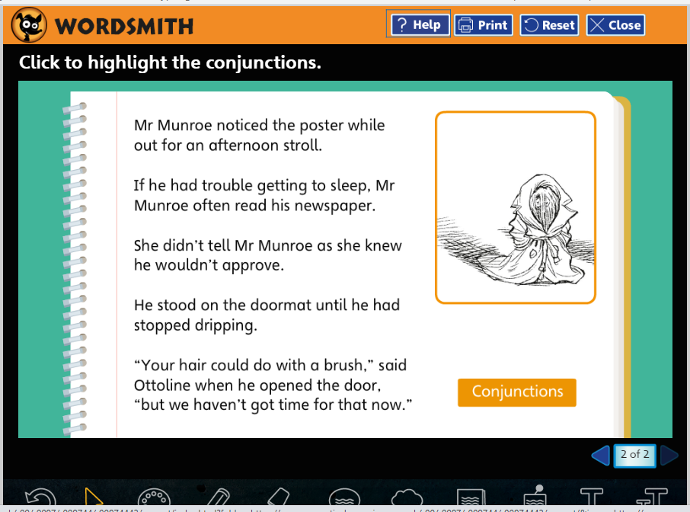

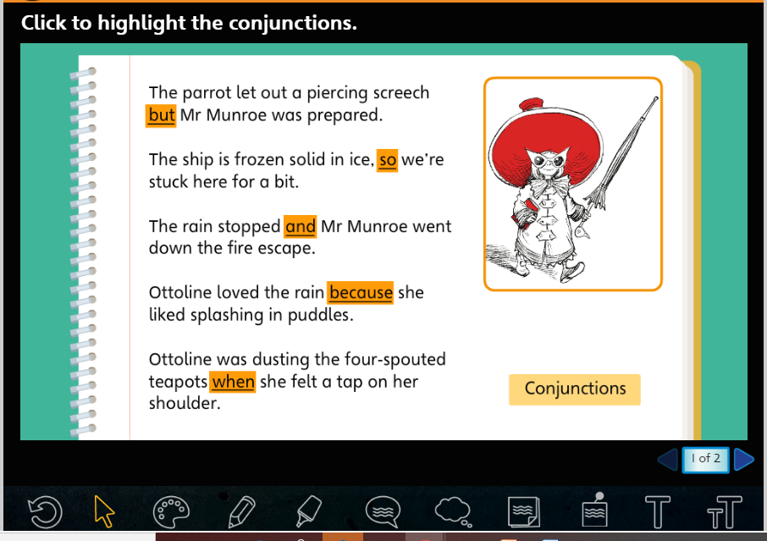

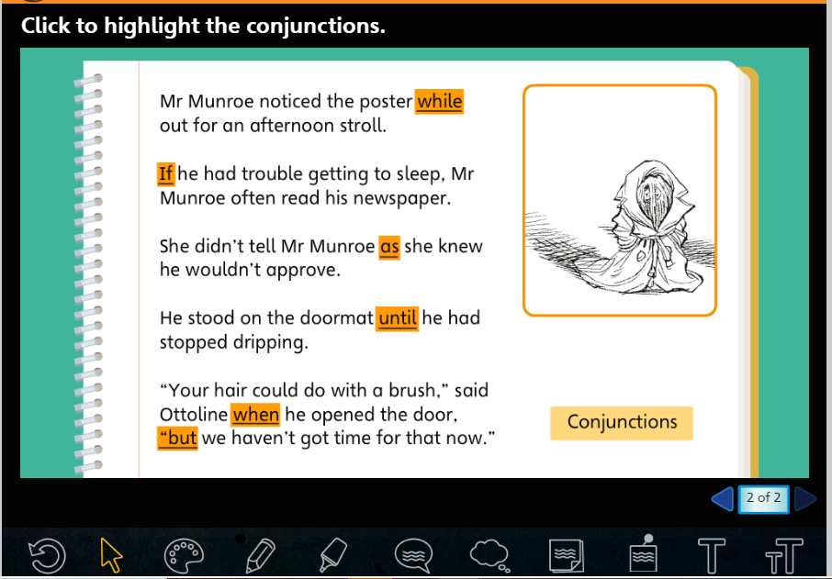

Task 2:
Here are some clauses. Are they complete sentences? Do they make sense on their own? What is missing?
- while out for an afternoon stroll
- until he had stopped dripping
- when he opened the door
- if he had trouble getting to sleep
- because she liked splashing in puddles
- so we are stuck here for a bit
These are the subordinate clauses. They don’t make sense on their own and need a main clause to make the sentence complete.
Here are some sentence starters and conjunctions you could use to make up a sentence that has a main clause and a subordinate clause. The conjunctions in red are a little more tricky to use so use these if you like a challenge!
Challenge: you could choose a conjunction and then write your own sentence. You could also put the subordinate clause in a different place in the sentence. Remember the subordinate clause can come at the beginning, middle or end of a sentence but it needs a comma after it if it starts the sentence and a pair of commas round it if it comes in the middle.

and but so because
when while until if as
although since unless so that

Pick a sentence starter, choose a conjunction and complete the sentence.
Ottoline was worried …
Mr. Munroe was waiting for a bus …
Ottoline was polishing her shoe collection …
Mr. Munroe wanted to show Ottoline something …
Ottoline went down to the basement …
Ottoline brushed Mr. Munroe’s hair …

