Comparing Classroom Objects Mass
Find the following items in your classroom and compare their masses.
Finish writing the sentence to describe which item is heavier or lighter.

Items
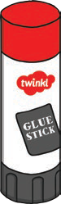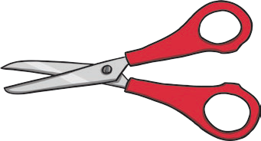 | The glue is
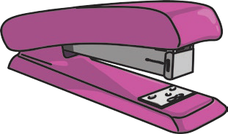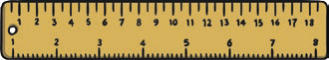 | The ruler is
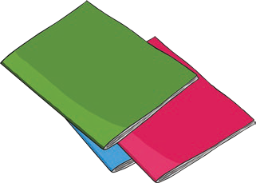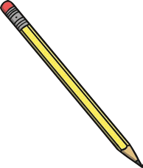 | The paper is
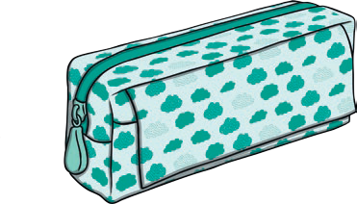 | The full pencil case is

