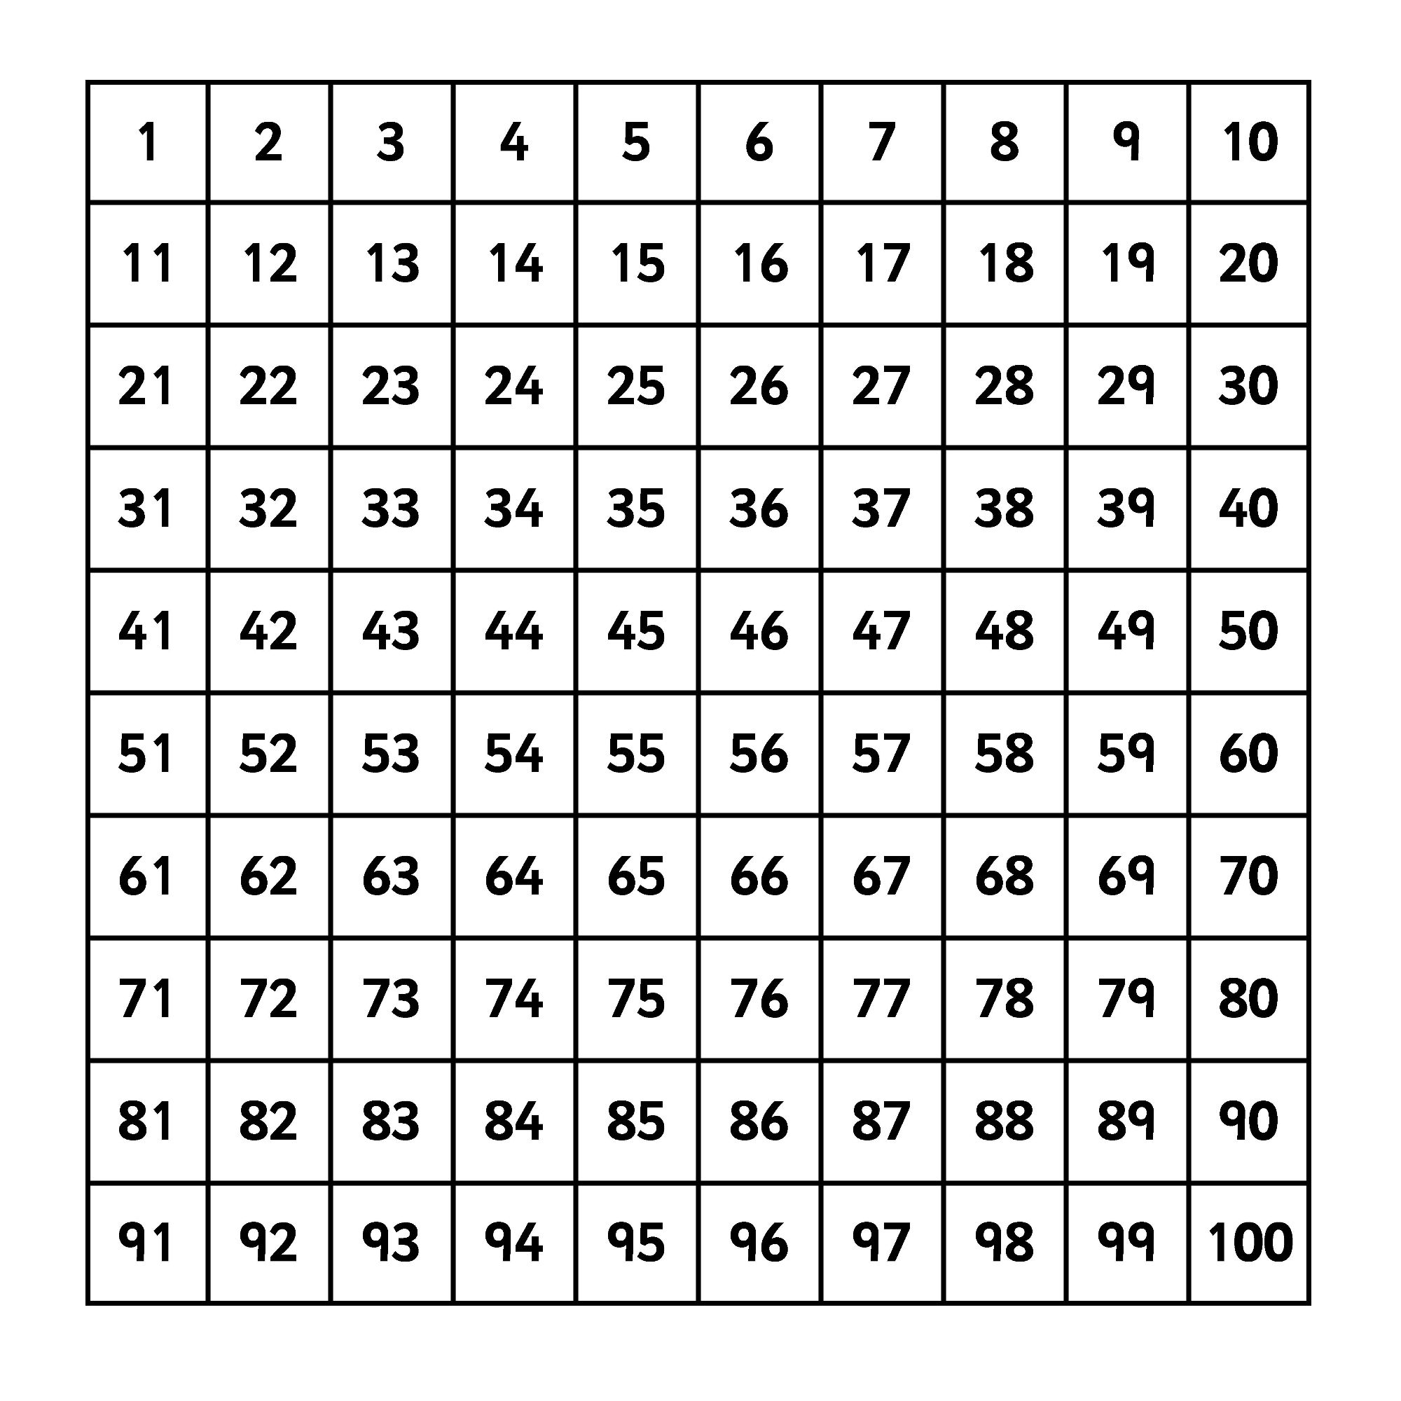
Multiplies of 5- Colour green
Multiplies of 2- Circle

