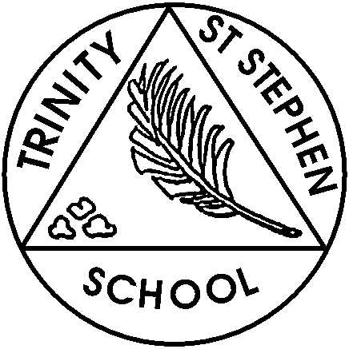
This week in Year 3

Monday 9th June 2025

English: We Have started a new unit on persuasive writing and will be looking at some of the features of this genre.
Maths: We will consolidate our work on Roman numerals o’clock, half past and quarter past and quarter to times and then start to look at analogue clock times to the nearest 5 minutes. Later in the week we will continue to find equivalent fractions.

Homework:
The homework handed out on Friday consisted of some work on accurate placing of capital letters and full stops along with a Maths activity on Roman numerals and telling the time. This homework is due in on Wednesday 11th June. If, due to exceptional circumstances, this homework is likely to be late, please let us know as soon as possible. 10 minutes reading and 5-10 minutes times tables and number bond practice should also form part of your child’s daily routine.

Spellings:
In the test on Wednesday 11th June, most children will be tested on homophones and near homophones: peace/piece, rain/reign/rein, medal/meddle, rode/road, scene/seen, fair/fare as well as the word, with.

New spellings will be sent out on Wednesday after the test. The new words will be a further list of homophones and near homophones: berry /bury, missed/mist, grate/great, grown/groan, plain/plane, weather/whether. The new words will be tested on Wednesday 18th June.
Other Matters:
- On Tuesday, Y3 are visiting The Natural History Museum in London to support this term’s Geography topic on volcanoes and earthquakes. Please remember a packed lunch (no nuts please!) if you have not pre-ordered from the school. A water bottle is also essential.
- Our DT topic this term is money containers in which we hope to develop our sewing skills. I would like to start the topic by exploring any purses or wallets that the children can bring in from home. They do not need to have any sewn seams. The aim is to develop an awareness of the range of money containers that exist. I would be very grateful if you could assist in sending in some purses or wallets on Monday.
- Pbones will resume this week now the musical festival rehearsals are finished. Please remind your child to bring their pbone to school on Friday as usual.

