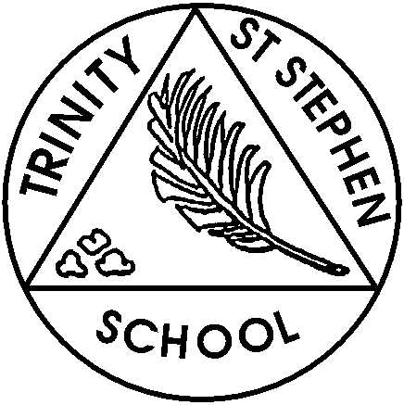
This week in Year 4

Monday 16th June
English:
This week in English the children will start reading ‘The Butterfly Lion’ by Michael Morpurgo. They will then be discussing what they have read so far, looking at vocabulary and using a dictionary to find the meaning of words. The children will also be rehearsing the Year 4 production.

Maths:
This week we continue our unit on Decimals. The children will be learning to divide 1-and 2-digit numbers by 100. They will build numbers using place value counters and use exchanges to support their understanding. Once confident working with place value counters, they will move to using place value charts and recognising that dividing a number by 100 moves all the counters two places to the right.

Homework:
Homework will be sent out on Wednesdays and needs to be returned to school by the following Monday. This week’s homework will include continuing to learn their lines off by heart and the songs for our Year 4 production, and a Maths activity.
Other Matters:
- The children have brought home their scripts for the Year 4 production please help them learn their lines off by heart – thank you.
- Sports Day – Thursday 19th June
- Year 4 production – 2nd July and 3rd July
- The children will have their PE lesson on Tuesdays and Fridays, they will need to remember to bring their PE kit in on those days. Please can all children have the correct PE kit in their bags – thank you.
- Please encourage your child to read daily at home and sign their reading record. I have informed the children that I will be checking their reading records every Friday.
- The children are learning the songs for The Hexagon which is on 24th June. Please encourage your child to learn these songs at home. A letter was sent home with all the links to the songs and words.
- My email address is a.brech@tssfirst.co.uk should you need to contact me.

