

Attendance & Punctuality Guide for Parents & Carers

2025/26 Academic Year

All parents and carers are be expected to comply with all national and local regulations regarding student Attendance & Punctuality. Twyford’s full Attendance Policy can be found here on the school website: https://twyford.org.uk/about-us/policies. All students have a right to full-time education.

Very Good |  | Worrying |  |  | Causing Serious Concern
The Effect of Absence on School Progress
A whole year has 365 days
A school year has only 190 days
This leaves:
175 days to spend on family time, visits, holidays,
shopping, household jobs and other appointments

No absence | 10 days  absence |  | 12 days  absence | 19 days  absence | 29 days  absence |  | 38 days  absence
190 days of education
190 days of education | 180 days of education
190 days of education |  |  | 178 days of education
190 days of education |  |  | 178 days of education | 171 days of education
 |  |  |  |  | 161 days of education
 |  |  |  |  |  |  | 152 days of education
100% | 95% |  | 94% | 90% | 85% |  | 80%
Very Good  Best chance of success.  Gets your child off to a flying start. |  |  | Worrying  Less chance of success.  Makes it harder for your child to make progress. |  |  | Serious Concern  Your child will find it very difficult to make progress; May result in a fine and/or court action.

Remember:
- 90% attendance is equal to 1 day off each fortnight
- Every students are absent impacts their education and possible life chances and opportunities in the future
- Students with medical conditions and/or disabilities have the same have the same rights to access full-time education; the Department of Educations guidance can be found here
There are 40 weeks at school in a year so a rate of 89% over 5 years would mean ½ a year of school missed and 78% over 5 years would mean 1 whole year of school missed.

London Borough of Ealing’s guidance for parents & carers include the following breakdown:
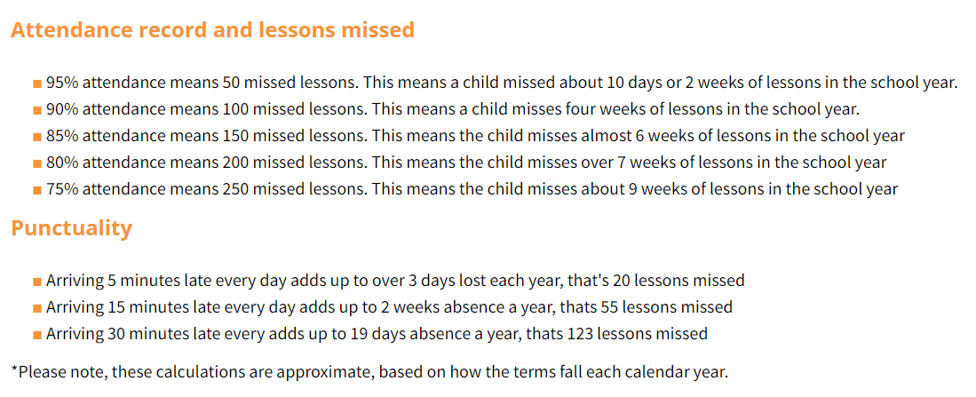

Reporting Sickness/Absence to the School Office:

DAILY NOTIFICATION TO THE OFFICE OF YOUR CHILD’S ABSENCE

As per the national and local Health & Safety and Safeguarding initiatives, it is imperative that all parents/carers notify the School Office in the morning by 8:30am if their child will not be attending school for a justifiable reason for each day that a student is absent.

- Email: Office@twyford.ealing.sch.uk
- What to include: State the student’s Full Name, Tutor Group & reason for absence
- You can also call our absence line on 020 8752 0141 - PRESS Option 2 once connected
- Please DO NOT: Email your child’s tutor teacher or HOY only without including the Office, otherwise it will not be recorded properly and/or be recorded as an unauthorised absence
- Sixth Form students should not provide their own reasons for absence – notification must come from a parent/carer.

TEXTING HOME

Text messages will be sent to parents/carers if we have not notification of student absences. Student absences that have not been reported to the school by a parent/carer on each relevant day must be reported by the school to the Educational Social Worker in the Ealing Borough.

It is not appropriate to withhold a reason for absence from the Office, or only informing a member of the Pastoral Team. If a reason for absence is not provided to the Attendance Officer, the absence will be unauthorised. Your child’s attendance record is a legal record and accurate reasons for authorisation must be recorded properly. All unjustified absences must be investigated.

Medical evidence will be required after 3 days of sickness absence (GP appointment letter, email, text message or card or copy of prescription). Should your child be required to be absent for a longer period of time, this will explicitly need to be outlined in a letter from a Medical Professional such as a Consultant/Specialist or hospital detailing expected recovery times. Parents/Carers should also be in touch with the Welfare Office if their child’s absence is related to a medically diagnosed condition, supported by evidence of a medical professional, such as a Consultant/Specialist.
Reporting Medical/Dental Appointments:

Parents/Carers should arrange medical/dental appointments outside of the school day where possible. If an appointment must be made during the school day, we recommend avoiding AM or PM registration periods and booking around lunchtimes.

Parents/Carers will need to inform the school in advance and include the reason and details (such as date/time of the appointment) for the Office to record on your child’s legal attendance record and for the Year Team to monitor. Please note that we will require evidence of on-going or follow-up appointments.

Signing in & out at the School Office (for Safeguarding reasons):

It is a matter of Safeguarding that all students (including Sixth Form students) must sign in and out at the front desk/reception area of the School Office upon arrival to, and before leaving the school premises.

If students are returning to school at a later point in the school day, they must sign back in at the front desk/reception. It is your child's responsibility to report to the Office at the correct time in order to be signed out; staff are not able to collect students from lesson.

In line with the Safeguarding expectations of signing in and out, Years 7-11 students must be in full school uniform and all Sixth Formers must be wearing a student ID badge (Sixth Form students who attend school without their ID Badge will be issued with detention).

Sixth Form students who leave school site before their lessons are complete without signing out at Reception will be at risk of a detention even if they have a valid reason for absence.

Reporting Planned Leave of Absences:

Any planned leave of absences must be reported by completing a Leave of Absence Form (found on the school website https://twyford.org.uk/attending-our-school/attendance) which needs to be submitted at least 4 weeks prior to the date of the absence.

Applications for a leave of absence will be reviewed and authorised by the Attendance Officer and the Pastoral Team and your child’s current percentage of attendance will be taken into account for authorisation. Students with attendance below 90% are unlikely to receive authorisation for further days of absence from school.

Holidays during term time are not permitted (unless in rare cases/exceptional circumstances agreed with the Attendance Officer & the Pastoral Team) and if taken, are likely to result in a fine from the Borough. All parents/carers are asked to review the Department for Education guidelines regarding possible fines and loss of school place here.

In the case of an international bereavement and compassionate leave, a death certificate will respectfully be requested.

Monitoring & Interventions for Persistent and Severe Attendance:
Every child has a right to full-time education and every student’s attendance is expected to be 95% or above (including students with Individual Health Care Plans and Education Health & Care Plans). Any attendance under 95% will be monitored and parents/carer informed – parents/carers may be asked to come into school to meet and discuss the concern. All unexplained absences will be marked as "unauthorised absence".

All parents/carers will be notified automatically when their child reaches the national threshold of below 90% of attendance.

- The Attendance Officer must send parents/carers a notification letter for ‘Attendance Below 90%’
- The Attendance Officer will liaise with the family and the Pastoral Team to ensure the student’s reasons for absence are identified & supported
- The Attendance Officer will send parents/carers a Persistent Absence notification letter for continuous absence below 90% requesting a meeting with the Attendance Officer & the Year Team to address what steps are required to improve attendance; absences will be referred to Children Missing Education Lead for Ealing Council, which may result in a fine and/or court intervention
- The Attendance Officer will send parents/carers a Severe Absence notification letter for ‘Attendance Below 50%’ and the Safer School Police Officer and Ealing Integrated Children’s Response Service will also need to be informed; further absences may also result in a fine and/or court intervention

Home Visits will need to be carried out for students who have persistent and severe absences, either by a member of the Pastoral Team or a School Liaison Police Officer before or during a referral to the Council.

Students with Individual Health Care Plans (IHCP) are well-supported, with a Welfare Team of over 10 years’ experience looking after hundreds of students with medical conditions and are expected to access their right to full-time education. All Individual Healthcare Plans are reviewed by the Ealing School Nursing Team. Students with high-risk medical needs that may meet the threshold of additional arrangements outside of mainstream schooling will be identified and discussed with the school ahead of a potential medical referral.

Fines & Prosecution:
For the 2025-26 academic year, we have been asked by the Department for Education and Ealing Council to warn you that if your child is absent from school without authorisation, the Local Education Authority has the power to issue Fixed-Penalty Notices of £80, rising to £160 if not paid within 21 days (Anti-Social Behaviour Act 2004). If you do not pay the fine after 28 days you may be prosecuted for your child’s absence from school, which could include a fine of up to £2,500, a community order or a jail sentence up to 3 months. The court also gives you a Parenting Order.

Punctuality:
Students should be ready at their Tutor room or assembly line up no later than 8:30am. Students will be marked in ‘late’ if they arrive after 8:30am. If students arrive late for school, they must make sure that they are marked present, as follows:
- Between 8:30am and 9:00am go straight to Tutor room/assembly
- After 9:00am go to the main reception desk to be signed in late (U code)
Punctuality is an important expectation of students and therefore if a student is late after 8:30am they will receive a lunchtime or afterschool detention (depending upon their key stage) for 20 minutes the same day. This will also include 2 negative conduct points for ‘poor punctuality’.

Persistent Poor Punctuality will be subject to the same guidelines as persistent or severe attendance (as detailed above) and may include school sanctions in addition to Council intervention. 10 sessions of ‘U’s (absences to either AM or PM registration) can trigger the issuance of a fine. Truancy to AM or PM registrations will be marked ‘U’ and can also be subject to the issuance of fines.

Safeguarding:
Our first priority is your child's welfare and therefore there may be occasions when our concern about your child means that we have to consult other agencies even before we contact you. The procedures we follow have been laid down by the Ealing Area Child Protection Committee.

Students should be aware that Safeguarding (Child Protection) issues will become the responsibility of one of the following Safeguarding Officers: Mr MacDonald-Brown, Miss Johnston, Miss Bajwa, Mr Bennett, Miss Holloway, Mrs Easton and Ms Swadkin. Information about our Safeguarding Team can be found here on the school website: https://twyford.org.uk/attending-our-school/safeguarding.

Children Missing in Education (CME):
Parents/Carers must comply with the 'Children missing in education' guidance by informing the school of plans to change school. The Leaving School Form must be completed and submitted to the school and can be found on the school website: https://twyford.org.uk/attending-our-school/attendance. It must be returned to the school before your child’s departure so we can begin preparing for your child’s smooth transition to their new school.
Attendance & Punctuality Contacts:
Miss Muhsin Mr MacDonald-Brown
School Attendance Officer Designated Safeguarding Lead

Mr Abdi
Family Support Worker (Severe Absenteeism)

Your child’s Head of Year and Head of Key Stage (Head of Lower, Upper & Sixth) will also be involved with Attendance & Punctuality.

