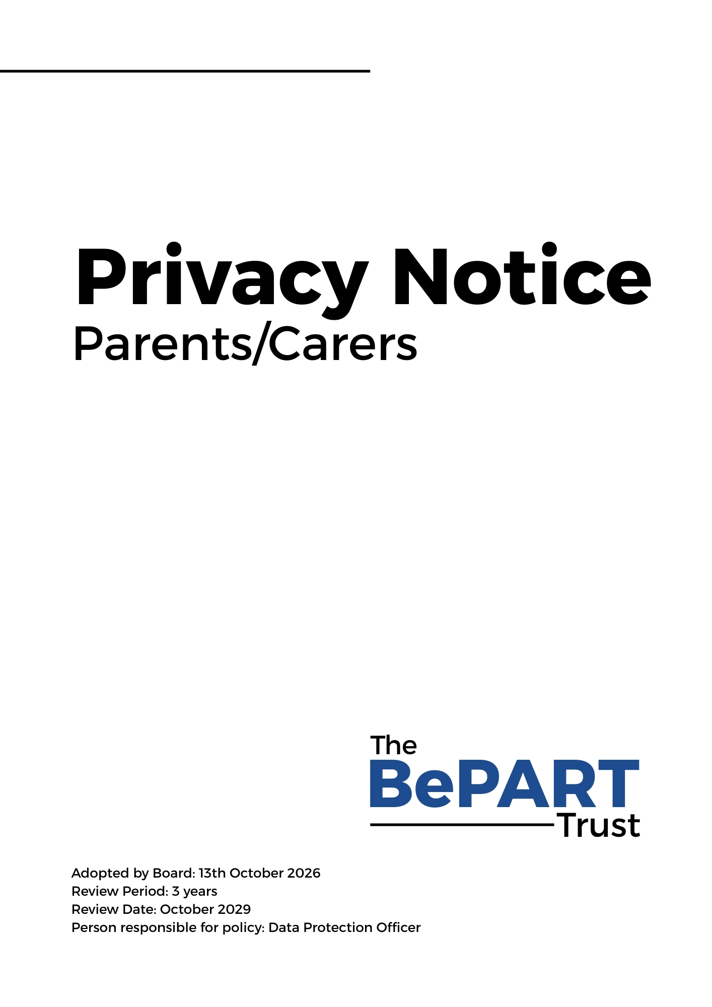

Privacy Notice (How we use parents/carers information)

BePART Educational Trust (referred to throughout this document as ‘the Trust’) collects data and information about parents/carers of our students so that we can operate effectively as an Organisation.
This privacy notice explains how and why we collect parent/carer data, what we do with it and what rights parents have. The term “parent” is widely defined in education law to include the natural or adoptive parents and also includes non-parents who have parental responsibility for the student, or with whom the student lives. This privacy notice also covers other members of student families who we may process data about from time to time, including for example, siblings, aunts, uncles and grandparents.

Why do we collect and use parent/carer information?

The Trust collects and uses parent/carer information under the following lawful bases:
- Where we have the consent of the data subject (Article 6(a));
- Where it is necessary for compliance with a legal obligation (Article 6 (c));
- Where processing is necessary to protect the vital interest of the data subject or another person (Article 6 (d));
- Where it is necessary for the performance of a task carried out in the public interest or in the exercise of official authority vested in the controller (Article 6 (e));

Where the personal data we collect about parents/carers is sensitive personal data, we will only process it where:
- We have explicit consent
- Processing is necessary to protect the vital interests of the data subject or of another natural person where the data subject is physically or legally incapable of giving consent and/or
- Processing is necessary for reasons of substantial public interest, on the basis of UK law which shall be proportionate to the aim pursued, where we respect the essence of the right to data protection and provide for suitable and specific measures to safeguard the fundamental rights and the interests of the data subject.

Please see our Data Protection Policy for a definition of sensitive personal data.

The Trust uses the parent/carer data to support our functions of running our Organisation, in particular:
- To decide who to admit to the school or college
- To maintain a Continued Interest list
- To support student learning
- To monitor and report on student progress
- To provide appropriate pastoral care
- To assess the quality of our services
- To comply with the law regarding data sharing
- For the protection and welfare of students and others in the Organisation, including our safeguarding/child protection obligations
- For the safe and orderly running of the Organisation
- To promote the Organisation
- To send you communications that may be of interest to you which may include information about events or activities, news, campaigns, appeals and other fundraising activities
- In order to respond to investigations from our regulators or to respond to complaints raised by our stakeholders
- In connection with any legal proceedings threatened or commenced against the Organisation.

The categories of parent/carer information that we collect, hold and share include:
- Personal information (such as name, address, telephone number and email address);
- Information relating to your identity, marital status, employment status, religion, ethnicity, language, medical conditions, nationality, country of birth and catering free school management / entitlement to certain benefits, information about court orders in place affecting parenting arrangements for students);
- Child protection and safe-guarding information. This information is not routinely collected about parents/carers or students and is only likely to be processed by the organisation in specific circumstances relating to particular students, for example, if a child protection issue arises or if a student is involved in a criminal matter. Where appropriate, such information may be shared with external agencies such as the child protection team at the Local Authority, the Local Authority Designated Officer and / or the Police. Such information will only be processed to the extent that it is lawful to do so and appropriate measures will be taken to keep the data secure;
- Criminal proceedings or convictions if known and applicable. We collect information about parents and carers before students join the Organisation and update it as and when new information is acquired.

This list is not exhaustive, to access the current list of categories of information we process, please see Data Protection Policy.

Collecting parent/carer information
Whilst the majority of information about parents / carers provided to us is mandatory, some of it is provided to us on a voluntary basis. In order to comply with the UK General Data Protection Regulation (UK GDPR), we will inform you whether you are required to provide certain parent / carer information to us or if you have a choice in this. Where appropriate, we will ask parents / carers for consent to process personal data where there is no other lawful basis for processing it, for example where we wish to ask your permission to use your information for marketing purposes or to request voluntary contributions. Parents / carers may withdraw consent given in these circumstances at any time.

Storing parent/carer data
A significant amount of personal data is stored electronically, for example, on our databases (SAPIAN/SIMS). Some information may also be stored in hard copy format.

Some data stored electronically may be saved on a cloud based system which will be hosted in the UK.

The Trust will only retain your personal information for as long as necessary to fulfil the purposes we collected it for, including for the purposes of satisfying any legal, accounting, insurance or reporting requirements. Details of retention periods for different aspects of your personal information will be available in our Data Retention Policy which will be available on the website. To determine the appropriate retention period for personal data, we consider the amount, nature, and sensitivity of the personal data, the potential risk of harm from unauthorised use or disclosure of your personal data, the purposes for which we process your personal data and whether we can achieve those purposes through other means, and the applicable legal requirements.

In some circumstances we may anonymise your personal information so that it can no longer be associated with you, in which case we may use such information without further notice to you. Once you are no longer a parent / carer we will retain and securely destroy your personal information in accordance with our Data Retention Policy.

Who do we share parent / carer information with?

The Trust routinely shares parent / carer information with:

Schools/colleges/universities that students attend after leaving us; From time to time, we may also share parent / carer information with other third parties including the following:
- local authorities
- researchers
- organisations connected with promoting the education or wellbeing of children in England
- other government departments and agencies
- organisations fighting or identifying crime

Some of the organisations referred to above are joint data controllers. This means we are all responsible to you for how we process your data.

In the event that we share personal data about parents / carers with third parties, we will provide the minimum amount of personal data necessary to fulfil the purpose for which we are required to share the data.

Requesting access to your personal data
Under data protection legislation, parents/carers have the right to request access to information about them that we hold (“Subject Access Request”). To make a request for your personal information, or be given access to your child’s educational record, contact The Data Protection Officer, John Paul Szkudlapski

The legal timescales for the Organisation to respond to a Subject Access Request is one calendar month. For further information about how we handle Subject Access Requests, please see our Data Protection Policy. You will not have to pay a fee to access your personal information (or to exercise any of the other rights). However, we may charge a reasonable fee if your request for access is manifestly unfounded or excessive. Alternatively, we may refuse to comply with the request in such circumstances.

What we may need from you
The Trust may need to request specific information from you to help us confirm your identity and ensure your right to access the information (or to exercise any of your other rights). This is another appropriate security measure to ensure that personal information is not disclosed to any person who has no right to receive it.
You also have the right to:
- object to processing of personal data that is likely to cause, or is causing, damage or distress
- prevent processing for the purpose of direct marketing
- object to decisions being taken by automated means
- in certain circumstances, have inaccurate personal data rectified, blocked, erased or destroyed; and
- a right to seek redress, either through the ICO, or through the courts
If you have a concern or complaint about the way we are collecting or using your personal data, you should raise your concern with us in the first instance or directly to the Information Commissioner’s Office at https://ico.org.uk/concerns/
Contact
If you would like to discuss anything in the privacy notice, please contact: The Data Protection Officer, John Paul Szkudlapski, BePART Educational Trust, Park Road West, Claughton, Wirral, CH43 8SQ

Changes to this Privacy Notice
We reserve the right to update this privacy notice at any time and we will provide you with a new privacy notice when we make any substantial updates. We may also notify you in other ways from time to time about the processing of your personal information.

