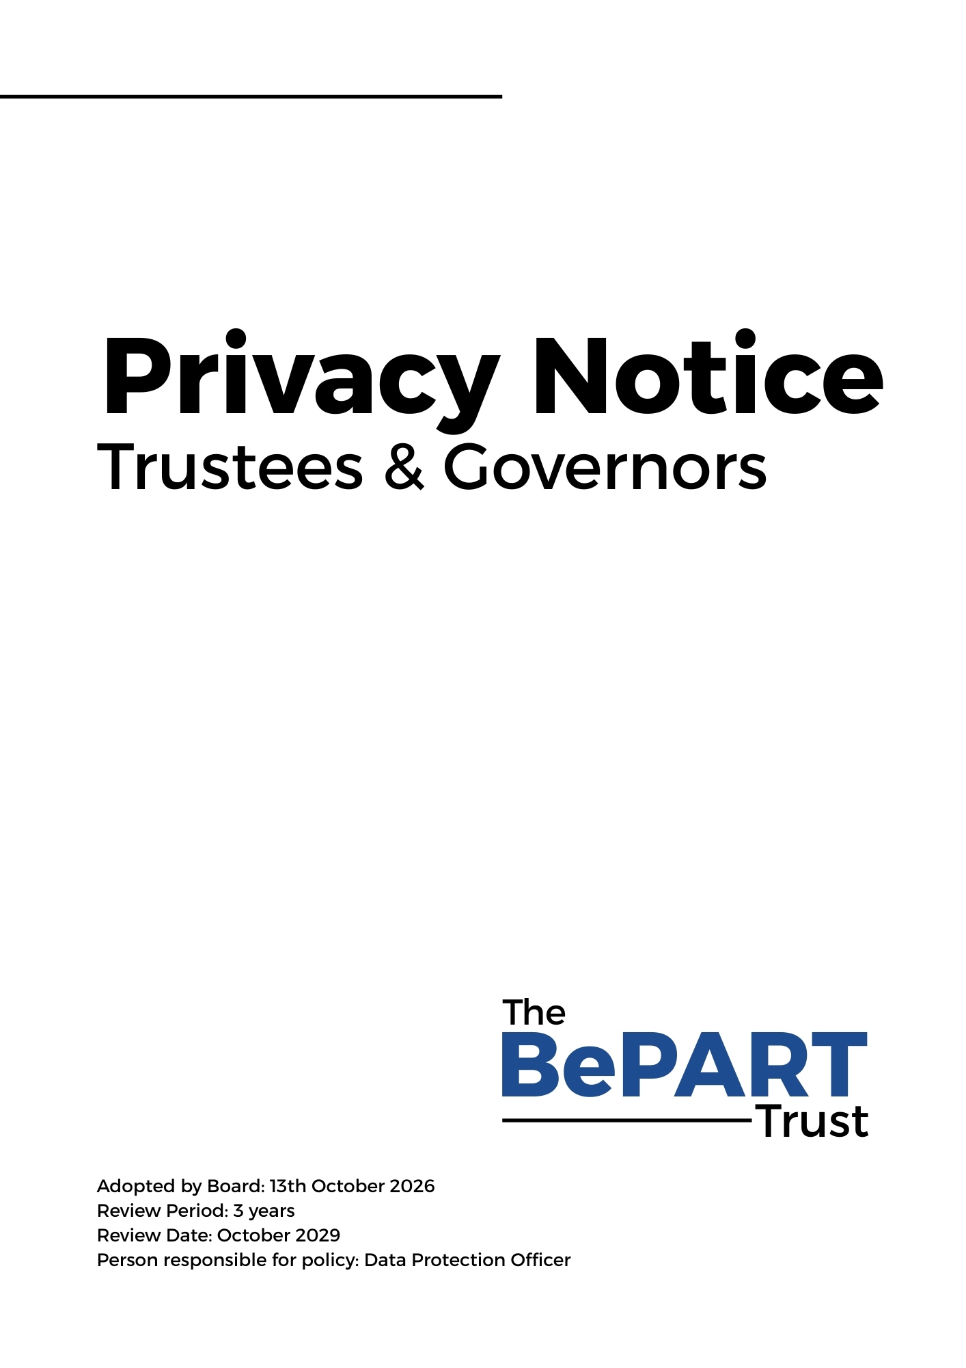

Privacy Notice (How we use Trustee & Governor information)

The BePART Educational Trust (referred to throughout this document as ‘the Trust’) is a "data controller" for Trustee/Governor information. This means that we are responsible for deciding how we hold and use personal information about you. You are being sent a copy of this privacy notice because it makes you aware of how and why your personal data will be used, and how long it will usually be retained for. It provides you with certain information that must be provided under the UK General Data Protection Regulation (UK GDPR).

Data protection principles
The Trust will comply with data protection law and principles, which means that your data will be:
- Used lawfully, fairly and in a transparent way.
- Collected only for valid purposes that we have clearly explained to you and not used in any way that is incompatible with those purposes.
- Relevant to the purposes we have told you about and limited only to those purposes.
- Accurate and kept up to date.
- Kept only as long as necessary for the purposes we have told you about.
- Kept securely.

The categories of Trustee/Governor information that we process include:
- identifiers, contacts and characteristics (such as name, date of birth, contact details and personal postcode)
- governance details (such as role, start and end dates and governor ID)

Why the Trust collects and uses Trustee/Governor information
The personal data collected is essential, in order for the Organisation to fulfil their official
functions and meet legal requirements.

We collect and use trustee/governor information, for the following purposes:

- to meet the statutory duties placed upon us
- processing is necessary for compliance and our legal obligations
- processing is necessary in order to protect the vital interests of the data subject or of another natural person;
- processing is necessary for the performance of a task carried out in the public interest or in the exercise of official authority vested in the controller;

All maintained school governing bodies, under section 538 of the Education Act 1996 and academy trusts, under the Academies Financial Handbook have a legal duty to provide the governance information as detailed above.

Collecting Trustee/Governor information
The Trust collects personal information via governor contact forms, DBS checks and email.

Trustee/Governor data is essential for the school’s operational use. Whilst the majority of personal information you provide to us is mandatory, some of it may be requested on a voluntary basis. In order to comply with UK GDPR, we will inform you at the point of collection, whether you are required to provide certain information to us or if you have a choice in this.

Storing Trustee/Governor information
The Trust holds data securely for the set amount of time shown in our data retention schedule. For more information on our data retention schedule and how we keep your data safe, please visit our website.

Who we share Trustee/Governor information with
We routinely share this information with:

- our local authority (where applicable)
- the Department for Education (DfE) under the requirements set out in the Academies Financial Handbook

Why we share Trustee/Governor information
We do not share information about our trustee/governors with anyone without consent unless the law and our policies allow us to do so.

For more information, please see ‘How Government uses your data’ section.

How Government uses your data
The governor data that we lawfully share with the DfE via GIAS:

- will increase the transparency of governance arrangements
- will enable the Organisation to identify more quickly and accurately individuals who are involved in governance and who govern in more than one context
- allows the Organisation to be able to uniquely identify an individual and in a small number of cases conduct checks to confirm their suitability for this important and influential role
Data collection requirements
To find out more about the requirements placed on us by the Department for Education including the data that we share with them, go to https://www.gov.uk/government/news/national-database-of-governors

Requesting access to your personal data

Under data protection legislation, you have the right to request access to information about you that we hold. To make a request for your personal information, contact The Data Protection Officer, John Paul Szkudlapski

The legal timescales for the Organisation to respond to a Subject Access Request is one calendar month. For further information about how we handle Subject Access Requests, please see our Data Protection Policy. You will not have to pay a fee to access your personal information (or to exercise any of the other rights). However, we may charge a reasonable fee if your request for access is manifestly unfounded or excessive. Alternatively, we may refuse to comply with the request in such circumstances.

What we may need from you
We may need to request specific information from you to help us confirm your identity and ensure your right to access the information (or to exercise any of your other rights). This is another appropriate security measure to ensure that personal information is not disclosed to any person who has no right to receive it.

You also have the right to:

- object to processing of personal data that is likely to cause, or is causing, damage or distress
- prevent processing for the purpose of direct marketing
- object to decisions being taken by automated means
- in certain circumstances, have inaccurate personal data rectified, blocked, erased or destroyed; and
- a right to seek redress, either through the ICO, or through the courts

If you have a concern about the way we are collecting or using your personal data, we ask that you raise your concern with us in the first instance. Alternatively, you can contact the Information Commissioner’s Office at https://ico.org.uk/concerns/

Contact

If you would like to discuss anything in this privacy notice, please contact: The Data Protection officer; John Paul Szkudlapski, BePART Educational Trust, Park Road West, Claughton, Wirral CH43 8SQ

Changes To This Privacy Notice

We reserve the right to update this privacy notice at any time, and we will provide you with a new privacy notice when we make any substantial updates. We may also notify you in other ways from time to time about the processing of your personal information.

