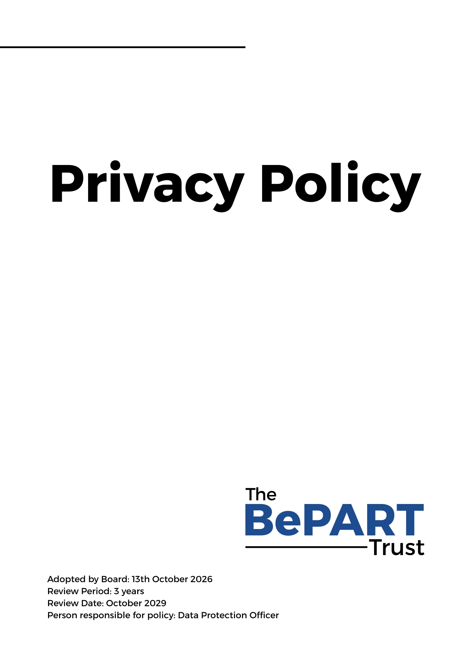

Privacy Policy

UK General Data Protection Regulation

Policy Statement
Every day The BePART Trust (referred to throughout this document as ‘the Trust’ or ‘organisation’) will receive, use and store personal information about its customers, learners and colleagues. It is important that this information is handled lawfully and appropriately in line with the requirements of the Data Protection Act 2018 and the UK General Data Protection Regulation (collectively referred to as the ‘Data Protection Requirements’).

The Trust takes its data protection duties seriously, because it respects the trust that is being placed in us to use personal information appropriately and responsibly.

About This Policy
This policy, and any other documents referred to in it, sets out the basis on which the Trust will process any personal data the Organisation collect.
This policy does not form part of any employee’s contract of employment and may be amended at any time.
The CEO is responsible for ensuring compliance with the Data Protection Requirements and with this policy. Any questions about the operation of this policy or any concerns that the policy has not been followed should be referred in the first instance to the Data Protection Officer or Director of HR.

What is Personal Data?
Personal data means data (whether stored electronically or paper based) relating to a living individual who can be identified directly or indirectly from that data (or from that data and other information in its possession).
Processing is any activity that involves use of personal data. It includes obtaining, recording or holding the data, organising, amending, retrieving, using, disclosing, erasing or destroying it. Processing also includes transferring personal data to third parties.
Sensitive personal data includes personal data about a person’s racial or ethnic origin, political opinions, religious or philosophical beliefs, trade union membership, genetic, biometric, physical or mental health condition, sexual orientation or sexual life. It can also include data about criminal offences or convictions. Sensitive personal data can only be processed under strict conditions, including with the consent of the individual.

Data Protection Principles
Anyone processing personal data, must ensure that data is:
- Processed fairly, lawfully and in a transparent manner.
- Collected for specified, explicit and legitimate purposes and any further processing is completed for a compatible purpose.
- Adequate, relevant and limited to what is necessary for the intended purposes.
- Accurate, and where necessary, kept up to date.
- Kept in a form which permits identification for no longer than necessary for the intended purposes.
- Processed in line with the individual’s rights and in a manner that ensures appropriate security of the personal data, including protection against unauthorised or unlawful processing and against accidental loss, destruction or damage, using appropriate technical or organisational measures.
- Not transferred to people or organisations situated in countries without adequate protection and without firstly having advised the individual.

Fair and Lawful Processing
The Data Protection Requirements are not intended to prevent the processing of personal data, but to ensure that it is done fairly and without adversely affecting the rights of the individual.
In accordance with the Data Protection Requirements, the Trust will only process personal data where it is required for a lawful purpose. The lawful purposes include (amongst others): whether the individual has given their consent, the processing is necessary for performing a contract with the individual, for compliance with a legal obligation, or for the legitimate interest of the business. When sensitive personal data is being processed, additional conditions must be met.

Processing for Limited Purposes
In the course of its Organisation, the Trust may collect and process the personal data set out in the Schedule 1. This may include data the Trust receives directly from a data subject (for example, by completing forms or by corresponding with us by mail, phone, email or otherwise) and data received from other sources (including, for example, location data, business partners, sub-contractors in technical, payment and delivery services, credit reference agencies and others).
The Trust will only process personal data for the specific purposes set out in the Schedule 1 or for any other purposes specifically permitted by the Data Protection Requirements. The Trust will notify those purposes to the data subject when it firsts collect the data or as soon as possible thereafter.

Notifying Individuals

If the Trust collects personal data directly from an individual, the Trust will inform them about:

The purpose or purposes for which the Trust intend to process that personal data, as well as the legal basis for the processing.
- Where the organisation relies upon the legitimate interests of the business to process personal data, the legitimate interests pursued.
- The types of third parties, if any, with which the Trust will share or disclose that personal data.
- The fact that the business intends to transfer personal data to a non-EEA country or international organisation and the appropriate and suitable safeguards in place.
- How individuals can limit the Trust’s use and disclosure of their personal data.
- Information about the period that their information will be stored or the criteria used to determine that period.
- Their right to request from us as the controller access to and rectification or erasure of personal data or restriction of processing.
- Their right to object to processing and their right to data portability.
- Their right to withdraw their consent at any time (if consent was given) without affecting the lawfulness of the processing before the consent was withdrawn.
- The right to lodge a complaint with the Information Commissioners Office.
- Other sources where personal data regarding the individual originated from and whether it came from publicly accessible sources.
- Whether the provision of the personal data is a statutory or contractual requirement, or a requirement necessary to enter into a contract, as well as whether the individual is obliged to provide the personal data and any consequences of failure to provide the data.
- The existence of automated decision-making, including profiling and meaningful information about the logic involved, as well as the significance and the envisaged consequences of such processing for the individual.

If the Trust receives personal data about an individual from other sources, the organisation will provide them with this information as soon as possible (in addition to telling them about the categories of personal data concerned) but at the latest within 1 month. An example of where this may happen is where the ESFA may transfer learners to the Trust.

The Trust will also inform data subjects whose personal data the organisation processes that the Trust are the data controller with regard to that data and its contact details are 0151 652 5575 and who oversees data control compliance.

Adequate, Relevant and Non-excessive Processing
The Trust will only collect personal data to the extent that it is required for the specific purpose notified to the data subject.

Accurate Data

The Trust will ensure that personal data held is accurate and kept up to date. The organisation will check the accuracy of any personal data at the point of collection and at regular intervals afterwards. The Trust will take all reasonable steps to destroy or amend inaccurate or out-of-date data.

Timely Processing
The Trust will not keep personal data longer than is necessary for the purpose or purposes for which it was collected. The Trust will take all reasonable steps to destroy, or erase from its systems, all data which is no longer required.

Processing in line with Data Subject’s Rights
The Trust will process all personal data in line with data subjects’ rights, in particular their right to:
- Confirmation as to whether or not personal data concerning the individual is being processed.
- Request access to any data held about them by a data controller
- Request rectification, erasure or restriction on processing of their personal data.
- Lodge a complaint with a supervisory authority.
- Data portability.
- Object to processing including for direct marketing.
- Not be subject to automated decision making including profiling in certain circumstances.

Data Security

The Trust will take appropriate security measures against unlawful or unauthorised processing of personal data, and against the accidental or unlawful destruction, damage, loss, alteration, unauthorised disclosure of or access to personal data transmitted, stored or otherwise processed.

The Trust will put in place procedures and technologies to maintain the security of all personal data from the point of the determination of the means for processing and point of data collection to the point of destruction.

Personal data will only be transferred to a data processor if they agree to comply with those procedures and policies, or if he puts in place adequate measures.

The Trust will maintain data security by protecting the confidentiality, integrity and availability of the personal data, defined as follows:

Confidentiality means that only people who are authorised to use the data can access it.

Integrity means that personal data should be accurate and suitable for the purpose for which it is processed.

Availability means that authorised users should be able to access the data if they need it for authorised purposes. Personal data should therefore be stored on the Company’s central computer system instead of individual PCs.

Security procedures include

Entry controls. Any stranger seen in Trust buildings should be attended to immediately

Secure lockable desks and cupboards. Desks and cupboards should be kept locked if they hold confidential information of any kind. (Personal information is always considered confidential.)

Data minimisation

Pseudonymisation and encryption of data. Please seek out advice from the Trust’s IT Services team on encryption

Methods of disposal. Paper documents should be shredded. Digital storage devices should be physically destroyed when they are no longer required by HR

Equipment. Staff must ensure that individual monitors do not show confidential information to passers-by and that they log off from their PC when it is left unattended. Password protection should be used for all mobile devices.

Subject Access Requests
Individuals must make a formal request for information held on them. Employees who receive a request should forward it to The Data Protection Officer, John Paul Szkudlapski immediately.
When receiving telephone enquiries, the Trust will only disclose personal data the Organisation holds on its systems if the following conditions are met:
The Trust will check the caller’s identity to make sure that information is only given to a person who is entitled to it.
The Trust will suggest that the caller put their request in writing if the organisation are not sure about the caller’s identity and where their identity cannot be checked.
Where a request is made electronically, data will be provided electronically where possible.
Trust employees will refer a request to the Director of HR
The Trust will respond to SAR’s with a one month period
No fee will be required when submitting a SAR

Changes to this Policy
The Trust reserves the right to change this policy at any time. Where appropriate, the Trust will notify changes by email.

SCHEDULE 1 DATA PROCESSING ACTIVITIES

Data | Lawful Basis | Recipient data is transferred to | Retention Period | Reason for Processing Data
Learner | - Consent  - Contract  - Legitimate Interest | - Pellcomp  - ESFA  - City and Guilds / ILM  - CMI  - Highfield  - SkillsFirst  - Edexcel  - AAT  - ACE  - MIAP  - EDRS | 5 Years | - Qualification Achievement  - Funding Claims
Employee | - Consent  - Contract  - Legitimate Interest | - People Pension  - IT Supplier  - Website Supplier  - HMRC  - H&S | 7 Years  12 years | - Eligibility  - Recruitment Process  Legal requirement
Software Training Delegates | - Consent  - Legitimate Interest | Print company for the purpose of printing certificates | 5 Years | Attendance at Training
Job Applicants | - Consent  - Legitimate Interest | 6 months (if direct applicants) | Length of contract | Eligibility  Recruitment process
Customers | - Consent  - Legitimate Interest | - ESFA  - CMI  - City and Guilds/ ILM  - Highfield  - SkillsFirst  - Edexcel  - AAT  - ACE  - MIAP  - EDRS | Length of Contract | Processing of Learner funding
Prospective Customers | Legitimate Interest | None | 3 years (Cleansed ahead of awareness campaigns) | Awareness of services
Privacy Notices
- Staff Privacy Notice (All staff of BePART Educational Trust)
- Candidate Privacy Notice (All candidates)
- Students Privacy Notice (BPS & BSFC)
- Parent Privacy Notice (BPS & BSFC)
- Governors & Trustees (BPS & BSFC)

