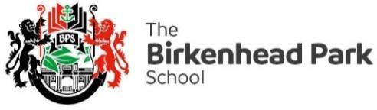

06 January 2021

BTEC and Vocational Examinations - January 2021

Dear Parents,

I hope that this letter finds you and your families safe and well. Following the government announcement last night, you will be aware that individual schools would be responsible for making the decision whether BTEC and vocational exams would go ahead this week.

Following a BePart Educational Trust and Wirral Headteacher meeting today, we have decided that in the interests of safety, wellbeing and fairness to our students, we are going to cancel the BTEC and Vocational exams scheduled to take place in January and February.

This is not a decision that has been taken lightly. We have taken into account all available guidance including local transmission rates within the community. We have also considered the Education Secretary briefing where he stated: "The government position is that we will not be asking students to sit ***all*** GCSE and A Levels" This being the case, we feel it is only fair to cancel the January examination series.

We understand that this is very short notice but please be assured that we are acting on information as soon as we receive it. We will continue to respond to updates as we receive them and keep parents and students informed accordingly.

We know that our students have worked extremely hard for these exams, and we will do our very best to ensure that they will not be disadvantaged when the final grades are released in the summer. We are also mindful that a lot of students have faced time out of lessons due to the enforced school closure in Year 10, and being asked to self-isolate as they may have been identified as a close contact of a positive Covid -19 in Year 11.

Although these exams have been cancelled, teaching, learning and assessment will continue remotely, students should continue to attend with the same positivity, resilience and work ethic.

I would like to thank you for the support that you have shown to the staff at school, especially in the last few days We remain committed to providing support to you and your children through these challenging times.

With very best wishes

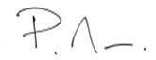

Mr P Mee

Deputy Headteacher