Dear Parents
I would like to share with you an update on our COVID measures in school in light of recent government announcements:
- From Thursday last week, face coverings are no longer advised in classrooms.
- From Thursday 27th January face coverings are no longer advised for staff, students or visitors in communal areas of the school. Staff and students should however follow wider advice on face coverings outside of school, including in crowded spaces such as transport to and from school.
Students should continue to test twice weekly at home, with lateral flow device (LFD) test kits, 3-4 days apart. Testing remains voluntary but is strongly encouraged.
We will also continue to encourage parents and other visitors to take a lateral flow device (LFD) test before entering the school.
In order to ensure adequate ventilation in classrooms, windows are likely to be open. Students will therefore be permitted to wear coats in classrooms this half term, if required, as the weather is likely to be colder. However, from Monday 28th February, we will revert to our normal uniform standards and expectations, which are that outdoor coats and hoodies should not be worn in classrooms.
Thank you for your support and for keeping us informed of any positive test results. Please contact school before sending your child in if you are unsure whether or not they have COVID symptoms.
Stay safe.
With very best wishes.
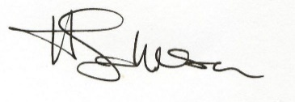
Mrs Johnson
Headteacher

