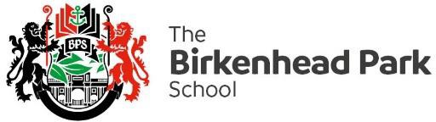

Dear Parent/Carer 19 July 2022

GCSE Results Day – Thursday 25 August 2022

I hope that you and your families are well.

I am writing to share the arrangements that we have put in place for GCSE results day on Thursday 25th August.

- The school will be open from 9:00am until 12:00 noon for students to collect their GCSE
Results.
- Students are asked to enter school by the Student entrance, where results will be available to collect in a sealed envelope from staff.
- Once students have collected their results they should speak to either Miss Galer or Miss Clarke. This will be a good opportunity to confirm post-16 college plans before leaving school. It will also be helpful for any students who are unsure about next steps.
- There will also be representatives from Wirral Met, Birkenhead Sixth Form College and Careers Connect on hand to provide any help or advice that may be needed.
- After students have collected their results, there will be an ice cream van on site, for students to receive a free ice cream

Finally, if your son/daughter is unable to collect their results and wishes for someone else to collect them on their behalf, they must put this in writing to the Exams Officer, Mrs Betley. The person collecting the results must bring this consent along with a form of identification on results day. Alternatively, students who cannot attend can request that their results are sent out via email from 9am on results day.
To receive results via email or for any other queries regarding GCSE results, please contact Mrs Betley at Dbe@birkenheadparkschool.com

I hope results day can be an opportunity for us all to celebrate their achievements and I wish them every success for their future.
With Best Wishes
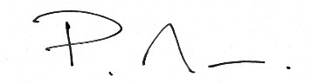
Peter Mee
Deputy Headteacher

