8^{h} January 2026
Dear Parents/Carers,

I hope that you and your family had a restful Christmas break.

KS3 Assessments – Monday 12th January 2026 – Monday 19th January 2026

To help teachers accurately assess your child’s progress, we have scheduled KS3 assessments to take place on the dates above.
- The focus of the assessments is for the students to demonstrate what they know from content that has been taught by their teacher so far this year.
- The assessments will take place in the Hall and the Gym for core subjects (English, Maths and Science) outlined by the timetable attached and in classrooms for all other subjects at a time chosen by the teacher.
- Your child’s teacher will inform them of when their assessment will be taking place.

Academic Resilience and Student Support

In order to support your child through these assessments, this week we will have ‘Super Teaching Week’. Students will need to build their academic resilience in lessons and revise the content covered before their assessments.

Please also encourage your child to revise at home so they can have the best chances of success. Below are the BPS revision strategies that we recommend you use.
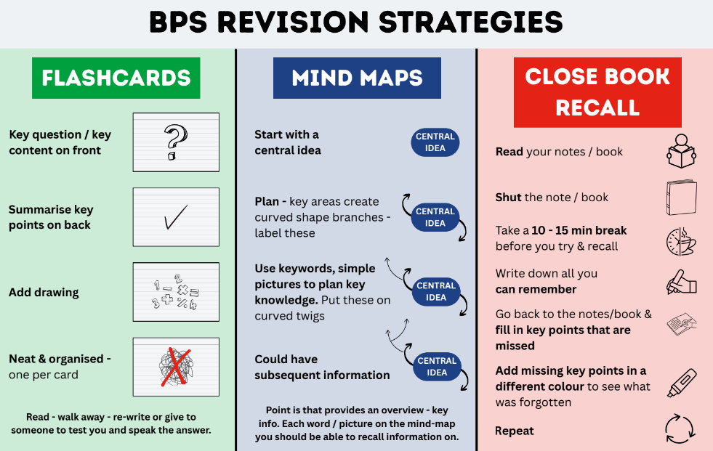

If you have any questions please don’t hesitate to contact your child’s Year Leader.

With Best Wishes
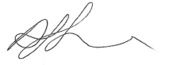

Miss Antonia Clarke
Assistant Headteacher

KS3 assessment timetable

*Please note that there will be assessments taking place during the ‘normal lessons’ slots as outlined individually by your child’s subject teacher.

