16th September 2026

Dear Parents and Carers

Year 7 Settling-in Parents’ Evening – Thursday 15th October 2026

I am delighted to invite you to our Year 7 Settling-in Parents’ Evening, which is being held on Thursday 15th October 2026 from 4.30pm to 6.30pm.

This is a highly valued part of our school calendar, which gives you the opportunity to meet with your child’s Form Tutor, Year Leader and members of the Pastoral Team and allow you to find out how they are settling-in to life at The Birkenhead Park School.
To book an appointment with your child’s Form Tutor, please use the link below:
https://www.schoolinterviews.co.uk/code/cvpcf

Please contact Mrs Thomas, Data Manager using the following email address: sth@birkenheadparkschool.com if you have any issues booking an appointment.

We do hope that you will be able to attend this evening and look forward to welcoming you. However, should you have any further questions, please do not hesitate to contact me in the first instance.

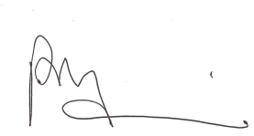
Yours sincerely

Mrs P Kirwan
Head of Pastoral Care


Year 7 Settling In Evening booking will be held at the following time:
- 4:30pm – 6:30pm Thursday 15th October 2026
To book your interviews, go to www.schoolinterviews.co.uk/code in your browser, and enter the event code cvpcf. Then follow these three simple steps:
 | First enter your name, your child's name, and your email address.  YES: Enter Yes as you will be attending  NO: Enter number attending  If you need to book for more than one student, change the “Book for x students” setting, and enter the other student's name.
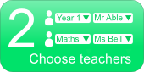 | On the next page, pick your child’s form tutor you want to meet, which is on the top of the letter.
 | Then you'll see a timetable showing when your chosen teachers are available. Simply click on the times that suit you.

When you have finished, your interview timetable will be emailed to you. You can return to the site and enter the event code cvpcf again to change or cancel your interviews.
If you don't have internet access, please call Mrs Thomas on 0151 652 1574 at the school office. She will be able to make a booking for you.

