

Mobile Phone Policy


Adopted by LGB: March 2026
Review Period: 1 year
Review Date: March 2027
Person responsible for policy: BPS Clerk

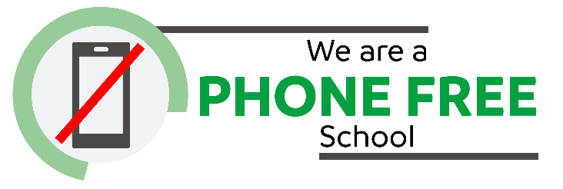

The Birkenhead Park School is a phone free school and uses a system called Yondr.

This policy also aims to address some of the challenges posed by mobile phone usage in school, such as:
- Safeguarding risks, including child on child abuse
- Data protection issues
- Potential for lesson disruption
- Appropriate use of technology in the classroom

How it works
- Students are given a secure Yondr pouch to keep their phone in during the school day .
- Upon arrival students put their phone into their Yondr pouch and lock it.
- Students keep their locked Yondr pouch in their school backpack throughout the school day.
- At the end of the school day, students unlock their Yondr pouch as they exit the school premises, and have full access to their phone.
- Students are required to bring their Yondr pouch to and from school each day, and are responsible for their pouch at all times.
- If a pouch is lost or damaged, there will be a replacement charge of £25 to the parent/carer.

Should a student be found to be using their mobile phone during the school day, their phone will be confiscated and stored securely until the end of the school day. Students will receive a negative behaviour point and a one hour, after-school detention. Phones are to be collected after completion of the detention.

Students who forget their Yondr pouch must hand their phone to a member of staff upon arrival at school. Their phone will be stored securely for the school day and can be collected at 3.35pm.

Persistent non-compliance of the above will result in a student receiving a fixed term exclusion, and progressing through our school’s behaviour stage process.

Appendix 1

Department for Education - Mobile phones in schools

https://assets.publishing.service.gov.uk/media/65cf5f2a4239310011b7b916/Mobile_phones_in_schools_guidance.pdf

