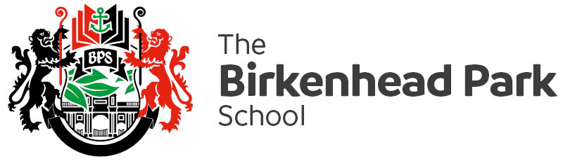
PHSE/ RSE Curriculum Overview 2022-2026
 | LP1 | LP2 | LP3
Year 7 | Living in the wider world and SRE  Self-esteem, resilience, Safe social media, friendship, families, romance | Living in the wider world and SRE  Bullying, cyber bullying, safe relationships, FGM, Smoking and vaping, alcohol | Health and Wellbeing  Mental Health, anger, Healthy living, exercise, consequences of not living healthily, energy drinks
Year 8 | SRE  Consent, contraception, pornography, sexting, STIS, grooming, running away | Health and wellbeing  Self-harm, personal development, , behaviour, mindfulness, body image (males and females) | Living in the wider world  Selfie safety, disabilities, homophobia, discriminating teenagers, drugs, county lines
Year 9 | Health and Wellbeing  Peer pressure, anxiety, stress, revision, success | Living in the Wider World  Knife Crime, Acid attack, law, extremisms, British values | SRE  LGBQT Community, Domestic violence, CRE, Body image, teenage parenting, Sexual harassment
Year 10 | SRE  Safe relationships, domestic and emotional relationships, sexting, Pornography and the laws, contraception, STI’s | SRE / Health and Wellbeing  FGM, Sexual harassment, gender equality, Eating disorders, checking the body for lumps, Alcohol, smoking and drugs | Living in the wider world  Mental health (anxiety, stress and depression), careers, further education, CV writing
Year 11 | SRE  Safe relationships, domestic and emotional relationships, sexting, Pornography and the laws, contraception, STI’s | SRE / Health and Wellbeing  FGM, Sexual harassment, gender equality, Eating disorders, checking the body for lumps, Alcohol, smoking and drugs | Living in the wider world  Mental health (anxiety, stress and depression), careers, further education, CV writing

