**KS4 Rationale:**

* RSE in Year 10/ 11 is delivered through specifically planned form time sessions and scheduled drop down days
* Topics build on prior knowledge from KS3
* Students will explore in more depth specific age appropriate content

**KS3 Rationale:**

* DO NOW activities focus on the core skills and retrieval practice
* DO NOW activities link to the agreed end points at Primary school ensure that students do not have gaps in their knowledge
* LP1 and LP2 focus on RSE ensuring that age appropriate content is taught

**Additional Information:**

Confidentiality- All concerns about safety of students must be considered within safeguarding procedures and any concerns passed on to the school’s DSL.

Local Health Services- Students are informed of how to access local health services for confidential health advice where they are signposted to services such as Brook, GUM Clinic at Arrowe Park, and Health Services in Schools.

Outside visitors- Only outside visitors that are fully accredited will be used. They are informed where their input fits into the curriculum and about the school’s confidentiality policy and safeguarding procedures prior to their session.

**Equal opportunities/ Protected Characteristics**

* All students and staff have a right to be treated with respect and sensitivity and to have access to opportunities regardless of their gender, race, religion, sexuality or any disability
* Development of a sense of justice and tolerance in young people in line with British Values and with the law.
* Expressions of prejudice, with or without the intention to offend, are a form of abuse, which will not be tolerated.
* All staff will refrain from portraying any views that may been deemed discriminatory including those of misogyny and attitudes to women, attitudes towards the LGBT community and attitudes towards sexual abuse.

RSE provides children and young people with the opportunity to receive information whilst exploring issues and values. RSE is not about the promotion of sexual activity. It is lifelong learning about different types of relationships, sexual health, sexuality, healthy lifestyles, diversity and personal identity. RSE fosters the emotional, social and cultural development of students and develops resilience and character, all of which are fundamental to students being happy, successful members of society.

RSE teaches students about the importance of stable and loving relationships, in all capacities, and how to nurture and develop these. It supports students in being able to identify acceptable and unacceptable behaviour in relationships, when relationships are unhealthy and how these situations can be managed.

RSE is also designed to support the students growing up in an increasingly digital world and the significant challenges this presents, particularly for young people. RSE provides students with the tools they need to make the right decisions and to keep themselves safe and happy. They need to be able to balance technology’s benefits with a critical awareness of their own and others’ online behavior, and develop effective strategies for staying safe and making a positive contribution online. Cyberbullying, online grooming, access to inappropriate images and sexting are just some of the ways in which digital technology can negatively impact on children’s and young people’s lives. These issues are explored in the RSE curriculum and also links to our whole-school internet policy.

In an age appropriate way and with a phased approach, RSE educates students on safer sex and sexual health. Knowledge in these areas is vital to ensuring students are prepared to make safe, informed and healthy choices as they progress through adult life. This is delivered in factual way, providing a balanced and objective view, allowing scope for students to discuss misconceptions and misinformation in a safe environment.

The RSE programme is securely embedded in the PSHE curriculum and is part of every student’s learning. The curriculum demonstrates progression and is supported by Brook and other outside agencies.

Key Stage 3 (Y7, 8 and 9) are taught RSE within the PSHE curriculum, currently delivered during one timetabled lesson each fortnight which covers 19 lessons across the academic year. Key stage 4 (Y10 and 11) are taught RSE through a range of methods including; form time, drop-down days, stand-alone sex education sessions which are delivered by a trained health professionals and within a programme of whole year group assemblies. RSE is also delivered within topics on health and in conjunction with Brook, Response and other agencies as appropriate. Other aspects of RSE are taught across the curriculum which ensures that all aspects of the curriculum is fully embedded in a variety of subject areas.

As well as provision for all students in a year group there are targeted approaches when necessary. Students may be carefully selected for targeted workshops based on their specific needs by Pastoral Leaders, Year leaders, and the safeguarding team where bespoke sessions will be delivered.

Children with SEND in KS3 attend the timetabled RSE/PSHE lessons and teachers will adapt the curriculum according to their needs so that they can access the lessons. There is similar personalised learning for students with physical and medical impairment.

As well as timetabled PSHE lessons and work covered in some other subjects students are made aware through assemblies and training sessions of support services such as the Kooth online counselling website. Health Services in Schools is also an established part of school provision.

**PHSE/ RSE Curriculum Intent**

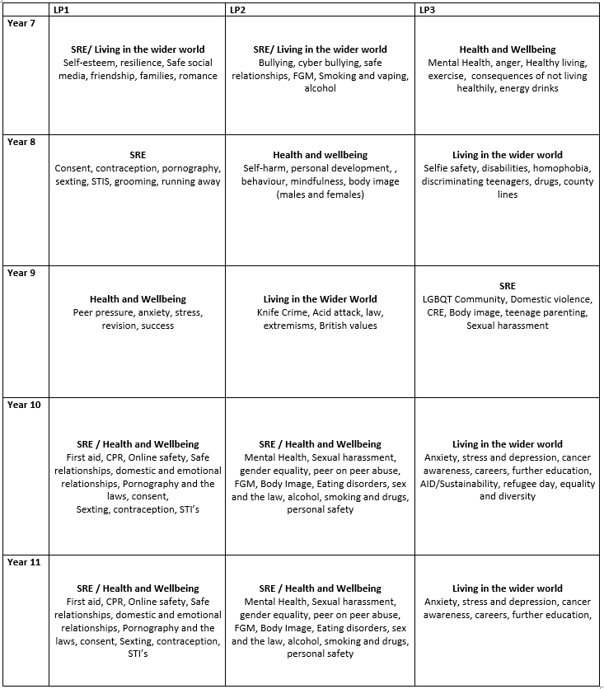

**Pedagogy within the Classroom:**

* Clear strategies used by teachers to handle sensitive content
* Use of ground rules to ensure a safe learning environment
* Distancing techniques used in the classroom when talking a about sensitive content
* Clear boundaries set out by teachers when answering questions
* Discussions will be handled sensitively
* Single sex grouping may be used when workshops are run by external providers

**Lesson planning:**

* Lessons are planned using the whole school agreed structure focusing on our teaching and learning priorities
* Lessons are prepared in advance, focusing on specific and appropriate content with reference to the law
* Lessons are planned to ensure there is no bias or opinion displayed by the teacher and will not promote any sexist, misogynistic or homophobic view points
* Lessons are planned to support students with SEND and content will be tailored where appropriate

**PHSE/ RSE Curriculum: 5 Year plan**

**Assessment:**

* The national curriculum states that there is no formal assessment needed for PHSE/ RSE education.
* Informal assessments will be conducted through LSQs to check understanding
* Responsive teaching techniques will be used to address any misconceptions

**Build-up of knowledge:**

* Knowledge will be pitched at an appropriate level specific to student age and will reflect the needs of the school and the demographic of the student population