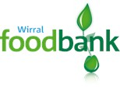
In order to receive help from Wirral Foodbank, you need to have a code number from an electronic voucher.

If you need a voucher, you can obtain one from either:

Wirral Council Helpline 0151 666 5050

Ask Us Wirral 08082 78 78 48

