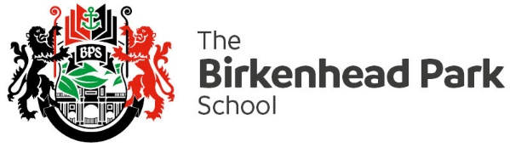
RS Curriculum Overview 2022 - 2026
 | LP1 | LP2 | LP3
Year 7 | Christianity  Who is God?, Trinity and Jesus, the Bible, Genesis, Adam and Eve, Evil and suffering, Noah’s Ark, Denominations, Euthanasia, Death penalty, afterlife | Jesus’ influence  Who was Jesus?, The incarnation of Jesus, Key events in Jesus’ life (miracles), What does the Bible teach about Jesus?, What does Jesus teach Christians?, Why is Jesus special? The death and significance of Jesus to Christians. | Humanism  What is Humanism?, Humanism on God, Humanist Ethics, Humanist meaning and purpose, Humanism end of life, Humanist celebrations, Humanist origins of the universe, Humanist thinkers, Humanist views, Humanist society
Year 8 | Islam  Who is Allah?, Who is Muhammad?, The Quran, Angels- Jibril, 5 pillars, Salah- prayer, Hajj, Ramadan/ Eid, , Euthanasia, Death penalty, Afterlife | Buddhism:  Siddhartha, 8 noble truths, 5 precepts, Karma, Buddhist monks, Mandalas, Euthanasia, Death penalty, Afterlife | Judaism-  Abraham, Moses and the 10 commandments, The Torah, Pesach, Shabbat, Kosher, Euthanasia, Death penalty, Afterlife
Year 9 | Religious Perceptions and Equality: (Islam, Christianity and Humanism)  Religion and human rights, Freedom of speech, Making fun of religions, What is hate speech?, Western perceptions of Islam, The media and religion, Poverty, People in religion | Ethics:  Morality, Utilitarianism, Situation ethics, When does life begin?, designer babies, artificial intelligence, animals vs humans. | Philosophy of Religion  What is truth?, What is doubt? Is God real? Is God an illusion?
Year 10 GCSE option | Christian beliefs  The nature of God, Evil and suffering, The oneness of God and the trinity, Creation, Incarnation, Crucifixion, Resurrection, Afterlife, Heaven and hell, Sin, Salvation  Muslim beliefs  Oneness of God, Sunni vs Shia, Nature of God, Angels, Predestination, Life after death, Prophet hood, Ibrahim, Muhammad, Holy Books | Christian practices  Worship, Prayer, Baptism, Holy communion, Pilgrimage, Celebrating festivals, Food banks, Street pastors, Evangelism, Church growth, Poverty  Muslim practices  5 pillars, Salah, Sawm, Zakat, Hajj, Jihad, Id,  Ashura | Theme A- relationships and family  Human sexuality, Sexual relationships, Contraception, Marriage, Divorce, Nature of families, Purpose of families, Gender equality  Theme B- religion and life  Origins of universe, Value of world, Environment, Animals, Origins of human life, Abortion, Euthanasia, Death and afterlife
Year 11 GCSE option | Theme E- religion, crime and punishment  Crime and punishment, Reasons for crime, Law breakers, Aims of punishment, Suffering  Criminal, Forgiveness, Death penalty  Theme F- religion, human rights and social justice  Social justice, Human rights, Religious freedom, Race, Women, Wealth,  Exploitation of the poor, Giving money to the poor | Digging deeper on the skills and knowledge from paper 1 | Digging deeper on the skills and knowledge from paper 2

