**(Year 7) rationale- why now and why this way?**

* Following the Wirral Agreed Syllabus.
* Year 7 starts with ‘who/ what is God?’ and the reasons in which Christians believe in their faith. We explore how the Bible was written (and its format) and the key messages from the stories and parables, including Genesis, Adam and Eve and the Birth and importance of the life of Jesus. We investigate how these may influence a Christian today. We study how influential figures in the Bible such as Jesus, Moses or the disciples play significant roles in our communities within society today. We also look at the themes of family life, medical issues and death and explore how Christians deal with these issues. Christianity is a topic that our students will have a range of knowledge of when they start with us in year 7. Some may have attended primary school with a Christian ethos, others with no religious denomination. While students may have been taught in accordance with the national curriculum, knowledge will be diverse. We feel that it is not only important for our pupils to learn about religion but also from religion. This is achieved by delving into the religion and understanding the narratives and identifying how they apply to society today. Students will have the opportunity to explore Christianity in our school and the surrounding area and gain an understanding of how religion impacts them even if they are not religious themselves. This knowledge will be built upon at GCSE.
* Year 7 ‘Spring term’ builds upon ‘Autumn term’ and looks at the life of Jesus for 8 lessons. This will allow students to broaden their Christian knowledge and look more deeply at Christian teachings through parables and Biblical scriptures. We investigate how these may influence a Christian today.
* During ‘Summer term’ our topic is ‘Humanism’. This series of lessons will explore worldviews that do not focus on religious authority or teachings. Students will explore how non-religious people express themselves and ‘justify’ their beliefs. This topic will allow many students to explore their own beliefs and allow discussion-based activities. This will allow ‘personal knowledge’ as pupils will be given the opportunity to reflect on their knowledge across year 7 and build an awareness of their own presuppositions and values about the religious and non-religious traditions that they study.
* Students will be encouraged to develop and reflect upon their own beliefs.

Cultural capital: Christian attitudes, attitudes toward Christians, medical laws, roles of gender in society, polygamy, purpose of marriage, religious communities in Birkenhead, changing face of religions, crime and punishment, prejudice, discriminations, religious influence on common law, the Royal Family, British values.

**(Year 8) rationale- why now and why this way?**

* Following the Wirral Agreed Syllabus.
* In year 8 students will begin ‘Autumn term’ with Islamic teachings. Birkenhead has a significant number of Muslim communities and we feel it important to educate our pupils in matters regarding Islamic key beliefs. It is important that students understand Allah with reference to the Christian notion of God as both religions are monotheistic and share some key values. This topic develops student understanding of Islamic teaching through looking at key stories and teachings from the Quran and issues in modern day life such a family life, medical issues, and life after death. This knowledge will be built upon at GCSE.
* ‘Spring term’ allows students to study an Indic religion: Buddhism. Buddhism is a religion with no God and a religion that students usually do not study at KS3 hence why we feel it is important to study- it will allow students to have a balanced knowledge of western and eastern religions and the difference between their teachings and practices. Again, we look at the themes of family life, medical issues and death and explore how Muslims and Buddhists deal with these issues in the 21st century.
* ‘Summer term’ studies Judaism which coincides with year 8 History ‘Summer term’- The Holocaust. We feel it is important for students to know detailed information about the Jewish religion whilst finding out how Jews were treated during Hitler’s reign (and beyond). We start the topic by looking at the basic key teachings of Abraham and Moses before looking at key practices including Pesach, Shabbat, and kosher laws- these topics really bring the religion to life for our students. Again, we also look back to the themes of family life, medical issues and death and explore how Jews deal with these issues.
* Students will be encouraged to develop and reflect upon their own beliefs.

Cultural capital: attitudes toward Jews, roles of gender in society, historical treatment of Jews, Crime and punishment, immigration, prejudice, discrimination, purpose of marriage, religious communities in Birkenhead, medical laws, authority, influential figures, extremism, terrorism, British Values, racism

**KS4 GCSE**

* Pupils will follow AQA Religious studies specification A (Christianity and Islam, Themes: A, B, E, F). We have chosen this specification and these themes as we feel it is important for our pupils to learn about and from the main religions that are followed in our area.
* Students will be aware that Christianity and Islam are two of the most diverse religious traditions and beliefs in Great Britain today. Students will study the influence of the beliefs, teachings and practices of individuals, communities, and societies.

*Christianity:*

* Key beliefs including the nature of God and differing beliefs regarding creation.
* Key practices including worship, festivals, and roles in the community.

*Islam:*

* Key beliefs including Sunni and Shi’a Islam, the role and importance of Muhammed and beliefs regarding the afterlife.
* Key practices including prayer, duties, and the importance of celebrating festivals.
* Students will also study philosophical and ethical arguments related to issues such as abortion, capital punishment and sex before marriage, and their impact and influence on the modern world. Students will show their understanding of religion through the application of teachings from religion and beliefs.

Theme A: relationships and families

Students will explore the following topics: Contraception and family planning, sex before marriage, cohabitation and marriage and divorce.

Theme B: religion and life

Students will explore the following topics: When does life begin, abortion, euthanasia, animal experimentation and look at differing beliefs about how life began.

Theme E: religion, crime, and punishment

Students will explore the following topics: Corporal punishment, death penalty, forgiveness, and the origins of evil and suffering.

Theme F: religion, social justice, and human rights

Students will explore the following topics: Prejudice, discrimination, and inequality with reference to wealth, race, gender, and religion.

* Students will be encouraged to develop and reflect upon their own beliefs.

Cultural capital: Christian and Islamic attitudes, attitudes toward Christians and Muslims (in the UK/ world and Birkenhead), medical laws, roles of gender in society, polygamy, purpose of marriage, religious communities in Birkenhead, changing face of religions, crime and punishment, prejudice, discriminations, religious influence on common law, extremism, terrorism, authority, sex, animal rights, divorce, British Values, racism.

**Year 10- Component 1: The study of religions: beliefs, teachings, and practices**

**(Year 9) rationale- why now and why this way?**

* Following the Wirral Agreed Syllabus.
* Autumn term for year 9 begins with Perceptions of religion and allows teachers to address misconceptions of religions and attitudes towards beliefs before GCSE. We explore whether British society is influenced by religious people, beliefs, and teachings. We will explore how human rights are effected by religious viewpoints and question if we can ever be truly autonomous in our decision-making process with reference to ethical and contentious world issues.
* Spring term allows students to focus on ethical dilemmas and how religious and non-religious people make moral decisions such as ‘Is abortion ever ethical?’, ‘who has the right to end a life?’ and ‘when does life begin?’. This unit of work will encompass many SRE topics. This knowledge will be built upon at GCSE.
* Summer term has a focus on ‘Philosophy of religion’. Students are able to explore big questions such as ‘what is truth?’, Is God in the world?’ and ‘Is religion just an illusion?’. Students will explore the views of a wide range of western philosophers. This term will allows students to develop their listening, thinking, questioning and debating skills.
* This knowledge will be built upon at GCSE.
* Students will be encouraged to develop and reflect upon their own beliefs.

Cultural capital: race, sexuality, media, extremism, evangelism, contraception, sex, miscarriage, abortion, heaven, hell, purgatory, freewill, human rights, British values, religious communities in Birkenhead, changing face of religions, crime and punishment, prejudice, discriminations, religious influence on common law, racism.

**RE overview**

KS3 pupils follow the Wirral Agreed Syllabus. We have chosen to study Islam, Christianity, Buddhism, Judaism and Humanism at KS3 as we feel this will allow our students to have the breadth and depth of knowledge of the religions they will encounter outside of school. The depth of knowledge will be particularly focused on Islam, Christianity and Buddhism in year 9 and finally Islam and Christianity will be our focus in KS4. Each LP in year 7 and 8 focuses on contentious issues and the religious attitudes towards them i.e. abortion, euthanasia, and life after death. We will explore the beliefs regarding these issues for each religion and explore this in more detail with those students who decide to take RS GCSE. Students will be continuously encouraged to develop and reflect upon their own beliefs.

KS4 pupils will follow AQA Religious studies specification A (Christianity and Islam, Themes: A, B, E, F). We have chosen this specification and these themes as we feel it is important for our pupils to learn about and from the main religions that are followed in our area.

**Assessment:**

* Assessment takes place regularly. ‘Blue Questions’ are used to allow teachers to test student performance but are clear this does not show ‘learning’ from the long -term memory.
* End of unit assessments are completed at the end of each LP and are planned to test current and prior knowledge.
* Assessment QLA is used to address student’s misconceptions and re-test rather than re-teach.

**Long term Memory/ Retrieval of Knowledge:**

* Each lesson has a recap from previous lessons in some form.
* Low- stakes testing is used.
* ‘Making it stick’ long term recall is also revisited each lesson as a settler activity- this is after an extended period at the point when students are just about to forget to make it effective. (see below image)
* Teachers ask questions to address misconceptions – ‘hinge questions’ are used.

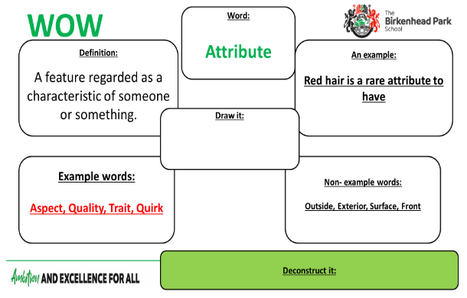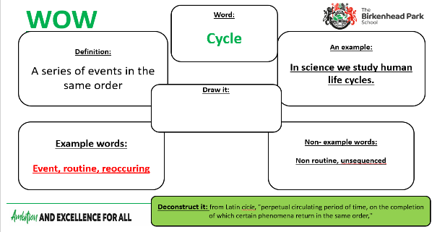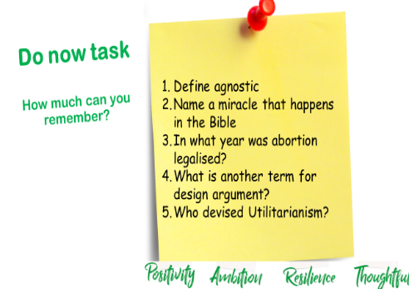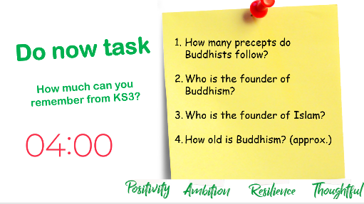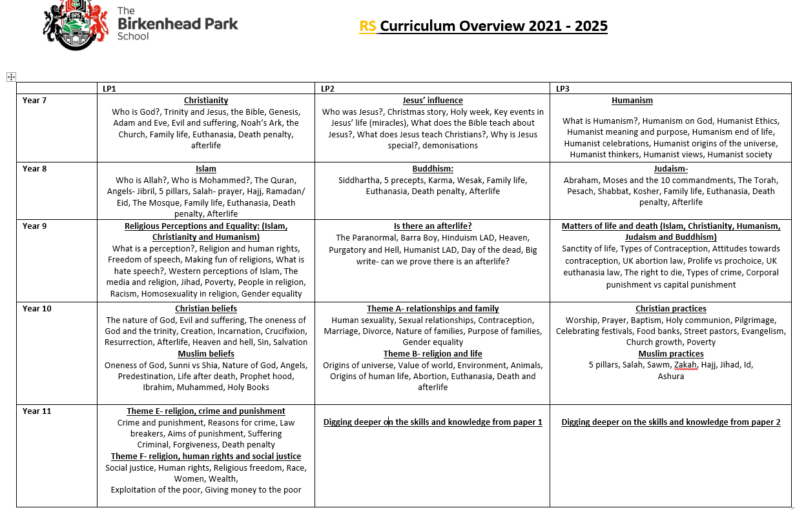

**Pedagogy within the Classroom:**

* Teachers will ensure that instructions are given that do not cognitively overload students.
* Teachers will use the ‘I, WE, YOU’ strategy in breaking down questions as outlined in the Humanities plan to create resilient and independent learners.
* Teachers will ensure regular, low-stakes testing is used to create strong bonds with the long-term memory.
* Teachers will provide every opportunity for students to engage in purposeful discussion/ reading to share ideas and provide links to students past learning, across faculties and in the outside wider world allowing students to have a broader understanding.

**Build-up of Skills:**

* The skills identified for success at GCSE is outlined and planned backwards from Year 11- 7.
* These skills are built upon each year from year 7 but are **not** GCSE questions at year 7 and 8. They are age appropriate for each Year group and allow students to fully access assessments and low stakes testing.
* The language is similar to allow students to become familiar and build up a layer of skills each year- to review and refine these at regular intervals to become independent and resilient learners.
* Drawing on their substantive knowledge of places and skills and building on this prior knowledge
* Disciplinary knowledge will help secure the skills needed, for example reflecting and linking themes and religions together.